Correlation Coefficients and Trends (Model Notes)

Directions
1) Sketch one single straight line that you think best fits each set of data.
2) Highlight the values for a, b, and r (not r²).
 |  |  |  | 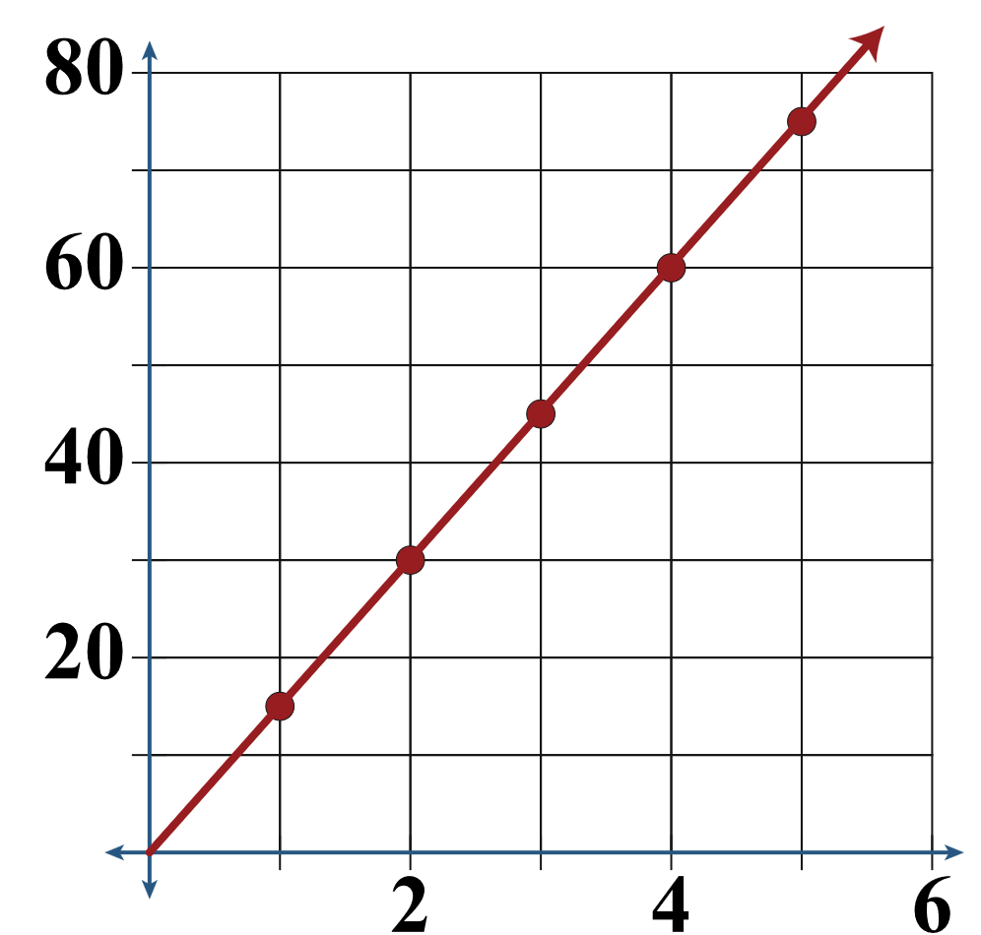 | 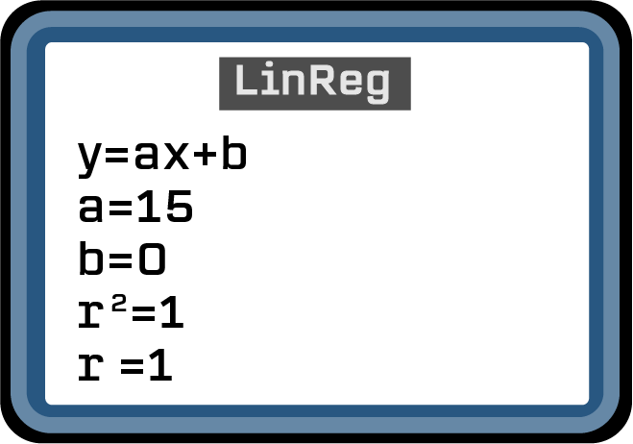
 | Tickets | Cost
 | 1 | $15
 | 2 | $30
 | 3 | $45
 | 4 | $60
 | 5 | $75
 |  |  |  | 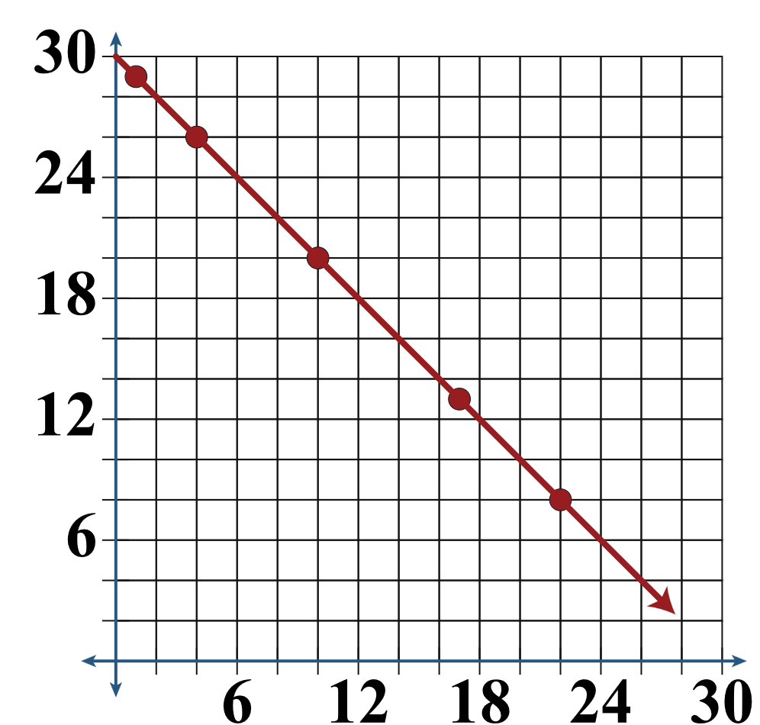 | 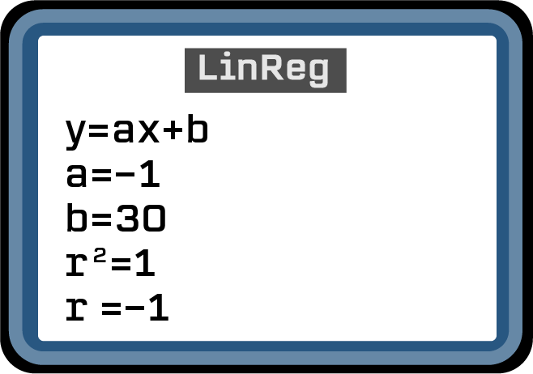
 | Candy  Eaten | Candy  Left
 | 1 | 29
 | 4 | 26
 | 10 | 20
 | 17 | 13
 | 22 | 8
 |  |  |  | 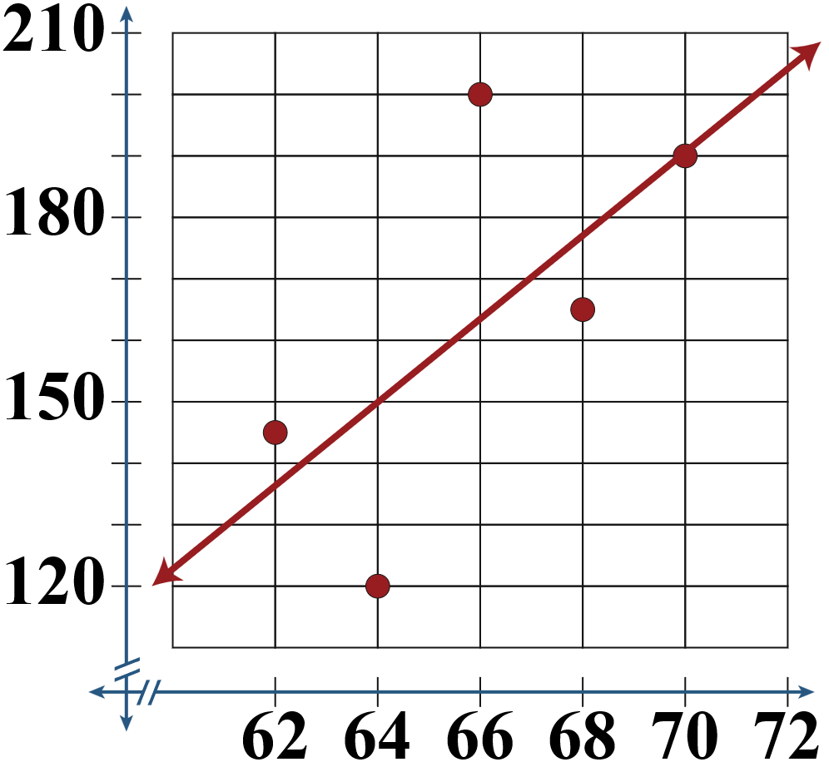 | 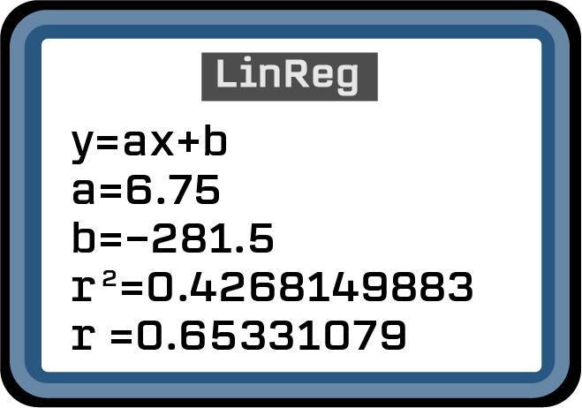
 | Height  (in.) | Weight  (lbs.)
 | 62 | 145
 | 64 | 120
 | 66 | 200
 | 68 | 165
 | 70 | 190

Observations
How do you see a and b represented on the line you sketched?
a is the slope of the line, and b is the y-intercept.
Compare the r-values of each data set. What do you think r represents?
r represents how well the data fits the line.

Linear Regression (Formalize Your Findings)
Your calculator uses linear regression to find a line of best fit, which is also known as a linear regression model.
- a represents the __slope__ of the line.
- b represents the __y-intercept__ of the line.
- r is the correlation coefficient. This r-value shows _how well the linear regression model
fits the data_.
- The closer the r-value is to __–1__ or ___1__, the better the line fits the data.

Linear or Exponential
- If a scatter plot can be represented with a straight line, then we say that the trend is __linear__.
- If a scatter plot cannot be represented with a straight line, then we say that the trend is __nonlinear__.
- When a data set is linear, the y-values change by __adding the same number__.
- When a data set is exponential, the y-values change by __multiplying by the same number__.
Week | Account  Balance |  | Example  You are saving money to buy a video game. The table shows your account balance at the end of each week. Is the data linear or not linear? How can you tell from the table?  The data is linear because $4 is added to the account balance every week.
1 | $4.00
2 | $8.00
3 | $12.00
4 | $16.00
5 | $20.00
Find the linear regression model for your account balance and write it in the form y = mx + b.
y = 4x + 0 or y = 4x
Give the correlation coefficient and explain its meaning.
r = 1. This means that the linear regression model perfectly fits the given data.
Predict the amount of money in your account after 10 weeks.
y = 4(10) + 0 = 40 + 0 = 40 After 10 weeks, I should have $40.

