Correlation Coefficients and Trends: Guided Notes

Directions
1) Sketch one single straight line that you think best fits each set of data.
2) Highlight the values for a, b, and r (not r²).
 |  |  |  | 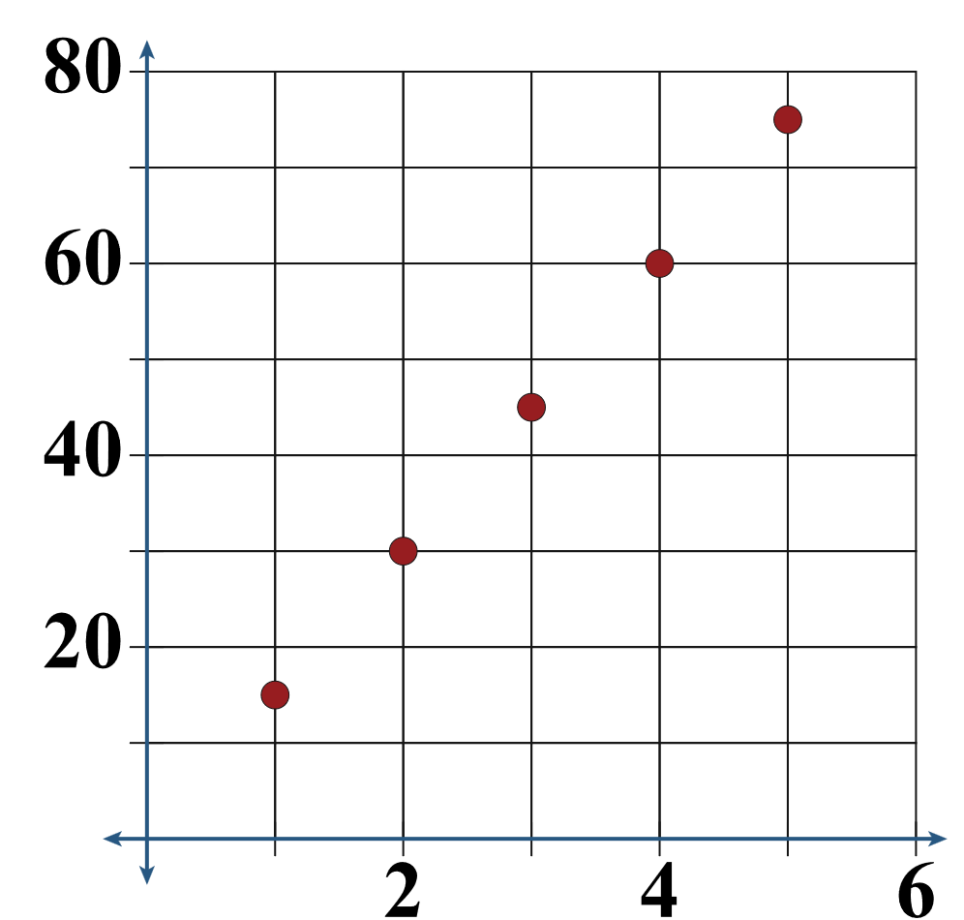 | 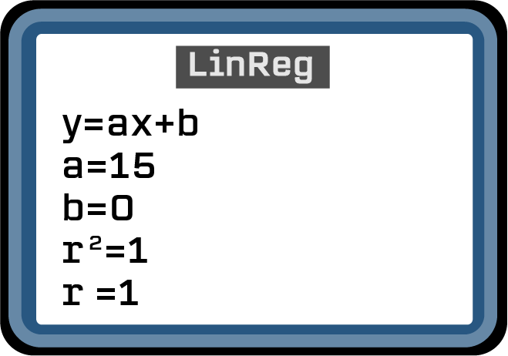
 | Tickets | Cost
 | 1 | $15
 | 2 | $30
 | 3 | $45
 | 4 | $60
 | 5 | $75
 |  |  |  | 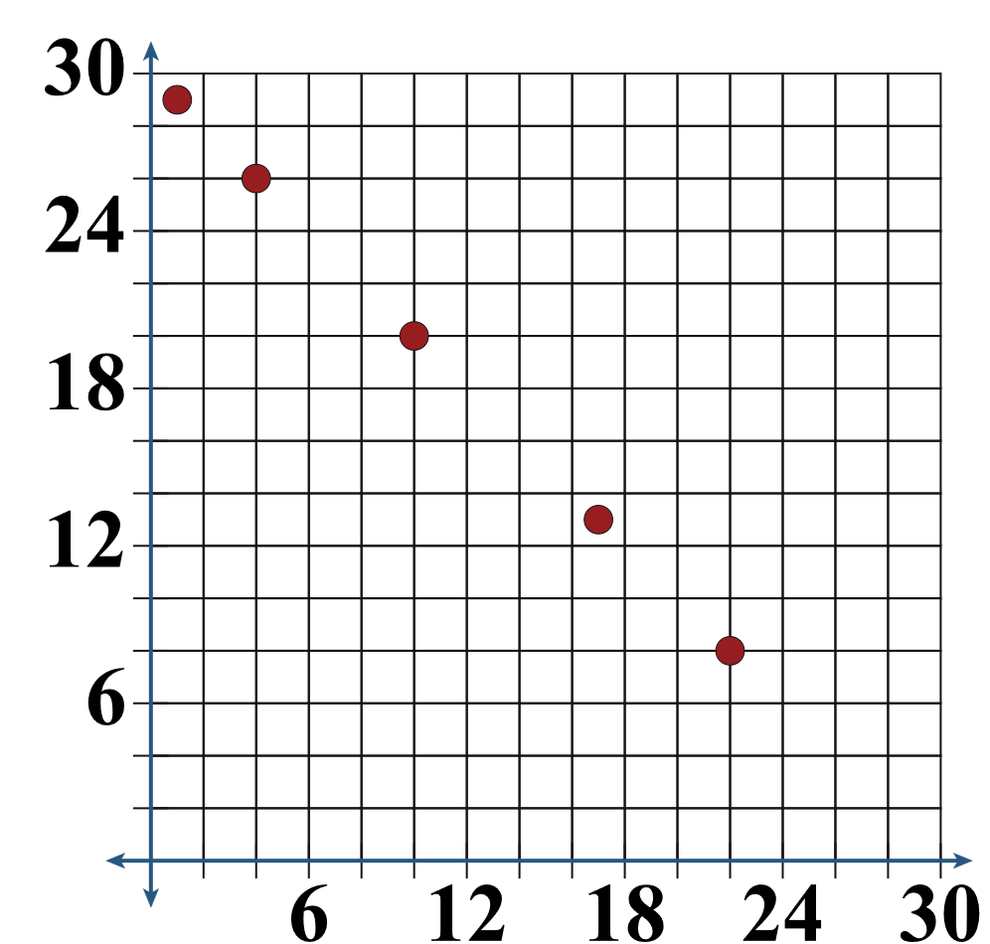 | 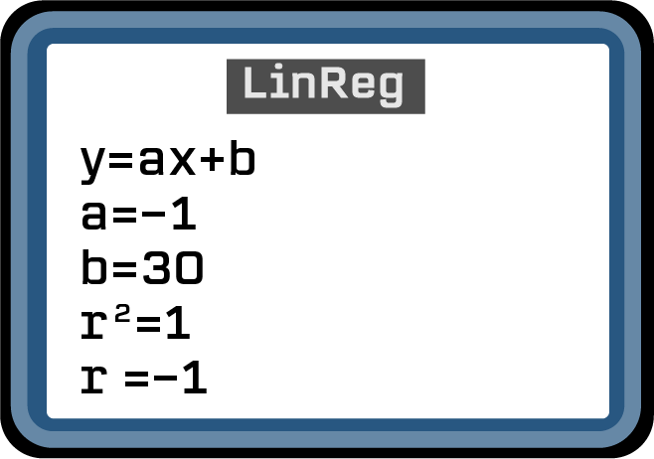
 | Candy  Eaten | Candy  Left
 | 1 | 29
 | 4 | 26
 | 10 | 20
 | 17 | 13
 | 22 | 8
 |  |  |  | 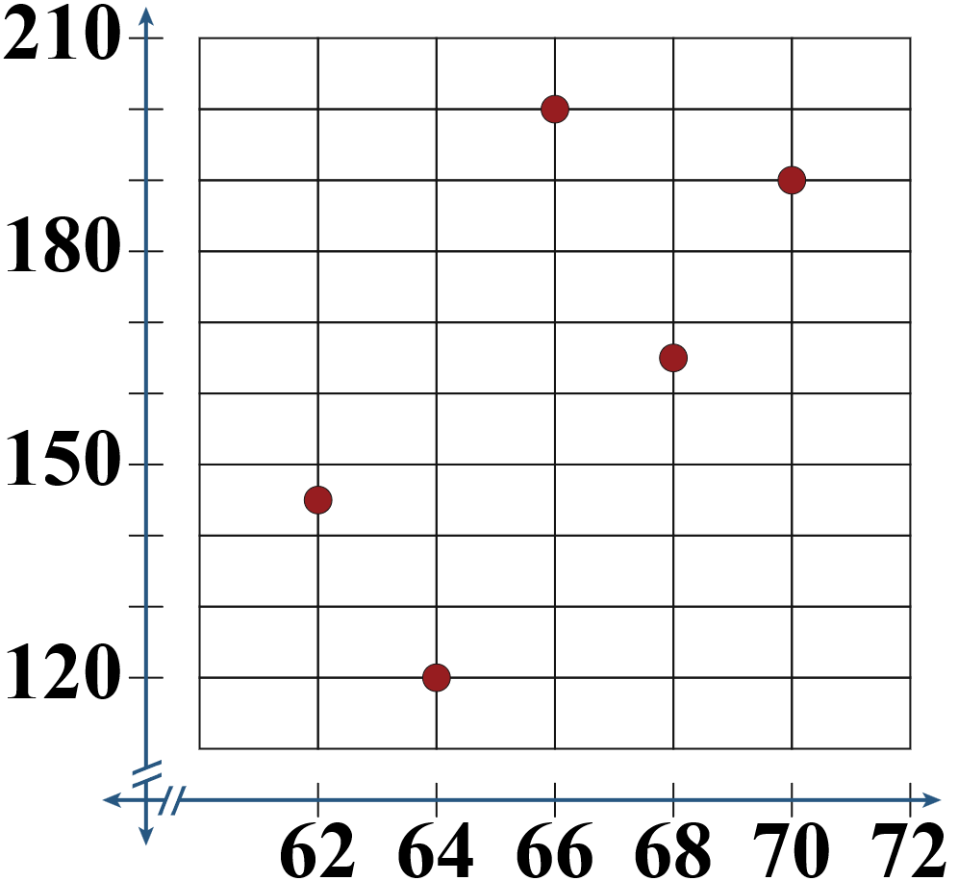 | 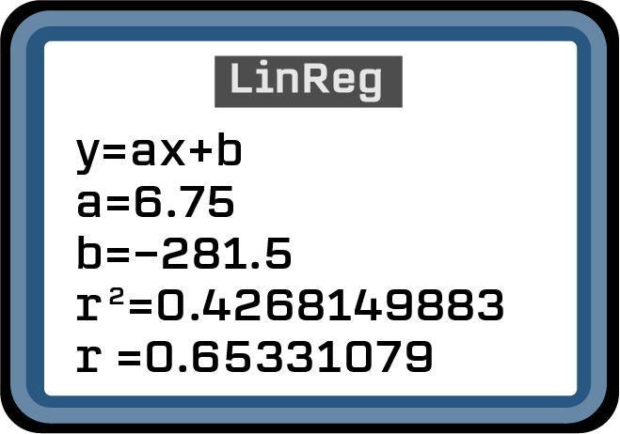
 | Height  (in.) | Weight  (lbs.)
 | 62 | 145
 | 64 | 120
 | 66 | 200
 | 68 | 165
 | 70 | 190

Observations
How do you see a and b represented on the line you sketched?

Compare the r-values of each data set. What do you think r represents?

Linear Regression (Formalize Your Findings)
Your calculator uses linear regression to find a line of best fit, which is also known as a linear regression model.
- a represents the __________ of the line.
- b represents the __________ of the line.
- r is the correlation coefficient. This r-value shows _______________________________.
- The closer the r-value is to _____ or _____, the better the line fits the data.

Linear or Exponential
- If a scatter plot can be represented with a straight line, then we say that the trend is _______________.
- If a scatter plot cannot be represented with a straight line, then we say that the trend is _______________.
- When a data set is linear, the y-values change by _______________.
- When a data set is exponential, the y-values change by _______________.

Example
Week | Account  Balance |  | You are saving money to buy a video game. The table shows your account balance at the end of each week. Is the data linear or not linear? How can you tell from the table?
1 | $4.00
2 | $8.00
3 | $12.00
4 | $16.00
5 | $20.00
Find the linear regression model for your account balance and write it in the form y = mx + b.

Give the correlation coefficient and explain its meaning.

Predict the amount of money in your account after 10 weeks.

