Trends and Correlation Coefficients (Model Notes)

Directions
Use the tables to find a pattern of how the y-values increase or decrease. Write a general rule next to each table (ex. + 4, · 2, etc.).
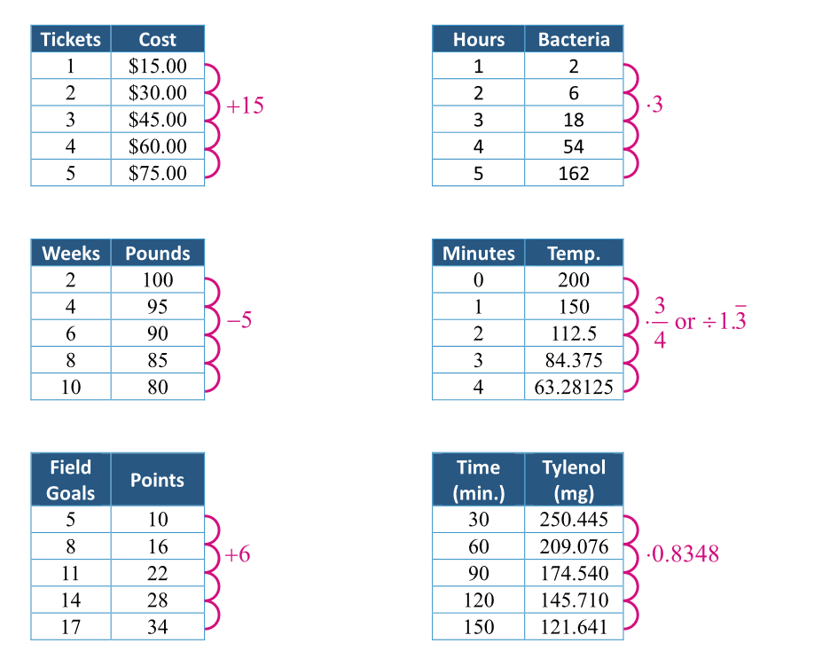

Observations
The data in the tables on the left is linear. Why do you think we use that word for it?
It probably makes a line. It looks a lot like how I find the slope of a line.
The data on the right is nonlinear—more specifically, it is exponential.
Using the table, how can you determine if a data set is linear? is exponential?
- It is linear if… you add or subtract the same thing from y each time.
- It is exponential if… you multiply each y by the same number each time.

Linear or Exponential (Formalize Your Findings)
- If a scatter plot can be represented with a straight line, then we say that the trend is __linear__.
- If a scatter plot cannot be represented with a straight line, then we say that the trend is __nonlinear__.
- When a data set is linear, the y-values change by __adding the same number__.
- When a data set is exponential, the y-values change by __multiplying by the same number__.

Linear Regression
Your calculator uses linear regression to find a line of best fit, which is also known as a linear regression model.
- a represents the __slope__ of the line.
- b represents the __y-intercept__ of the line.
- r is the correlation coefficient. This r-value shows _how well the linear regression model
fits the data_.
- The closer the r-value is to __–1__ or ___1__, the better the line fits the data.
Week | Account  Balance |  | Example  You are saving money to buy a video game. The table shows your account balance at the end of each week. Is the data linear or not linear? How can you tell from the table?  The data is linear because $4 is added to the account balance every week.
1 | $4.00
2 | $8.00
3 | $12.00
4 | $16.00
5 | $20.00
Find the linear regression model for your account balance and write it in the form y = mx + b.
y = 4x + 0 or y = 4x
Give the correlation coefficient and explain its meaning.
r = 1. This means that the linear regression model perfectly fits the given data.
Predict the amount of money in your account after 10 weeks.

y = 4(10) + 0 = 40 + 0 = 40 After 10 weeks, I should have $40.

