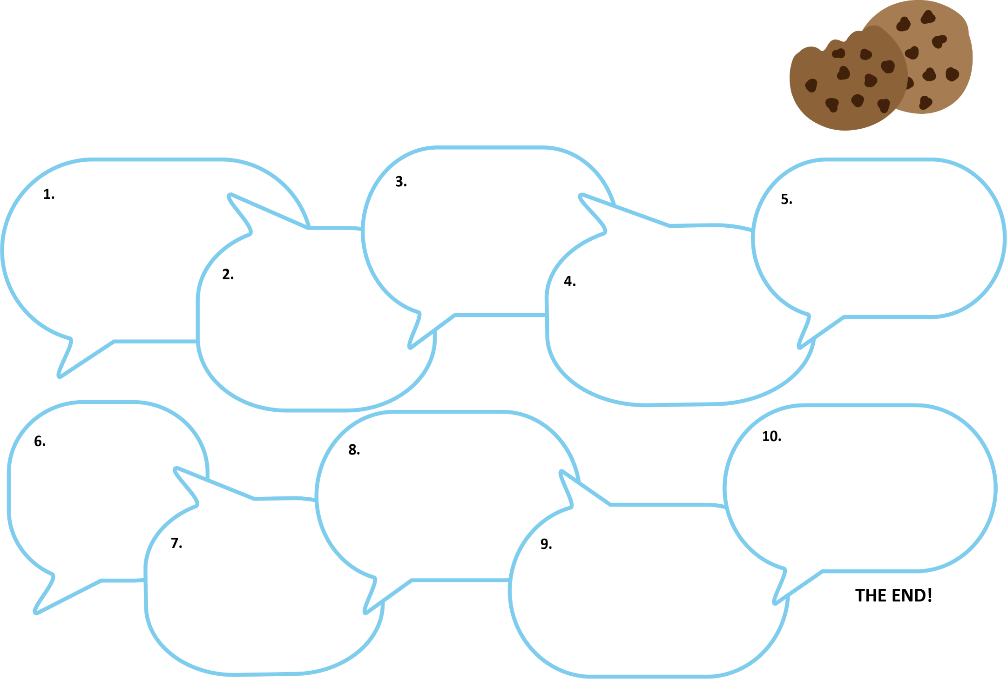
Chain Story
Begin your story with a conditional sentence like “If you give a mouse a cookie, he’s going to ask for a glass of milk.” Continue with another conditional sentence. Pass the paper to the next group member and repeat until your story has at least ten sentences. Include a title and an ending.
Group Members: ____________________________________________________________________
Chain Story Title: ____________________________________________________________________

