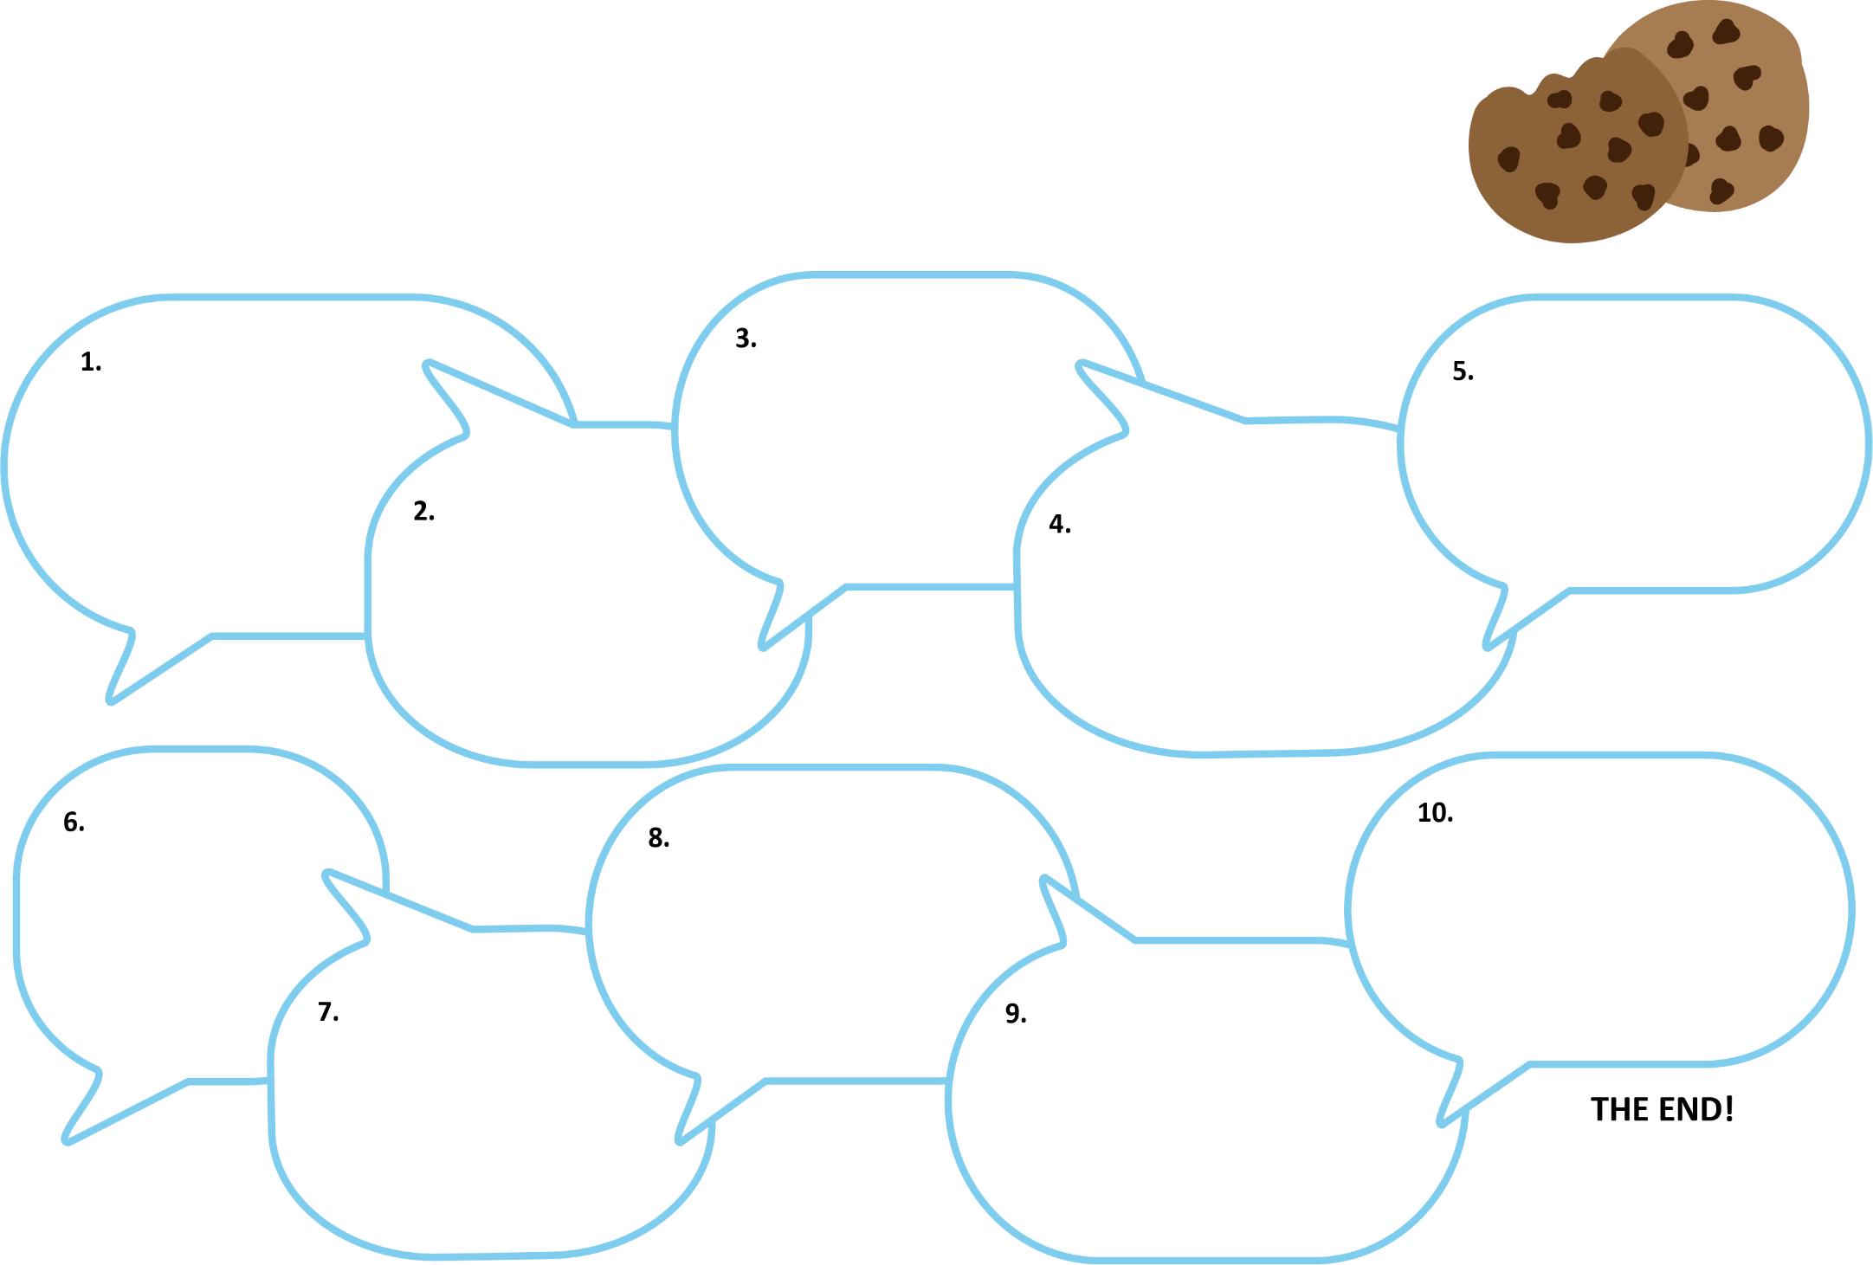Chain Story

Begin your story with a conditional sentence like “If you give a mouse a cookie, he’s going to ask for a glass of milk.” Continue with another conditional sentence. Pass the paper the next group member and repeat until your story has at least ten sentences. Include a title and an ending.

Group Members: ____________________________________________________________________

Chain Story Title: ____________________________________________________________________