poster and map activities

Boston Kidnappers Warning Poster
In the year 1850, police officers and other watchmen were allowed by law to arrest any black person and sell them into slavery. This poster, created by abolitionists in the free state of Massachusetts, warns black Bostonians about this law.
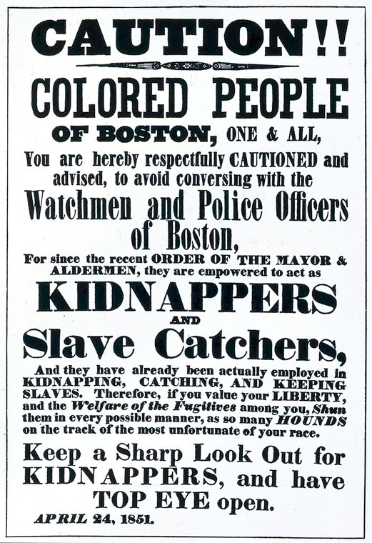
1. Even though the Constitution was ratified in 1789 and this text was published in 1851, how does this image relate to one of the four excerpts from the Constitution? Explain.

2. According to this poster, what people were legally allowed to capture black people in Boston and sell them into slavery? What does this tell us about the relationship between African Americans and law enforcement historically? How might this influence current relationships between the black community and the law enforcement community?

Source: Poster warning blacks in boston: kidnappers. (n.d.) Retrieved from https://www.tolerance.org/classroom-resources/texts/hard-history/poster-warning-blacks-in-boston-kidnappers

Modified and adapted from: Teaching tolerance. (n.d.) Poster warning blacks in boston: kidnappers text dependent questions. Retrieved from: https://www.tolerance.org/classroom-resources/texts/hard-history/poster-warning-blacks-in-boston-kidnappers

Map from “Freedom, Slavery, and the Coveted Territories”
This map, published in the 1850s, shows that westward expansion highlighted the debated over slavery. Existing states disputed whether new territories should be slave states or free states.
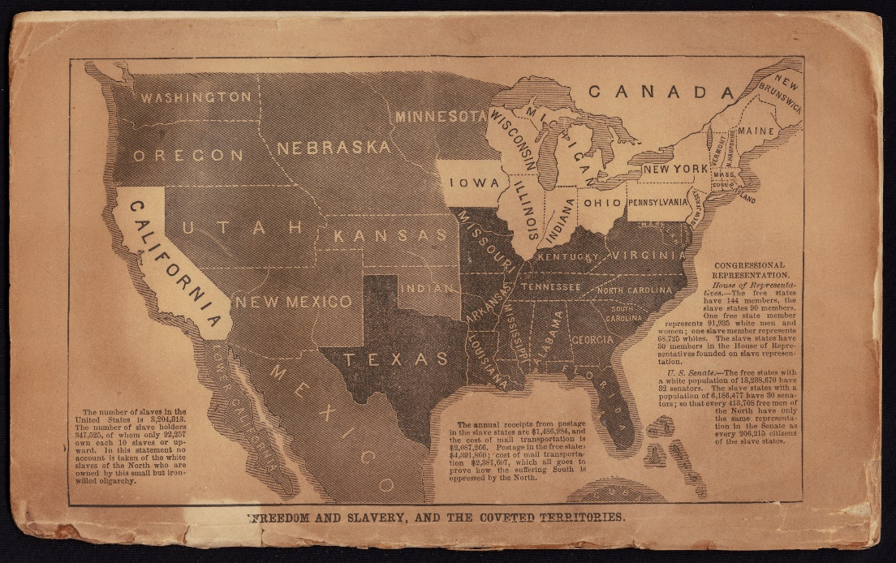
Source: John C. Fremont Campaign. (2017, April 14). Freedom and slavery, and the coveted territories. Cornell University—PJ Mode Collection of Persuasive Cartography. Retrieved from https://digital.library.cornell.edu/catalog/ss:19343669. Licensed under CC by 3.0.

“Freedom and Slavery, and the Coveted Territories” on Congressional Representation:
House of Representatives.—The free states have 144 members, the slave states 90 members. One free state member represents 91,985 white men and women; one slave member represents 68,725 whites. The slave states have 80 members in the House of Representatives founded on slave representation.
U.S. Senate.—The free states with a white population of 13,288,670 have 32 senators. The slave states with a population of 6,186,477 have 30 senators; so that every 413,708 free men of the North have only the same representation in the Senate as every 206,215 citizens of the slave states.
The number of slaves in the United States is 3,204,813. The number of slave holders 347,205, of whom only 21,257 own each 10 slaves or upward. In this statement no account is taken of the white slaves of the North who are owned by this small but iron-willed oligarchy.
- On this map, slave states are dark gray. Free states are white. Light grey represents territories that could be states in the future. In 1851, about 60 years after the Constitution was ratified, why would both the North and the South be interested in whether these territories would have slavery or not? Explain.

- Even though the Constitution was ratified in 1789 and this map was published in 1851, how does this image relate to one of the four excerpts from the Constitution discussed in class? Explain.

- The authors of this map are trying to show how one region of the country has more than its fair share of power in the national government. Looking at the text, is it the northern free states, or southern slave states? Explain. How did the structure of the Constitution allow slavery to persist for so long in the United States? What legacies of slavery are we still dealing with today?

Modified and adapted from: Teaching Tolerance. (n.d.) Map from “Freedom and slavery, and the coveted territories” text dependent questions. Retrieved from: https://www.tolerance.org/classroom-resources/texts/hard-history/map-from-freedom-and-slavery-and-the-coveted-territories

