Citation: Adapted from NSTA publications: Life science Formative Assessments – Page Keeley

Name ______________________________________ Hr _______________ Date _______________

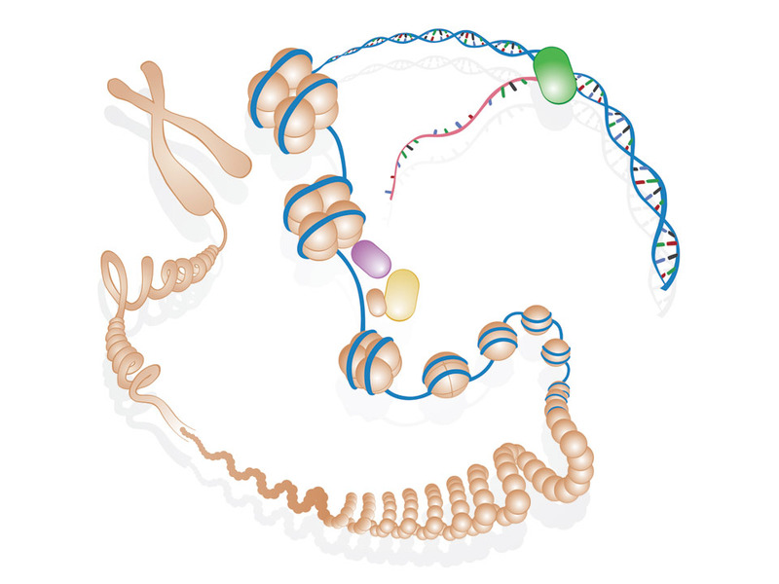
Genetic Structure
Conversation Snapshot

After Biology class while eating lunch four friends were heard discussing DNA, genes, and chromosomes. This is a snapshot of the conversation.

Billy states “I am a little confused by what Ms. Henderson told us today in class. DNA is found in the nucleus and on genes. Genes make up chromosomes, right?”
“That’s not what I heard her say. I think chromosomes make up DNA and that is found on genes. I agree with you about the whole nucleus thing,” says Kyle.
“Come on guys,” says Kelly “that is not what she said at all. She told us that genes are portions of DNA and DNA makes up chromosomes.”
Janet says, “ Kelly you got it backwards. Chromosomes are found on DNA in genes. I am not sure about the whole nucleus business but I know for sure all of these are found in the cell.”

Use the space to the right to answer the following question. You may draw to help illustrate your response.

Who do you think has the best understanding of DNA, chromosomes, and genes? Why?

