student handout 1
Name: ___________________________________
Below are two X-ray pictures of lungs. What differences do you notice between the two pictures? Please write your responses beside the pictures.

X-ray 1:
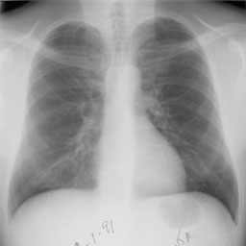
Explanation:

X-ray 2:

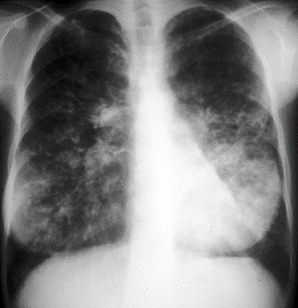
Explanation:

