student handout 1

**Name: ___________________________________**

Below are two X-ray pictures of lungs. What differences do you notice between the two pictures? Please write your responses beside the pictures.

X-ray 1:

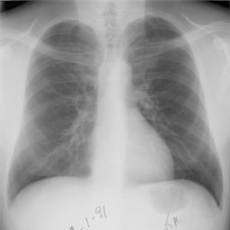

Explanation:

X-ray 2:

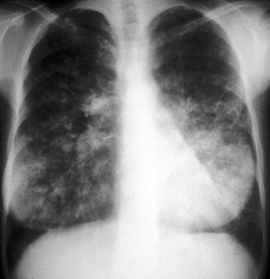

Explanation: