student handout 4 Name: __________________

# A T C G

One method employed by scientists in the search for the Cystic Fibrosis (CF) gene is the use of radioactivity in order to detect DNA on a piece of photographic film.

Examine Figure 1.1.

|  |  |  |  |
| --- | --- | --- | --- |
| _ |  |  |  |
|  |  | _ |  |
|  |  |  | _ |
|  |  |  | _ |
|  |  |  | _ |
|  |  |  | _ |
|  |  | _ |  |
|  |  |  | _ |
|  | _ |  |  |

This is an autoradiograph. Each blot on the film indicates one of the four nucleotides. Each base is found in its own column. Reading from left to right, a blot in the first column indicates that the nucleotide is adenine; a blot in the second column indicates that the nucleotide is thymine; a blot in the third column indicates that the nucleotide is cytosine; and a blot in the fourth column indicates that the nucleotide is guanine. Determine the base sequence for the top ten positions. The correct sequence is A, C, G, G, G, G, C, G, T. This is one method used by geneticists to find the sequence of nucleotides in a piece of DNA. The autoradiographs below represent the DNA sequences for the CF gene of the two individuals whose X-ray pictures you examined previously. Figure 2.1 comes from the individual with healthy lungs and Figure 2.2 comes from the individual with Cystic Fibrosis.

**Figure 2.1 A T C G Figure 2.2 A T C G**

|  |  |  |  |  |  |  |  |  |  |  |  |  |  |  |  |  |  |  |  |  |  |  |  |  |  |  |  |  |  |  |  |  |  |  |  |  |  |  |  |  |  |  |  |  |  |  |  |  |  |  |  |  |  |  |  |  |  |  |  |  |  |  |  |  |  |  |  |  |  |  |  |  |  |  |  |  |  |  |  |  |  |  |  |  |  |  |  |  |  |  |  |  |  |  |  |  |  |  |  |  |  |  |  |  |  |  |  |  |  |  |  |  |  |
| --- | --- | --- | --- | --- | --- | --- | --- | --- | --- | --- | --- | --- | --- | --- | --- | --- | --- | --- | --- | --- | --- | --- | --- | --- | --- | --- | --- | --- | --- | --- | --- | --- | --- | --- | --- | --- | --- | --- | --- | --- | --- | --- | --- | --- | --- | --- | --- | --- | --- | --- | --- | --- | --- | --- | --- | --- | --- | --- | --- | --- | --- | --- | --- | --- | --- | --- | --- | --- | --- | --- | --- | --- | --- | --- | --- | --- | --- | --- | --- | --- | --- | --- | --- | --- | --- | --- | --- | --- | --- | --- | --- | --- | --- | --- | --- | --- | --- | --- | --- | --- | --- | --- | --- | --- | --- | --- | --- | --- | --- | --- | --- | --- | --- |
| |  |  |  |  | | --- | --- | --- | --- | | **_** |  |  |  | |  | _ |  |  | |  |  | _ |  | | _ |  |  |  | |  | _ |  |  | |  |  | _ |  | |  | _ |  |  | |  | _ |  |  | |  | _ |  |  | |  |  |  | _ | |  |  |  | _ | |  | _ |  |  | |  |  |  | _ | |  | _ |  |  | |  | _ |  |  | | |  |  |  |  | | --- | --- | --- | --- | | **_** |  |  |  | |  | **_** |  |  | |  |  | **_** |  | | **_** |  |  |  | |  | **_** |  |  | |  |  | **_** |  | |  |  |  | **_** | |  |  |  | **_** | |  | **_** |  |  | |  |  |  | **_** | |  | **_** |  |  | |  | **_** |  |  | |  |  |  |  | |

1. What is the DNA sequence for the CF gene in Figure 2.1?
2. What is the DNA sequence for the CF gene in Figure 2.2?
3. What similarities exist between the two autoradiograph DNA sequences?
4. What differences exist between the two autoradiograph DNA sequences?

The DNA sequence for the CF gene represents the instructions for the sequence of amino acids for the CF protein. Use the DNA sequences from Figures 2.1 and 2.2 to determine the amino acid sequences for the two individuals.

Begin by using DNA replication for each sequence. This process occurs in the cell before protein synthesis can begin. This allows the cell to have a short, copied piece of DNA to work with to make the CFTR protein.

1. What would the replicated sequence for Figure 2.1 be?
2. What would the replicated sequence for Figure 2.2 be?

The first step in protein synthesis is transcription, so you must make mRNA using the DNA template sequences from Figures 2.1 and 2.2.

1. What is the mRNA sequence for the DNA sequence from Figure 2.1? (Remember to use the replicated DNA sequence from question #5.)
2. What is the mRNA sequence for the DNA sequence from Figure 2.2? (Remember to use the replicated DNA sequence from question #6.)

The second step in protein synthesis is translation. Using the mRNA sequences and the amino acid chart below, determine the amino acid sequences that are coded for by the DNA sequences from Figures 2.1 and 2.2.

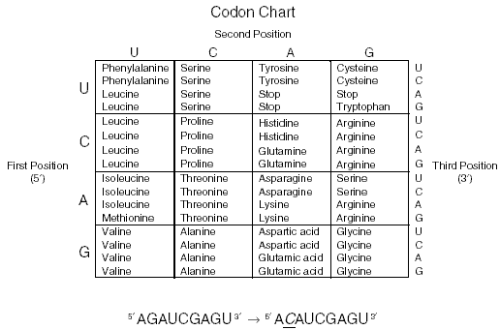

1. What is the amino acid sequence coded for by the replicated DNA sequence? (Use the mRNA sequence from question 7.)
2. What is the amino acid sequence coded for by the replicated DNA sequence? (Use the mRNA sequence from question 8.)
3. What similarities exist between the two amino acid sequences?
4. What differences exist between the two amino acid sequences?