
WANTED POSTERS

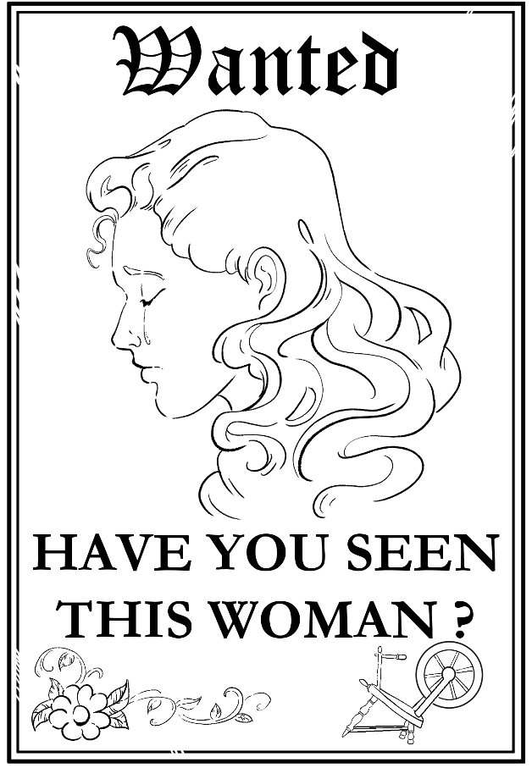
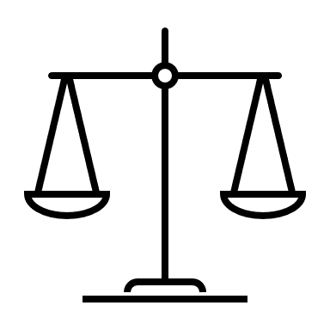
GOVERNMENT AGENCY: Office of Magical Contracts & Child Protection (OMCCP)
PLEA: Not Guilty

DEFENDANT:
- Name: [UNKNOWN]
- Alias: “The Miller’s Daughter” or “The Queen”
DATE OF OFFENSE: Year 3 of King’s Reign
CHARGES FILED:
- Child Abandonment – When a parent leaves a child alone without making sure they are safe, especially for a long time.
- Child Endangerment – Putting a child in a dangerous or unsafe situation.
- Fraud – Telling a lie or going along with a lie to get something you want.
- Breach of Contract – Not keeping a promise that was part of an important agreement
NATURE OF OFFENSE: Felony – Crimes involve potential harm to minors and fraudulent dealings with magical beings, possibly violating interkingdom treaties.

DISTRICT ATTORNEY’S OFFICE
CASE FILE NO.: 5482-RMP
SEE ALSO FILE NO.: 5483-RMP
(Rumpelstiltskin v. Royal Family)
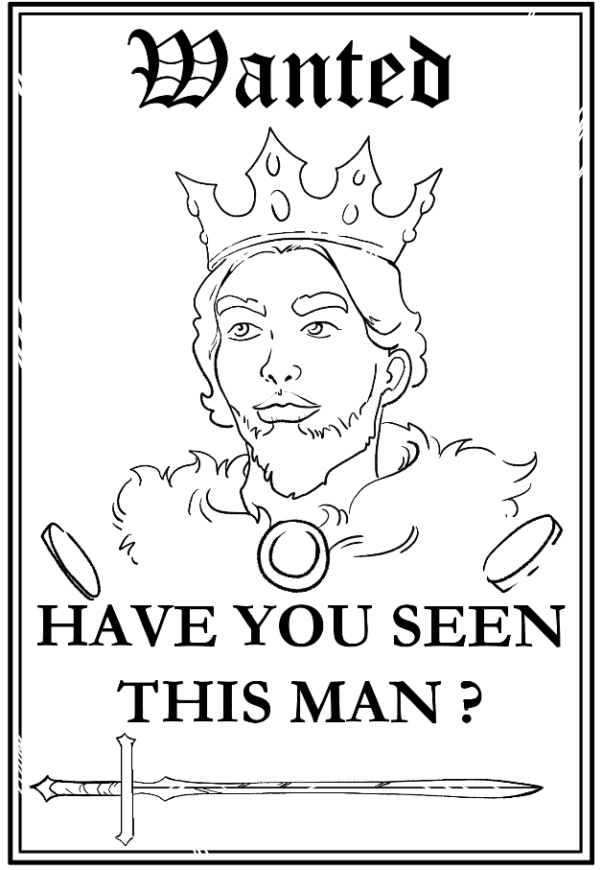
DEFENDANT:
- Name: [UNKNOWN]
- Alias: “The King”
DATE OF OFFENSE: Year 3 of King’s Reign
CHARGES FILED:
- Illegal Tax Contributions – A leader or person in power takes money or valuable things from people in a way that’s not fair.
- Abuse of Power – Using your position or role to hurt others instead of helping.
- Unlawful Imprisonment – Keeping someone locked up or trapped when they have not done anything wrong.
GOVERNMENT AGENCY: Council of Fair Governance and Magical Ethics (CFGME)
PLEA: Not Guilty

NATURE OF OFFENSE: Felony – High-level crimes against kingdom law, royal ethics, and individual rights

DISTRICT ATTORNEY’S OFFICE
CASE FILE NO.: 5484-RMP
SEE ALSO FILE NO.: 5482-RMP
(The Queen v. Rumpelstiltskin)
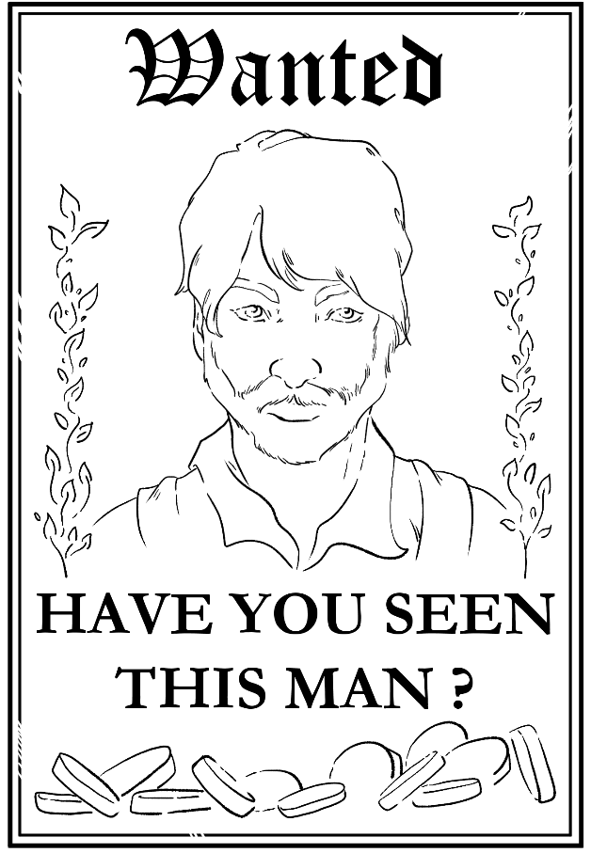
DEFENDANT:
- Name: [UNKNOWN]
- Alias: “The Miller”
DATE OF OFFENSE: Year 2 of King’s Reign
CHARGES FILED:
- Tax Fraud – Lying about money or gold to avoid paying what you owe in taxes.
- Reckless Endangerment – Doing something that puts someone else in serious danger.
- Bribery – When you give money or favors to someone to try to get them to do something they shouldn’t do.
- Defamation – Spreading a false story that causes trouble or hurts the reputation of another.
GOVERNMENT AGENCY: Division of Folk Figure Oversight & Accountability (DFFOA)
PLEA: Not Guilty

NATURE OF OFFENSE: Felony – Offenses rooted in greed, deception, and disregard for personal safety of dependents.

DISTRICT ATTORNEY’S OFFICE
CASE FILE NO.: 5485-RMP
SEE ALSO FILE NO.: 5484-RMP
(People v. The King)
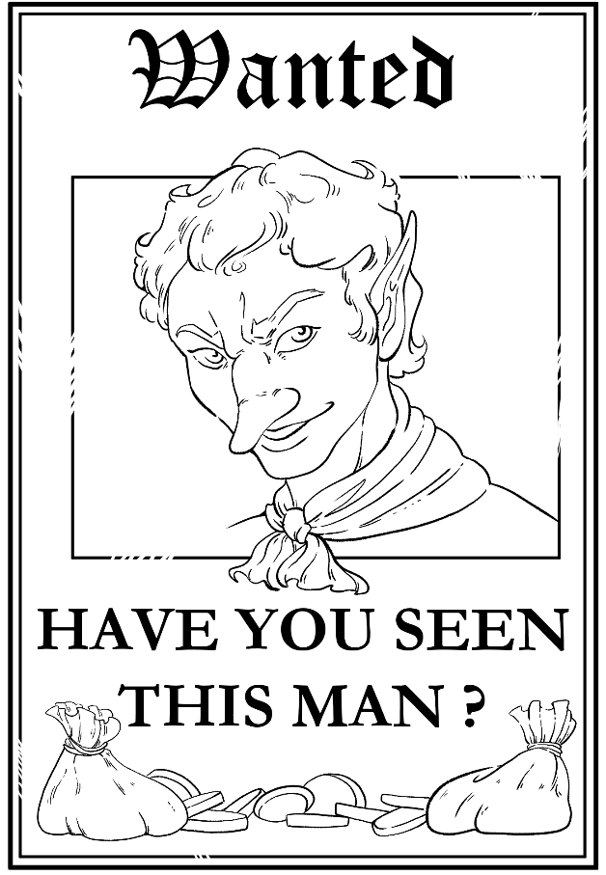
DEFENDANT:
- Name: Rumpelstiltskin
- Alias: “trickster” “strange little man”
DATE OF OFFENSE: Year 3 of King’s Reign
CHARGES FILED:
- Attempted Kidnapping – Trying to take a child who does not belong to you.
- Exploitation – Treating someone unfairly or using them when they are scared, confused, or in a tough situation.
- Extortion – Pressuring someone to give you something they care about by threatening them.

DISTRICT ATTORNEY’S OFFICE
GOVERNMENT AGENCY: Bureau of Magical Contract Enforcement (BMCE)
PLEA: Not Guilty

NATURE OF OFFENSE: Felony – Involves coercive magical contract practices, violation of child protection codes, and manipulative exchange under duress.

CASE FILE NO.: 5483-RMP
SEE ALSO FILE NO.: 5482-RMP
(The Queen v. Rumpelstiltskin)

