WANTED POSTERS

*******

GOVERNMENT AGENCY:Office of Magical Contracts & Child Protection (OMCCP)

PLEA:Not Guilty

DEFENDANT:

* Name: [UNKNOWN]
* Alias: “The Miller’s Daughter” or “The Queen”

DATE OF OFFENSE:Year 3 of King’s Reign

CHARGES FILED:

1. **Child Abandonment –** When a parent leaves a child alone without making sure they are safe, especially for a long time.
2. **Child Endangerment –** Putting a child in a dangerous or unsafe situation.
3. **Fraud –** Telling a lie or going along with a lie to get something you want.
4. **Breach of Contract – Not keeping a promise that was part of an important agreement**

NATURE OF OFFENSE: **Felony** – Crimes involve potential harm to minors and fraudulent dealings with magical beings, possibly violating interkingdom treaties.

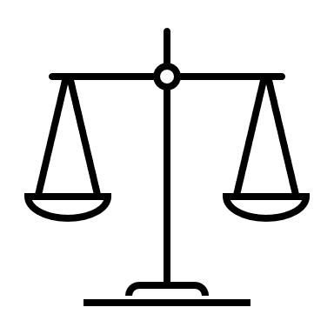

# DISTRICT ATTORNEY’S OFFICE

**CASE FILE NO.**: 5482-RMP  
**SEE ALSO FILE NO.**: 5483-RMP

(Rumpelstiltskin v. Royal Family)



*******

DEFENDANT:

* Name: [UNKNOWN]
* Alias: “The King”

DATE OF OFFENSE:Year 3 of King’s Reign

CHARGES FILED:

1. **Illegal Tax Contributions –** A leader or person in power takes money or valuable things from people in a way that’s not fair.
2. **Abuse of Power –** Using your position or role to hurt others instead of helping.
3. **Unlawful Imprisonment –** Keeping someone locked up or trapped when they have not done anything wrong.

GOVERNMENT AGENCY:Council of Fair Governance and Magical Ethics (CFGME)

PLEA:Not Guilty

NATURE OF OFFENSE: **Felony** – High-level crimes against kingdom law, royal ethics, and individual rights.



# DISTRICT ATTORNEY’S OFFICE

**CASE FILE NO.**: 5484-RMP  
**SEE ALSO FILE NO.**: 5482-RMP

(The Queen v. Rumpelstiltskin)



DEFENDANT:

* Name: [UNKNOWN]
* Alias: “The Miller”

DATE OF OFFENSE:Year 2 of King’s Reign

CHARGES FILED:

1. **Tax Fraud –** Lying about money or gold to avoid paying what you owe in taxes.
2. **Reckless Endangerment –** Doing something that puts someone else in serious danger.
3. **Bribery –** When you give money or favors to someone to try to get them to do something they shouldn’t do.
4. **Defamation –** Spreading a false story that causes trouble or hurts the reputation of another.

GOVERNMENT AGENCY:Division of Folk Figure Oversight & Accountability (DFFOA)

PLEA:Not Guilty

NATURE OF OFFENSE: **Felony** – Offenses rooted in greed, deception, and disregard for personal safety of dependents.



# DISTRICT ATTORNEY’S OFFICE

**CASE FILE NO.**: 5485-RMP  
**SEE ALSO FILE NO.**: 5484-RMP

(People v. The King)



DEFENDANT:

* Name: Rumpelstiltskin
* Alias: “trickster” “strange little man”

DATE OF OFFENSE:Year 3 of King’s Reign

CHARGES FILED:

1. **Attempted Kidnapping –** Trying to take a child who does not belong to you.
2. **Exploitation –** Treating someone unfairly or using them when they are scared, confused, or in a tough situation.
3. **Extortion –** Pressuring someone to give you something they care about by threatening them.

# DISTRICT ATTORNEY’S OFFICE

GOVERNMENT AGENCY:Bureau of Magical Contract Enforcement (BMCE)

PLEA:Not Guilty

NATURE OF OFFENSE: **Felony** – Involves coercive magical contract practices, violation of child protection codes, and manipulative exchange under duress.



**CASE FILE NO.**: 5483-RMP  
**SEE ALSO FILE NO.**: 5482-RMP

(The Queen v. Rumpelstiltskin)