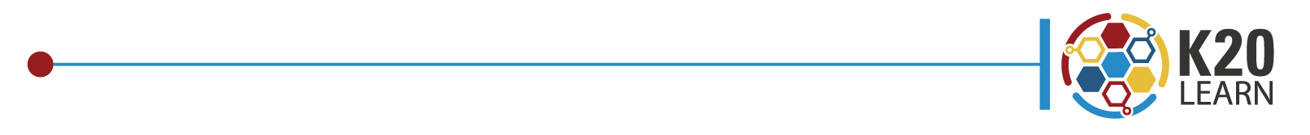
IT’S OPTIC-AL

O | OBSERVATIONS  What do you observe?
P | PARTS  What parts seem to stand out?
T | TITLE  What might the title, author, or date suggest?
I | INTERRELATIONSHIP  How do the parts of the visual interact to convey the artist’s message?
C | CONCLUSION  What conclusions do you have about the  visual, the message, or the artist?

