THE GREAT PLANT DISCOVERY
You and your team of fellow botanists have found a new species of plant. On your poster paper, describe your plant using the following:
- Create a name for the plant.
- Determine these 5 characteristics:
  - Height of plant(s)
  - Types of leaves
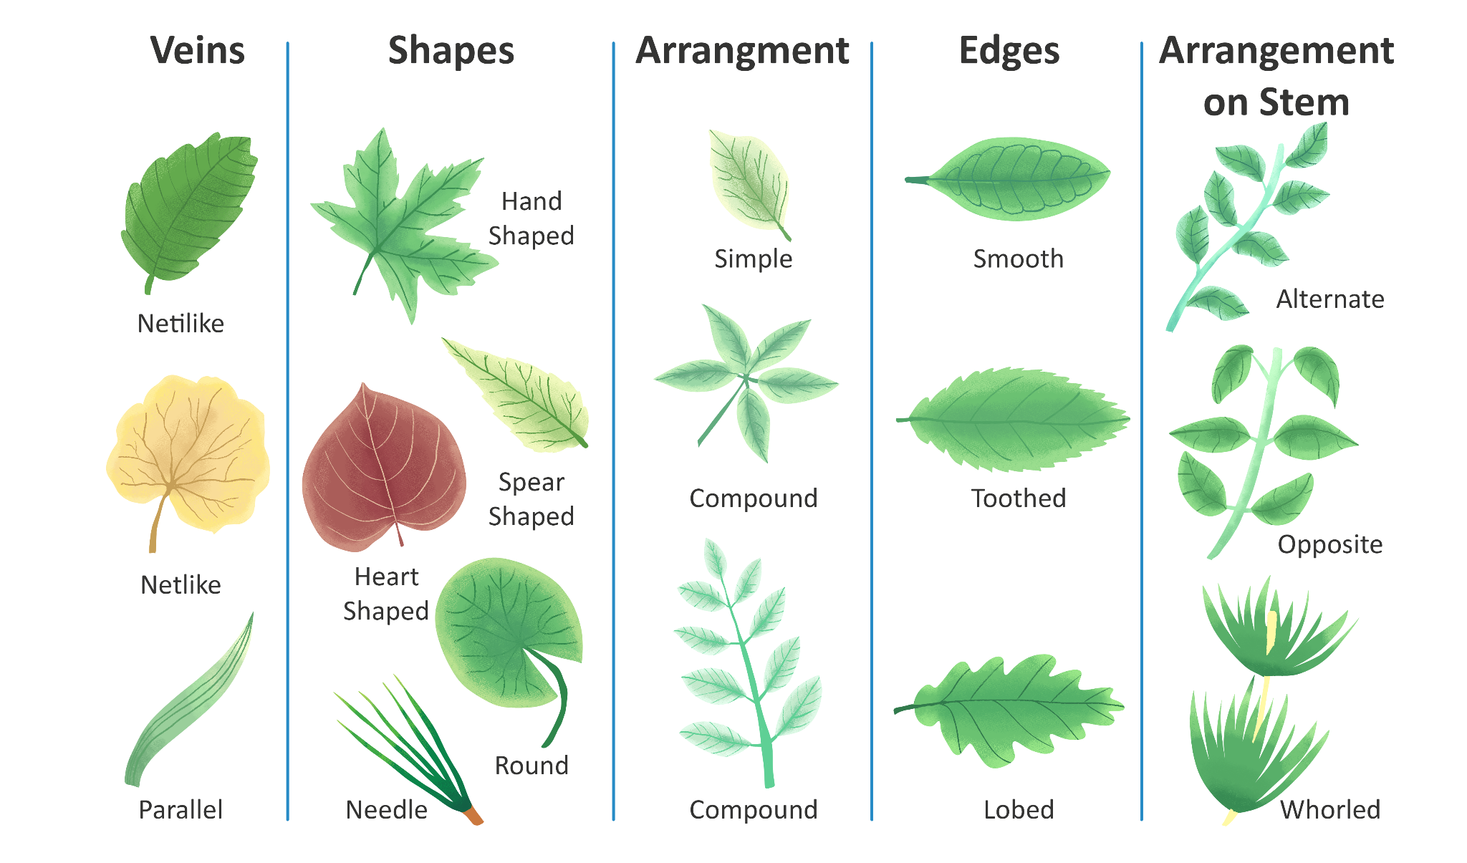
  - Stem roots
  - Response to stimuli (taste, touch, gravity, light)
  - Protective feature

- Draw the plant and label the characteristics along with a description of each characteristic.

