DNA KEYCHAIN INSTRUCTIONS
Materials:
- Pony beads (48 colors; 16 with 4 different colors, 16 black, and 16 white)
- Two wires (one of each: 36 gauge and 18 gauge)
- Glitter pony beads (1 to 4)
- Key ring (1)
- Sharpie for deletion (1)
- Mutation card (1)
Original DNA: AGCCTGAT
Complimentary Strand: ____________________
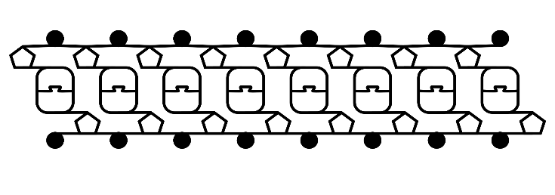
Retrieve a card for a mutation from your teacher. Identify what type of mutation it is below. Using the original DNA strand above, add in the mutation provided on your card to the image below. Identify the colors that will be used for your bases.

Type of Mutation: _______________

Collect the Wires
- Collect from your teacher an 18-inch long piece of the heavier gauge wire.
- Collect from your teacher a 24-inch long piece of the lighter gauge wire.
Pick Your Beads
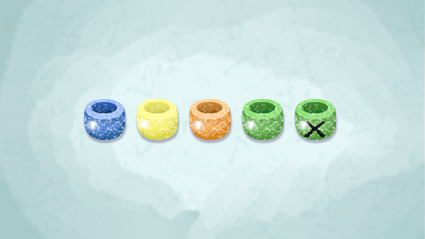
- Gather the black and white beads for the phosphate and sugar on the sides of the DNA.
- Gather the beads for your mutated strand and its complement, using four colors to represent the base pairs (Adenine-Thymine) and (Guanine-Cytosine).
- Grab the correct number of glitter beads needed according to your mutated strand.
- Use the sharpie for any deleted bases to add an X to those beads.
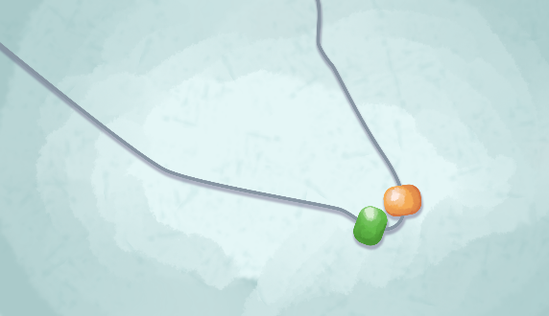
Bend the Wires and Start Building
- Take the thinner wire and bend into a u shape (around the middle).
- Add two beads from a bead pair.
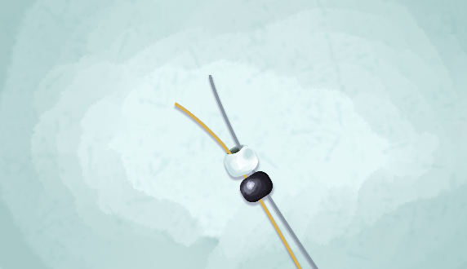
- Take the thicker wire and the thinner wire and add the phosphate and sugar beads to both wires.

Add the First Base Pair
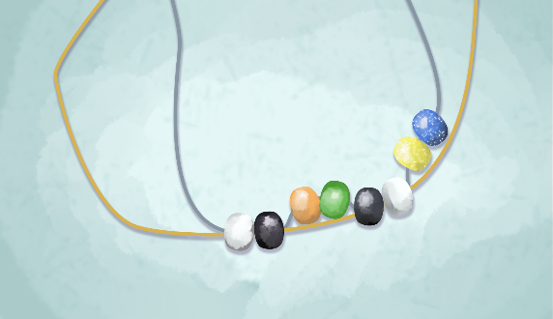
- Now add another base pair on one side of the thin wire.

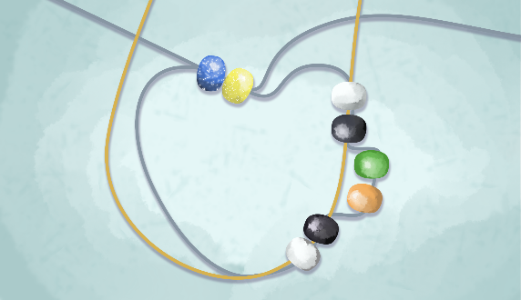
- Feed the other thin wire through the beads from the opposite direction. The wires should cross like laces in a shoe.

- Pull the ends of the wires to put the beads together (don’t pull too tightly).

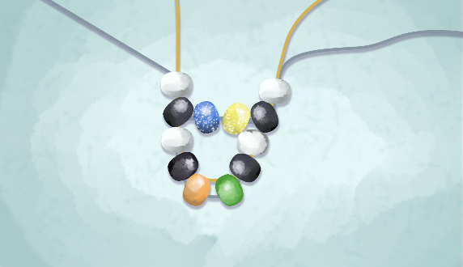
Add Another Phosphate and Sugar
- The thin wire should now be aligned with the thick wire.
- Another phosphate and sugar molecule go onto both wires.

Add Another Phosphate and Sugar
- The thin wire should now be aligned with the thick wire.
- Another phosphate and sugar molecule go onto both wires.

Continue to Build
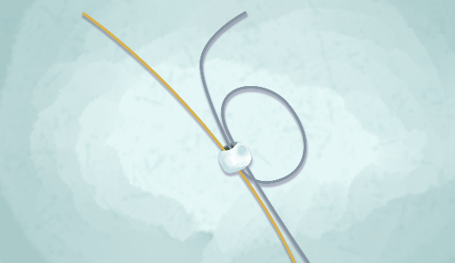
- Continue steps to add bases to the thin wire and then phosphate and sugar to both wires.

Finish the DNA Keychain
- End with phosphate and sugar beads.
- Wrap the wires around the end bead.
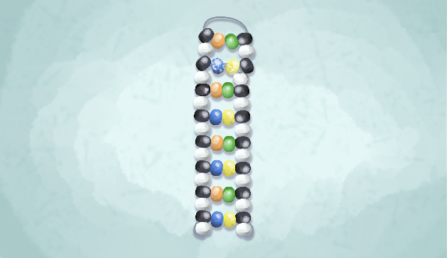
- Snip the wire as close to the bead as possible to avoid sharp edges.
- Flip the top base pairs to the inside of the thicker wire.
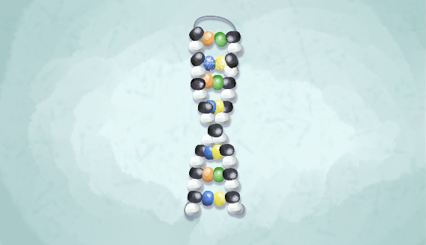
- Attach the key ring.
You can lightly twist to represent the shape of DNA in the alpha helix.
Adapted from:
Kim. (n.d.). How to make a DNA model the kids can carry with them. The Learning Hypothesis. https://learninghypothesis.com/dna-model/

