Does This Match?
On the graph below, see if you can plot the points from the table to match up on the line.
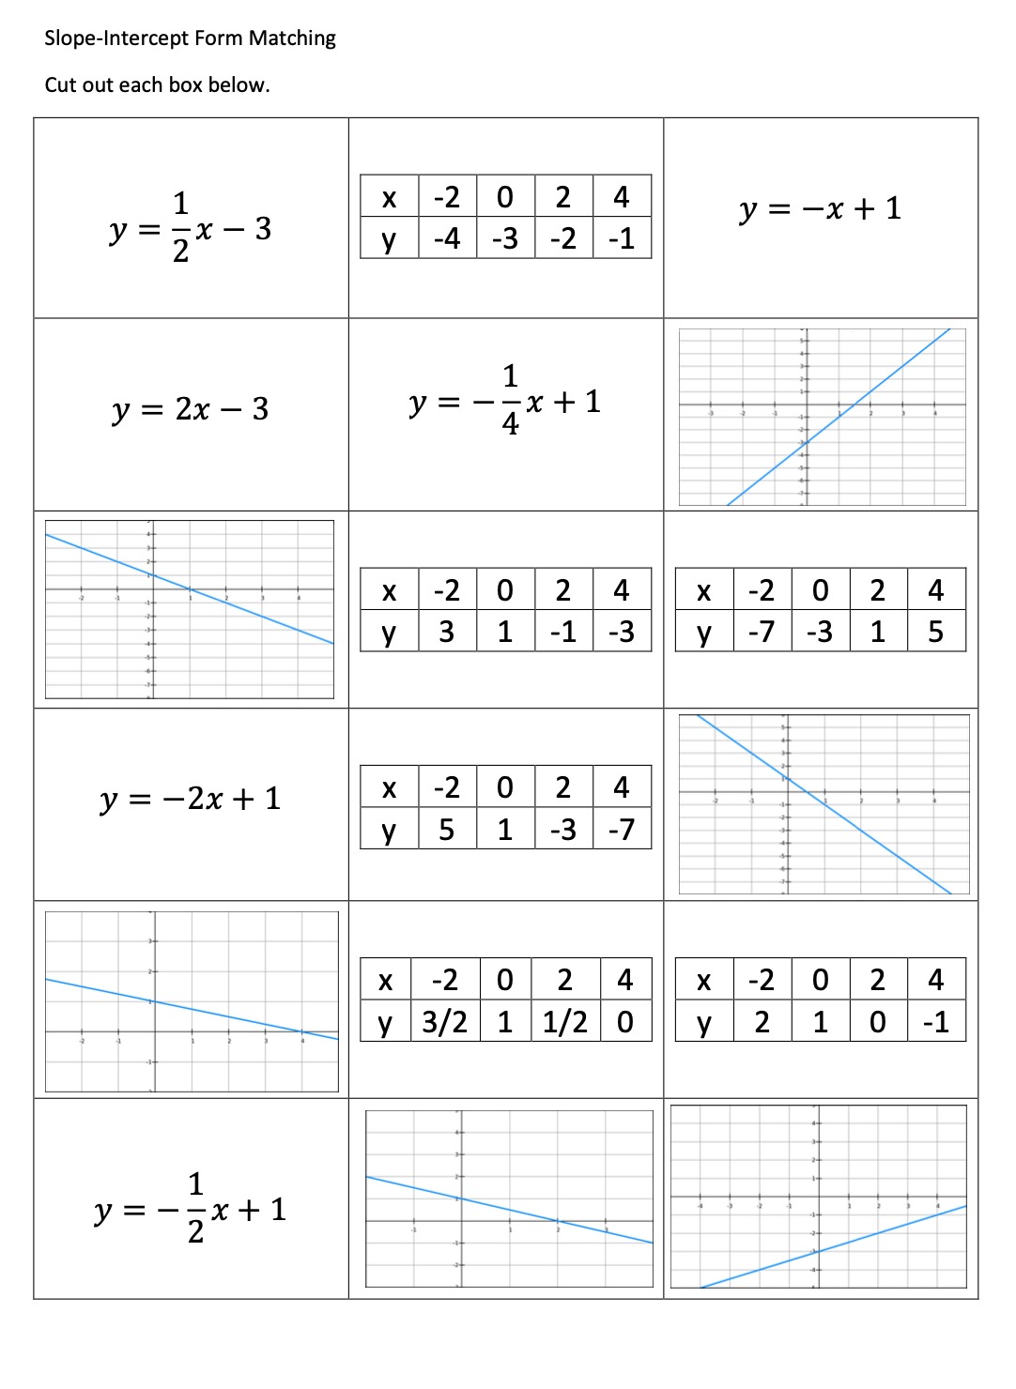

Does this match?

INTRO TO SLOPE

What’s My Movement?
When plotting points and moving from one point to the next, how would Slope Dude move to determine the slope of the line?

Write, Pair, Share:
Using what you know about plotting points on a graph, write the direction to move to the next point. Pair with a partner and share your answers.

Vocabulary and Symbols
Describe the following geometry words in your own words. Draw the symbol if there is one associated with it.

y-Intercept:

Dependent Variable:

Independent Variable:

Slope-Intercept Form:

Slope:

Identify the Slope and y-Intercept
Determine which is the y-intercept and which is the slope in each equation.

y = 2x + 3 m= ____ b= _____
y = -2x + 3 m=_____ b=_____
y = -2x - 3 m=_____ b=_____
y = ½ x + 3 m= _____ b=_____
y = -½ x + 3 m=_____ b=_____
y = -½ x - 3 m=_____ b=_____
y = 3x + 2 m=_____ b=_____
y = -3x + 2 m=_____ b=_____
y = -3x - 2 m=_____ b=_____
y = -x + 2 m=_____ b=_____
y = x + 2 m=_____ b=_____
y = 2x + 1 m=_____ b=_____

What’s My Slope?
Draw a positive, negative, zero, and undefined slope.

Write, Pair, Share:
What would an equation for each slope look like? Come up with your own equation and it share with a shoulder partner.

