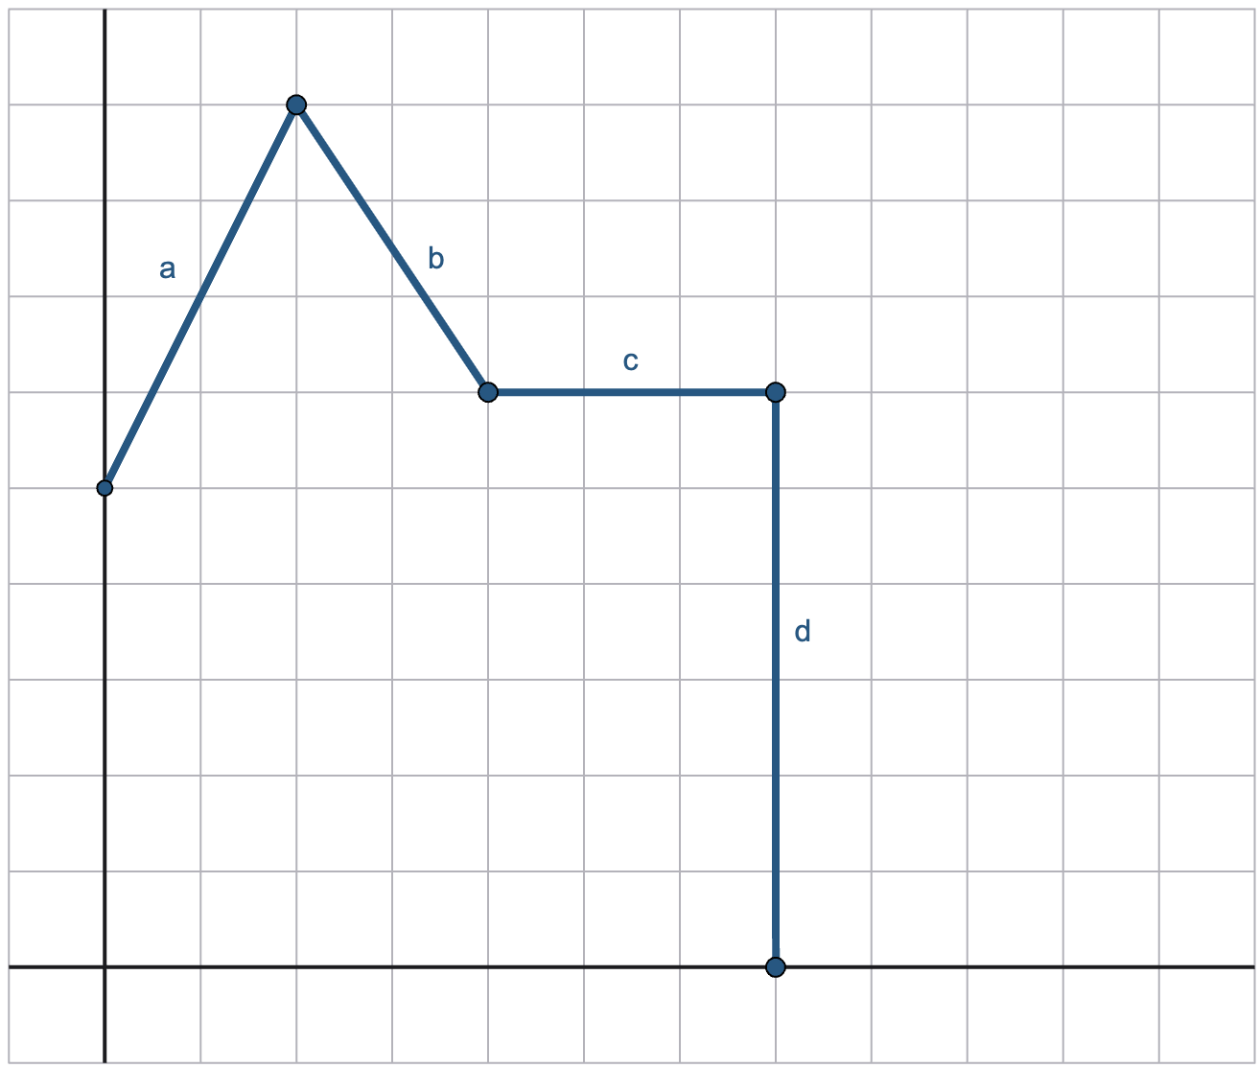
REAL-WORLD SCENARIOS

Directions:
For each line segment, find the slope and y-intercept. Then, come up with a real-world scenario that would explain what may have caused the graph to look this way during that interval.

Line a
Slope = ______
Y-Intercept = ______
Real-World Scenario:

Line b
Slope = ______
Y-Intercept = ______
Real-World Scenario:

Line c
Slope = ______
Y-Intercept = ______
Real-World Scenario:

Line d
Slope = ______
Y-Intercept = ______
Real-World Scenario:

