PICTURES
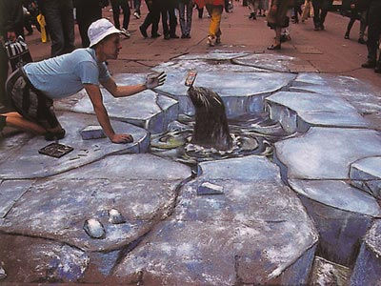
Beever, J. (n.d.). Arctic Street Conditions with Soft Drink [photograph]. Retrieved from http://www.julianbeever.net/index.php?option=com_phocagallery&view=category&id=2&Itemid=8

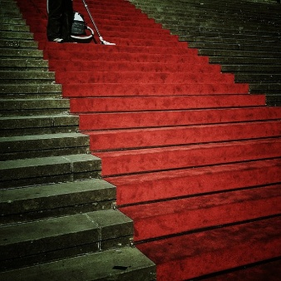

LoboStudioHamburg. (n.d.). Stairs Emergence Input Free Photos [photograph]. Retrieved from http://all-free-download.com/free-photos/red-carpet-stairs.html

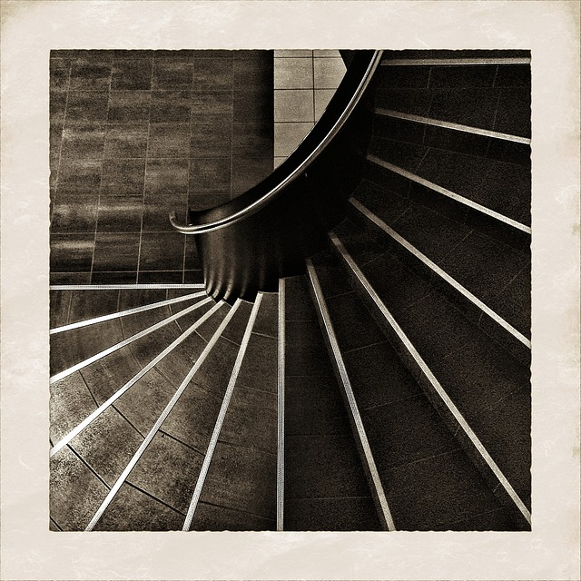

STAIRS, EMERGENCE, INPUT, ARCHITECTURE, PERSPECTIVE [photograph]. (n.d.). Retrieved from http://www.karengunton.com/blog/

