Right Triangle Exploration (Sample Responses)

# Gathering Data

Record your findings to complete the table below.

* Make sure each row contains the corresponding parts of each triangle.
* Identify or calculate the values of the angle measures of each triangle.
* Use a ruler to find the measurement of each side length. Use ***centimeters***.

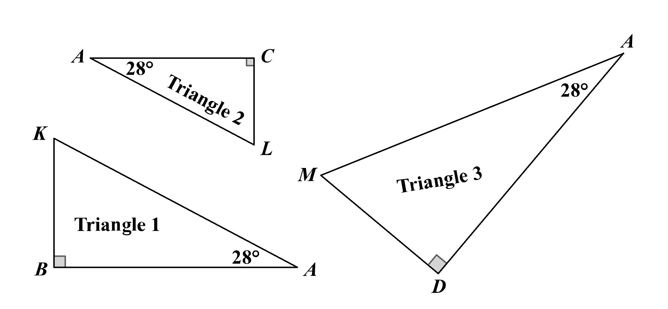

| Triangle 1 | Triangle 2 | Triangle 3 |
| --- | --- | --- |
|  |  |  |
|  |  |  |
|  |  |  |
|  |  |  |
|  |  |  |
|  |  |  |

# Comparing Data

Use your measurements from the previous table to write each ratio below in decimal form.

| Ratio 1 | Ratio 2 | Ratio 3 | Ratio 4 |
| --- | --- | --- | --- |
|  |  |  |  |
|  |  |  |  |
|  |  |  |  |

# Making Observations

What have you observed about these ratios?

*Each ratio was very similar for every triangle.*

# Making Predictions

Create a hypothesis about the relationship among the lengths of the sides of the right triangles based on the information that your group gathered and discussed.

*When we divided the long side by the hypotenuse, we got about 0.9 (ratio 1).*

*Ratio 2 seems to be the short side divided by the hypotenuse.*

*Ratio 3 was the long side divided by the short side.*

*And ratio 4 was the reciprocal of ratio 3.*

*These corresponding parts seem to make similar ratios.*