Using Trig Ratios

**1)** In  shown below,  and . What is ?

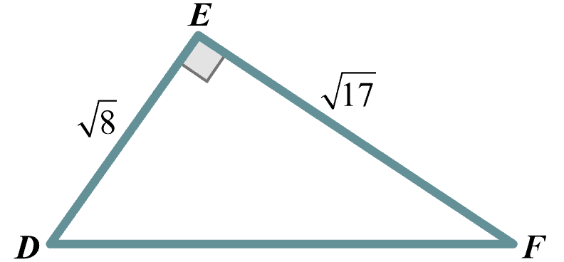

**2)** The lengths of 3 sides of a right triangle , which is shown below, are all given in feet.

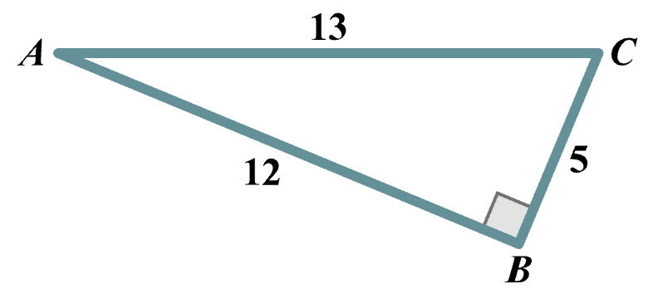

Which ratio has the value of ?

**(a)** *sin*(*A*)

**(b)** *sin*(*C*)

**(c)** *cos*(*B*)

**(d)** *cos*(*C*)

**(e)** *tan*(*A*)

**(f)** *tan*(C)

**3)** For an angle with measure  in a right triangle,  and . What is the value of ?

**4)** In  shown below, the length of  is 8 inches and . What is the length, in inches, of ?

