HIROSHIMA PICTURE ENGAGE
Additional links for Hiroshima landscape pictures

http://life.time.com/history/hiroshima-and-nagasaki-photos-from-the-ruins/#1

http://www.boston.com/bigpicture/2009/08/hiroshima_64_years_ago.html

http://japanfocus.org/-Peter_J_-Kuznick/2642

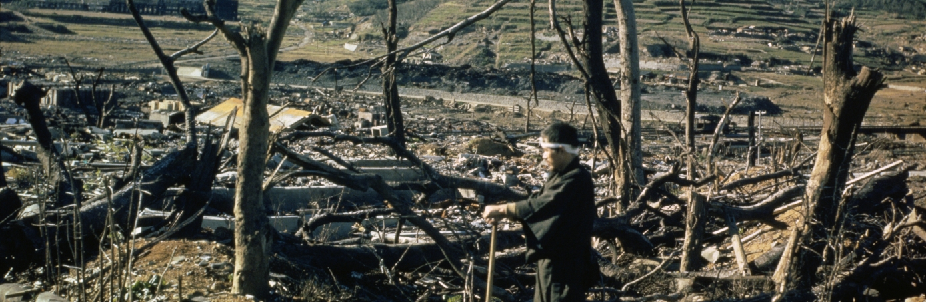
Bombing of Hiroshima and Nagasaki [photograph]. (1945). Retrieved from http://www.history.com/topics/world-war-ii/bombing-of-hiroshima-and-nagasaki

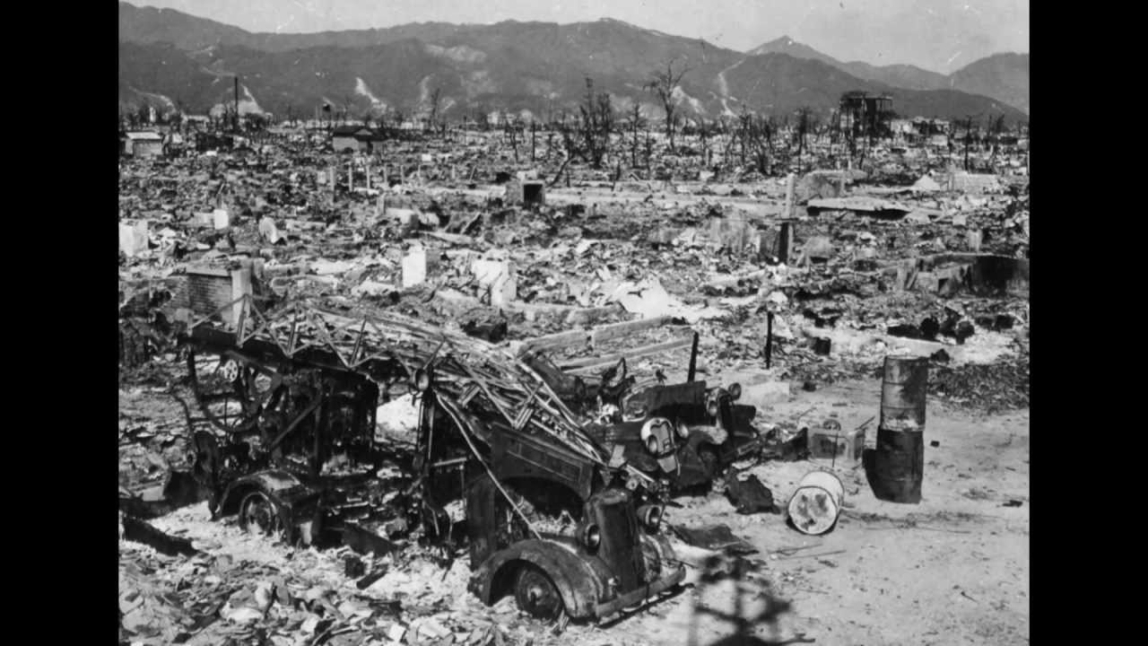
U.S. National Archives. (1945). [photograph]. Retrieved from http://www.andyworthington.co.uk/2009/08/06/never-forget-the-bombing-of-hiroshima-64-years-ago-today/

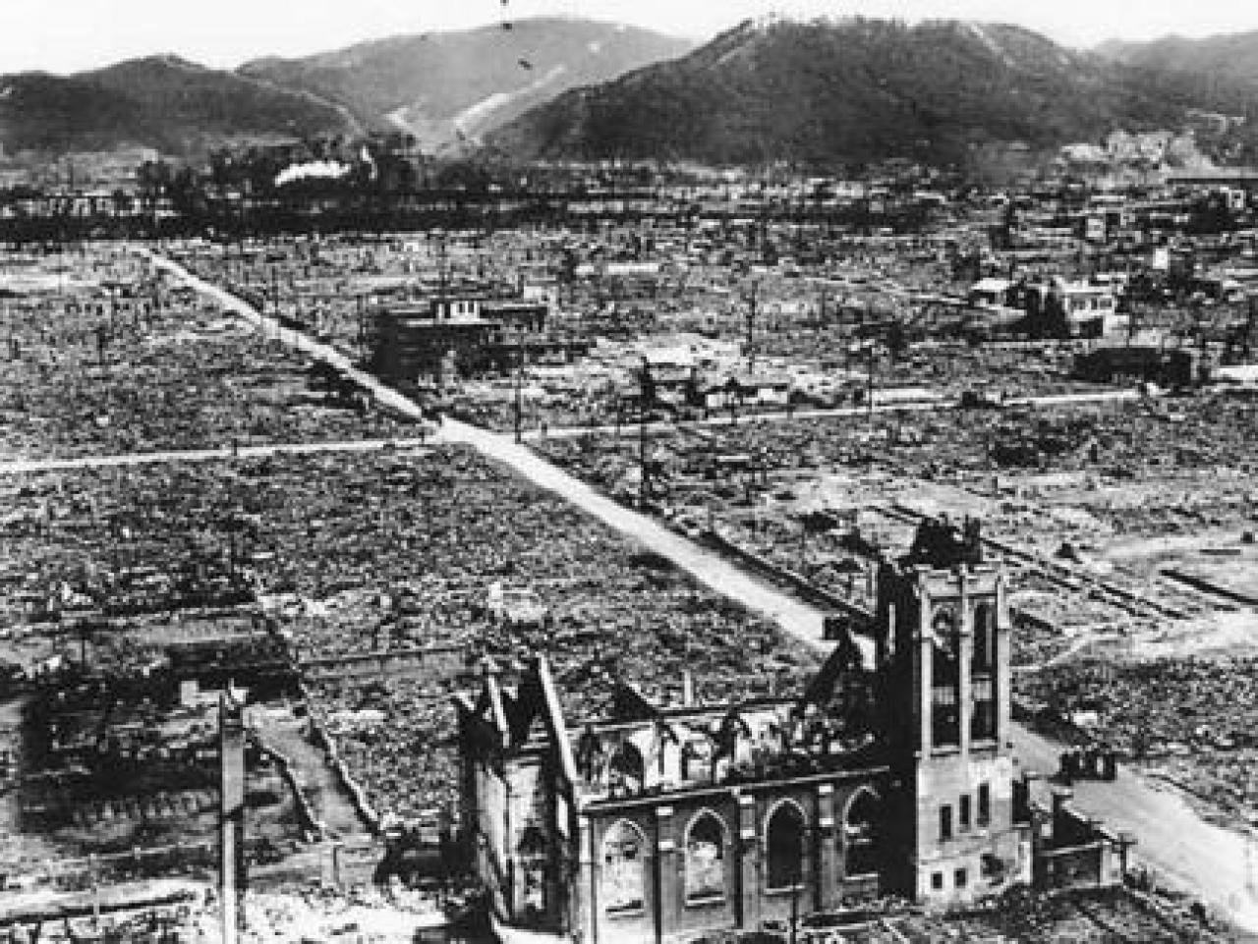
Hiroshima Church. (1945). [photograph]. Retrieved from http://www.neatorama.com/2012/02/27/the-unluckiest-train-ride/

