The Power of Words
This handout is designed to help you explore the power of words. Take a moment to read through the following sentences. Under the sentence, a box has been provided for you to draw what you read. Create a picture based on the information provided in each sentence.

Original Sentence | Rewrite
The couple sat on the bench in the park. | The old couple silently sat on the bright red bench in the snow-covered park.
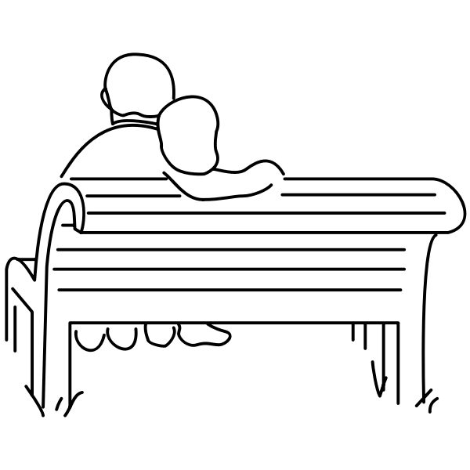

Reflection:
Notice how both sentences from above are dealing with the same basic information, but the second sentence provides a few more adjectives and adverbs to help the reader get a better mental picture.

Directions:
Now try it yourself. Draw the first simple sentence given below. Then, in the space to the right, rewrite the sentence adding details with adjectives, adverbs, and verbs.
Finally, draw the picture you have created in your new sentence. You will notice that the pictures look quite different.

Original Sentence | Rewrite
The dog was by the tree. | The adjective dog was adverb, verb by the adjective, adjective tree.

