# Vocabulary for Teachers

* **Control (Variable)** **–** all other aspects of an experiment that must be held constant so as to not interfere with the outcome of the experiment
* **Correlation** **–** a relationship between two or more measures (or variables)
* **Dependent Variable** **–** the expected outcome of an experiment that is dependent upon the manipulated variable
* **Hypothesis** **–** a statement that signifies the outcomes of an experiment based on various parameters
* **Independent Variable** **–** an aspect of an experiment that is manipulated by the experimenter
* **line of best fit** **–** a type of line that approximates the correlation of data when represented on a scatter plot
* **Linear Model** **–** a mathematical function that algebraically represents a situation, in this case an equation of a line for the line of best fit
* **Negative Correlation** **–** a type of correlation in which the approximation of the correlation (line of best fit) has a negative slope
* **Positive Correlation** **–** a type of correlation in which the approximation of the correlation (line of best fit) has a positive slope
* **Relatively No Correlation** **–** a type of correlation in which there is no reasonable approximation for the data
* **Scatter Plot** **–** A graph of plotted points that show the relationship between two sets of data. In this example, each dot represents one person's weight versus their height.
* 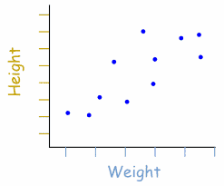
* **Shooting Percentage –** a measure of accuracy where 
* **Slope** **–** the direction, or rate of change, of a line 
* **Form** **–** a specific form of the equation of a line where and in which *m* represents the slope and *b* represents the y-intercept of a line
* **Y-Intercept** **–** the point at which a line intersects the y-axis of a coordinate plane (the y-intercept does not exist for vertical lines)