LIGHT INVESTIGATION

HOW DO EARTHWORMS REACT TO LIGHT?  
How do you think the earthworm will behave when given the choice between light and darkness? Why do you think this?

______________________________________________________________________________

______________________________________________________________________________

______________________________________________________________________________

**Directions:**

Prepare a chamber to test your worm’s reaction to light. The chamber should resemble the one below:

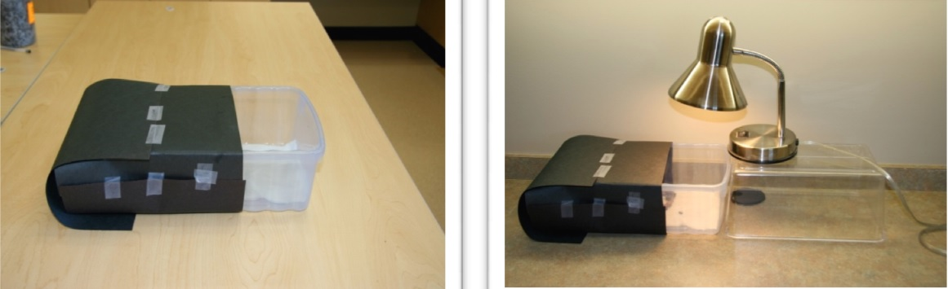

1. Put a moistened paper towel in the bottom of the chamber.
2. Place three worms in the middle of the container where the light and dark meet.
3. Allow the worms to rest for 10 minutes.
4. Document any movement (or not) of the worms.
5. Collect observations and tally the worms’ behavior use the table on the next page, or record the data in your notebook.

|  |  |
| --- | --- |
| **Earthworms’ Response** | **Observations (include the number that preferred this side)** |
| Move to the **light** side |  |
| Move to the **dark** side |  |
| **Unusual Behavior**  (The did not move, it had half its body on each side of the paper towels) |  |

Identify the stimulus:

____________________________________________________________________________

Identify the response:

___________________________________________________________________________

Did your results support what you thought would happen? YES NO

Explain

______________________________________________________________________________

How does what you learned in this lab help explain the earthworms’ behavior you witnessed in the video at the beginning of this lesson?

______________________________________________________________________________

______________________________________________________________________________

______________________________________________________________________________

TEMPERATURE INVESTIGATION

HOW DO EARTHWORMS REACT TO TEMPERATURE?How do you think the earthworm will behave when given the choices among different temperatures?   
Why do you think this?

_____________________________________________________________________________________________

_____________________________________________________________________________________________

_____________________________________________________________________________________________

**Directions:**

For each of these temperature investigations, place a paper towel in the bottom of the behavior chamber. **The paper towel should only cover half of the box so you can see if they prefer to stay on that towel or not.** When testing out the hot paper towel, be sure it is not too hot because you don’t want to harm the worm. The towel should not be so hot it burns your hand.

**Cold Investigation**

1. Wet a paper towel and place it in the freezer for 5 minutes. Your teacher may have already done this for you.
2. Get 3 worms.
3. Put the frozen towel in the bottom of the chamber, covering only half of the bottom.
4. Place the worms on the towel.
5. Record observations in the table on the next page or in your lab notebook.

**Tap Water Investigation**

1. Wet a paper towel using tap water.
2. Get 3 worms.
3. Put the wet towel in the bottom of the chamber, covering only half of the bottom.
4. Place the worms on the towel.
5. Record observations in the table on the next page or in your lab notebook.

**Hot Water Investigation**

1. Wet a paper towel using hot water, or briefly microwave a wet paper towel. **DO NOT MAKE THE TOWEL TOO HOT!**
2. Get 3 worms.
3. Put the wet towel in the bottom of the chamber, covering only half of the bottom.
4. Place the worms on the towel.
5. Record observations in the table on the next page or in your lab notebook.

|  |  |
| --- | --- |
| **Earthworms’ Response** | **Observations (include the number that stayed on the towel)** |
| Movement on **tap water** paper towel |  |
| Movement on **frozen** paper towel |  |
| Movement on **hot** paper towel |  |
| **Unusual Behavior**  (The did not move, it had half its body on each side of the paper towels) |  |

Identify the stimulus: ________________________________________________________________________

Identify the response: ________________________________________________________________________

Did your results support what you thought would happen? YES NO

Explain _____________________________________________________________________________________________

­­­­­­______________________________________________________________________________

How does what you learned in this lab help explain the earthworms’ behavior you witnessed in the video at the beginning of this lesson?

_____________________________________________________________________________________________

________________________________________________________________________________________________________

_______________________________________________________________________________________________________

ODOR INVESTIGATION

HOW DO EARTHWORMS REACT TO ODORS?  
How do you think the earthworm will behave when given the choices among different odors?   
Why do you think this?

_____________________________________________________________________________________________

_____________________________________________________________________________________________

_____________________________________________________________________________________________

**Directions:**

1. Cover the bottom of your chamber with a wet paper towel using tap water.
2. Choose either the left or right side and put several drops of vinegar on the paper towel on that side.
3. Get 3 worms.
4. Put the worms in the middle of the chamber.
5. Record observations in the table below or in your lab notebook.

|  |  |
| --- | --- |
| **Earthworms’ Response** | **Observations (include the number that preferred this scent)** |
| Move towards **scented** side |  |
| Move towards **non-scented** side |  |
| **Unusual Behavior**  (The did not move, it had half its body on each side of the paper towels) |  |

Identify the stimulus: ________________________________________________________________________

Identify the response: ________________________________________________________________________

Did your results support what you thought would happen? YES NO

Explain

_____________________________________________________________________________________________

_____________________________________________________________________________________________

How does what you learned in this lab help explain the earthworms’ behavior you witnessed in the video at the beginning of this lesson?

_____________________________________________________________________________________________

________________________________________________________________________________________________________

________________________________________________________________________________________________________

VIBRATION INVESTIGATION

HOW DO EARTHWORMS REACT TO VIBRATIONS?  
How do you think the earthworm will behave when you tap on one side of the chamber?   
Why do you think this?

_____________________________________________________________________________________________

_____________________________________________________________________________________________

_____________________________________________________________________________________________

**Directions:**

1. Cover the bottom of your chamber with a wet paper towel using tap water.
2. Get a tuning fork.
3. Get 3 worms.
4. Put the worms on one side of the chamber.
5. Hit the tuning fork on the side of a table, then lightly hold the fork against the bottom of the chamber. If forks are not available, then just use your pencil and tap the bottom of the chamber repeatedly.
6. Record observations in the table below or in your lab notebook.

|  |  |
| --- | --- |
| **Earthworms’ Response** | **Observations (include the number that preferred this side)** |
| Move towards **vibrations** |  |
| Move away from **vibrations** |  |
| **Unusual Behavior**  (The did not move, did not show a preference either way) |  |

Identify the stimulus: ________________________________________________________________________

Identify the response: ___________________________________________________________

Did your results support what you thought would happen? YES NO

Explain

______________________________________________________________________________

______________________________________________________________________________

How does what you learned in this lab help explain the earthworms’ behavior you witnessed in the video at the beginning of this lesson?

______________________________________________________________________________

______________________________________________________________________________

______________________________________________________________________________