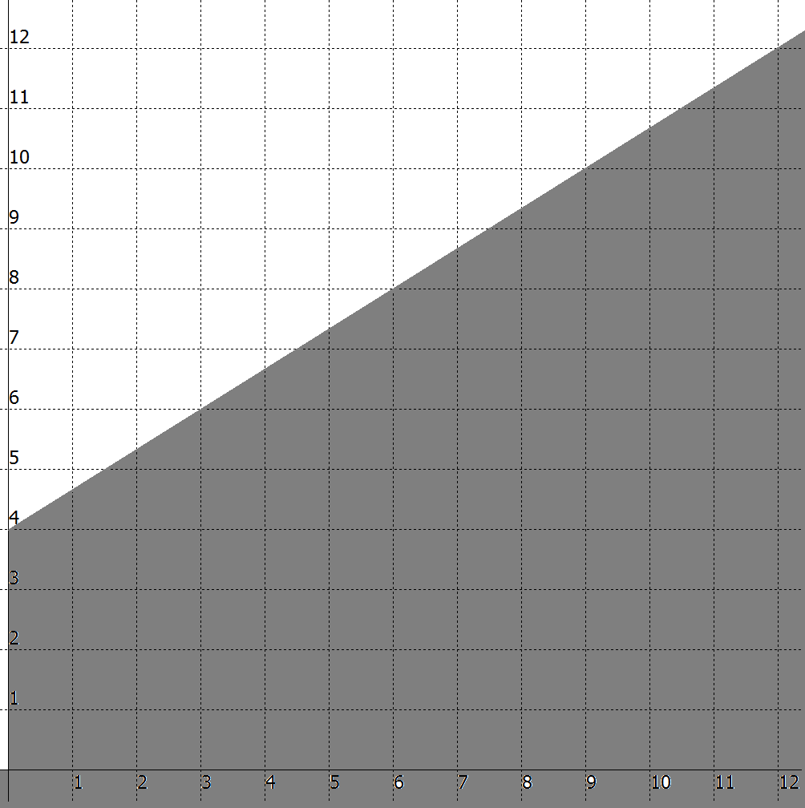  1. __________________________________  ____________________________________  ____________________________________  Algebraic expression: __________________ | 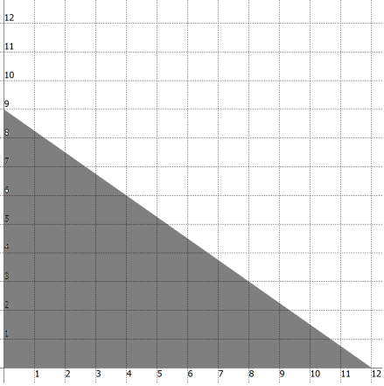  2. __________________________________  ____________________________________  ____________________________________  Algebraic expression: __________________
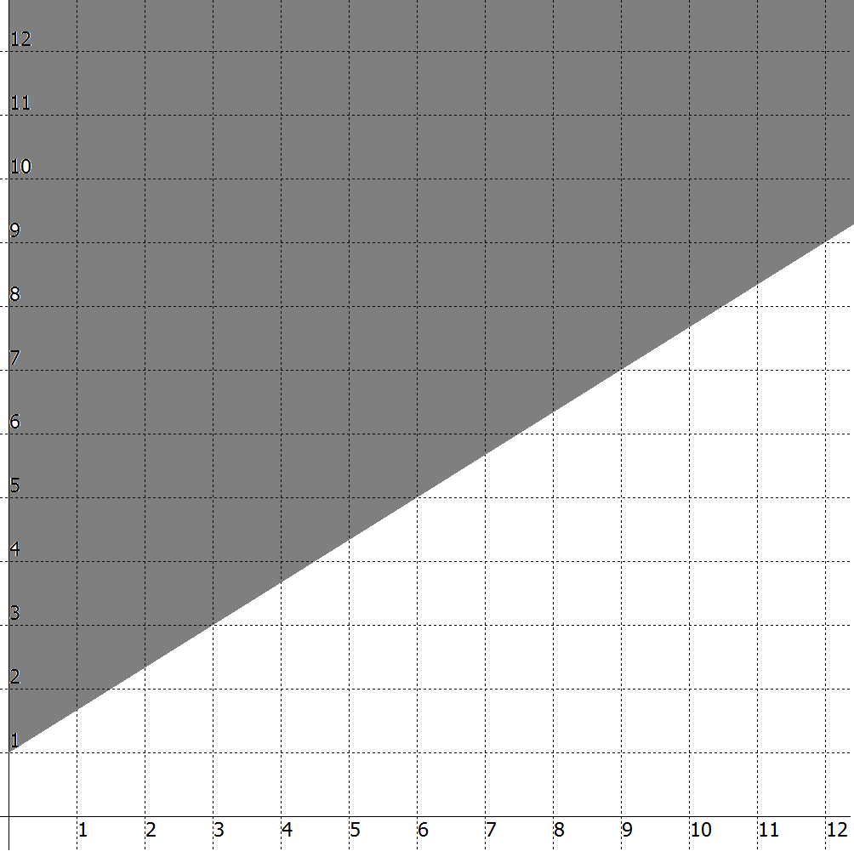  3. __________________________________  ____________________________________  ____________________________________  Algebraic expression: __________________ | 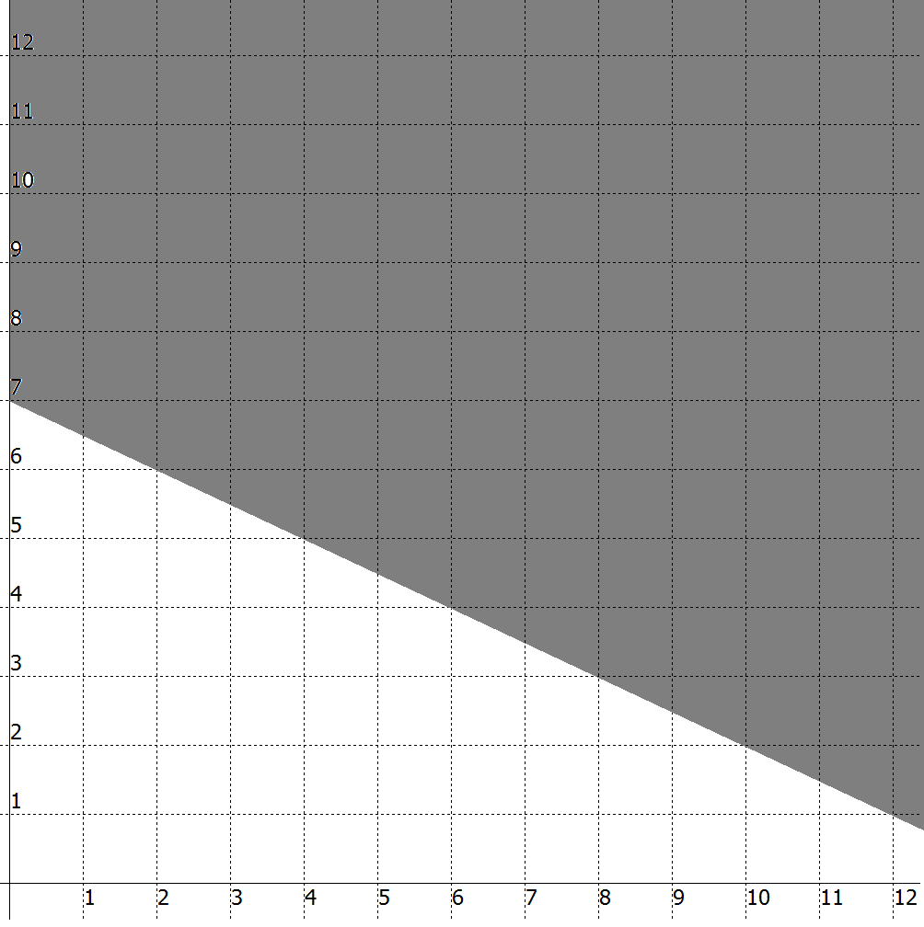  4. __________________________________  ____________________________________  ____________________________________  Algebraic expression: __________________
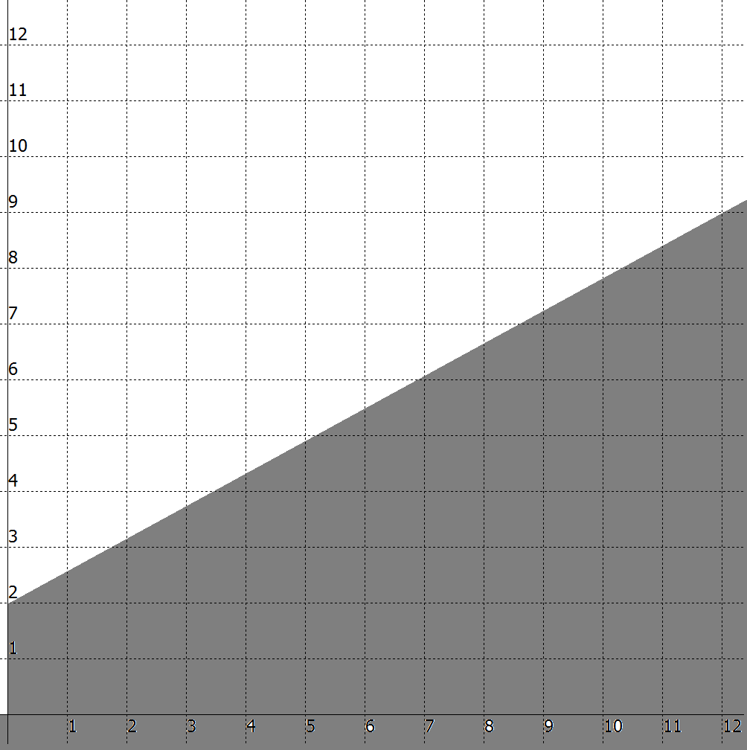  5. __________________________________  ____________________________________  ____________________________________  Algebraic expression: __________________ | 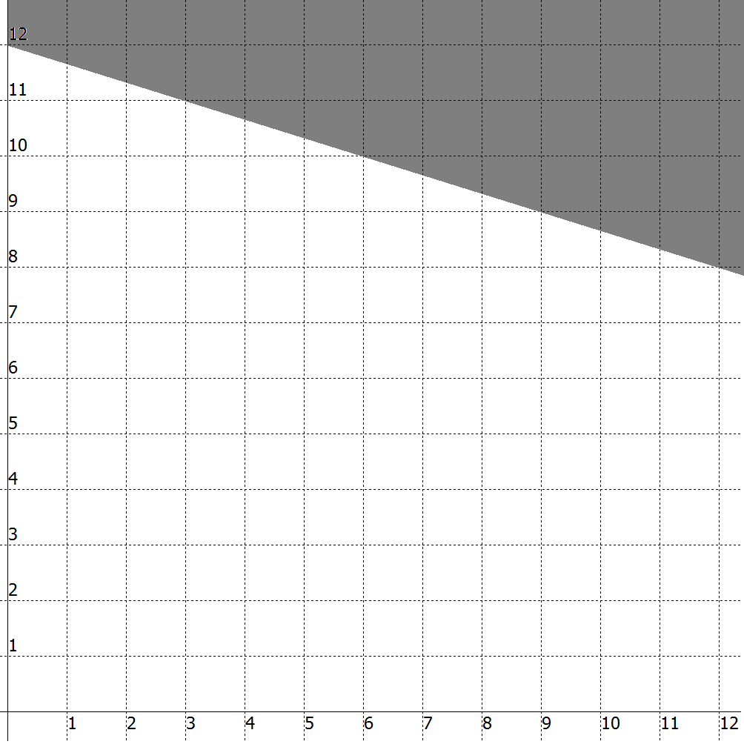  6. __________________________________  ____________________________________  ____________________________________  Algebraic expression: __________________
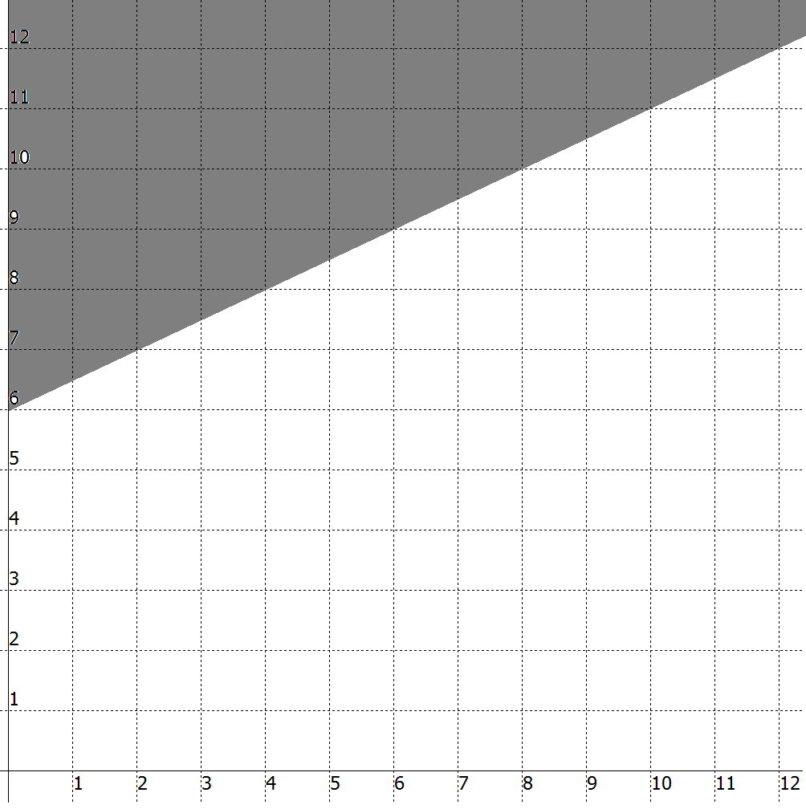  7. __________________________________  ____________________________________  ____________________________________  Algebraic expression: __________________ | 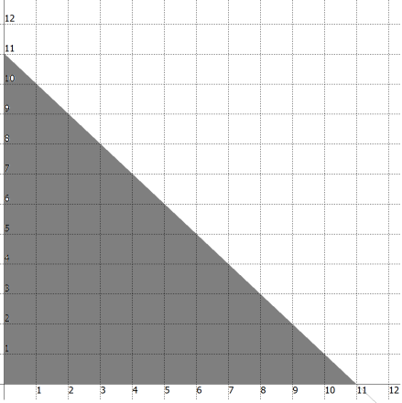  8. __________________________________  ____________________________________  ____________________________________  Algebraic expression: __________________

