Graphing Stories

For each graph shown, write a brief story to describe the inequality illustrated. Your story should explain what the line represents and what the shading represents. Finally, write an algebraic inequality for the graph show.
1. 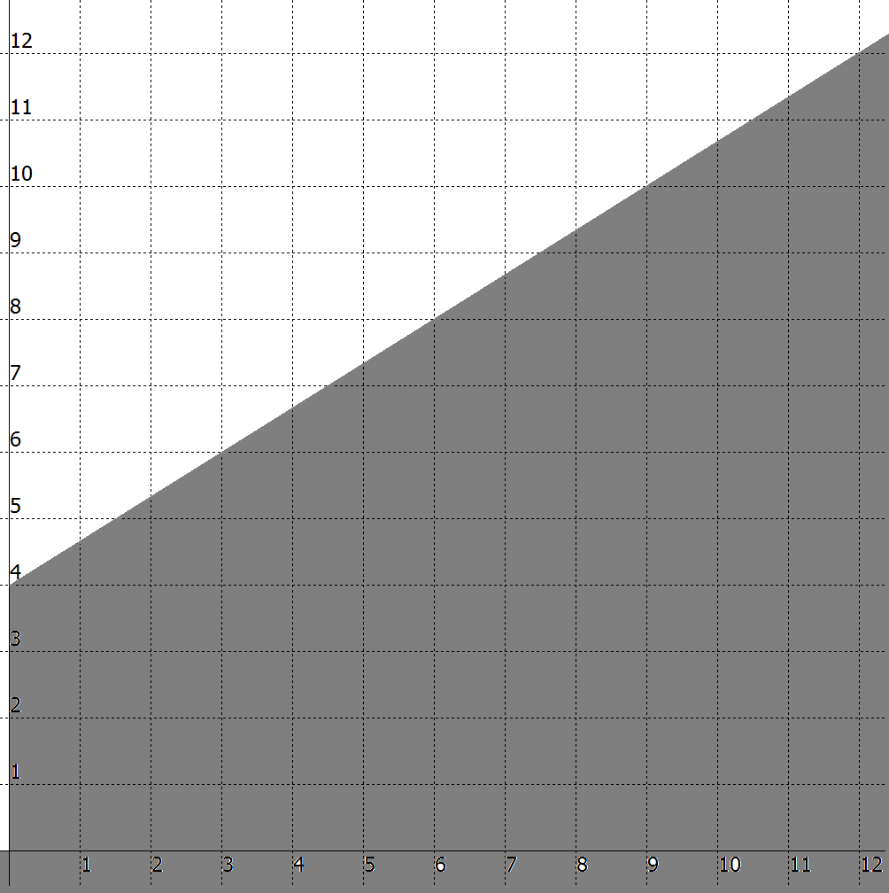 2. 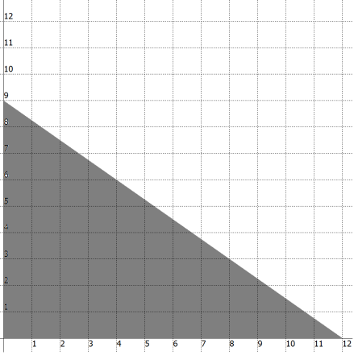
___________________________________ ___________________________________
___________________________________ ___________________________________
___________________________________ ___________________________________
Algebraic Expression: _________________ Algebraic Expression: _________________

3. 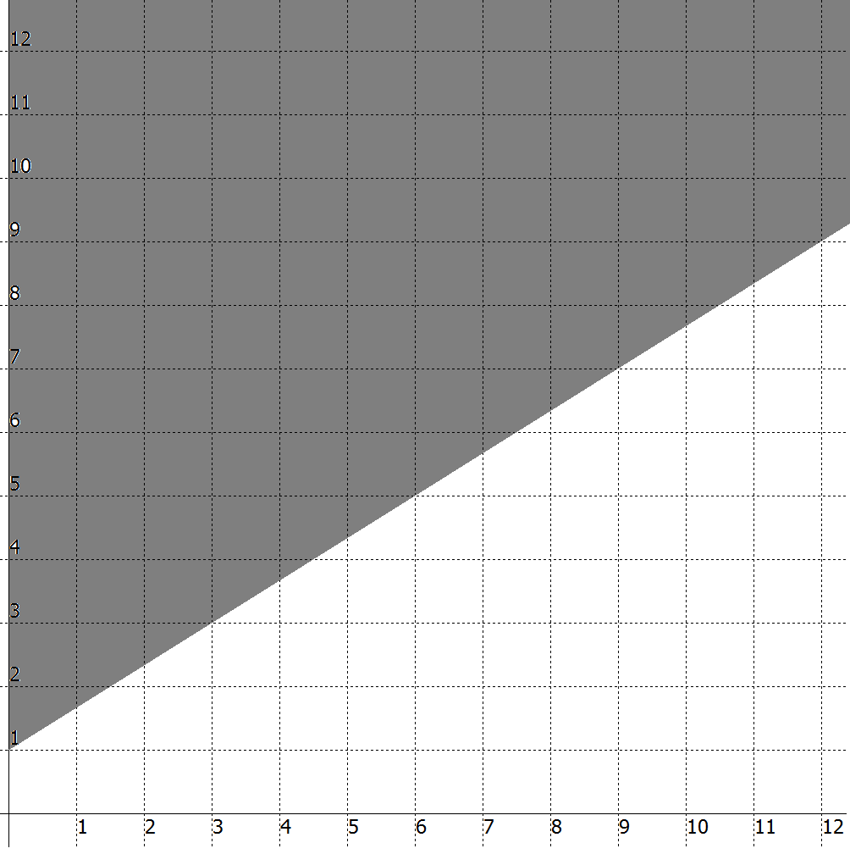 4. 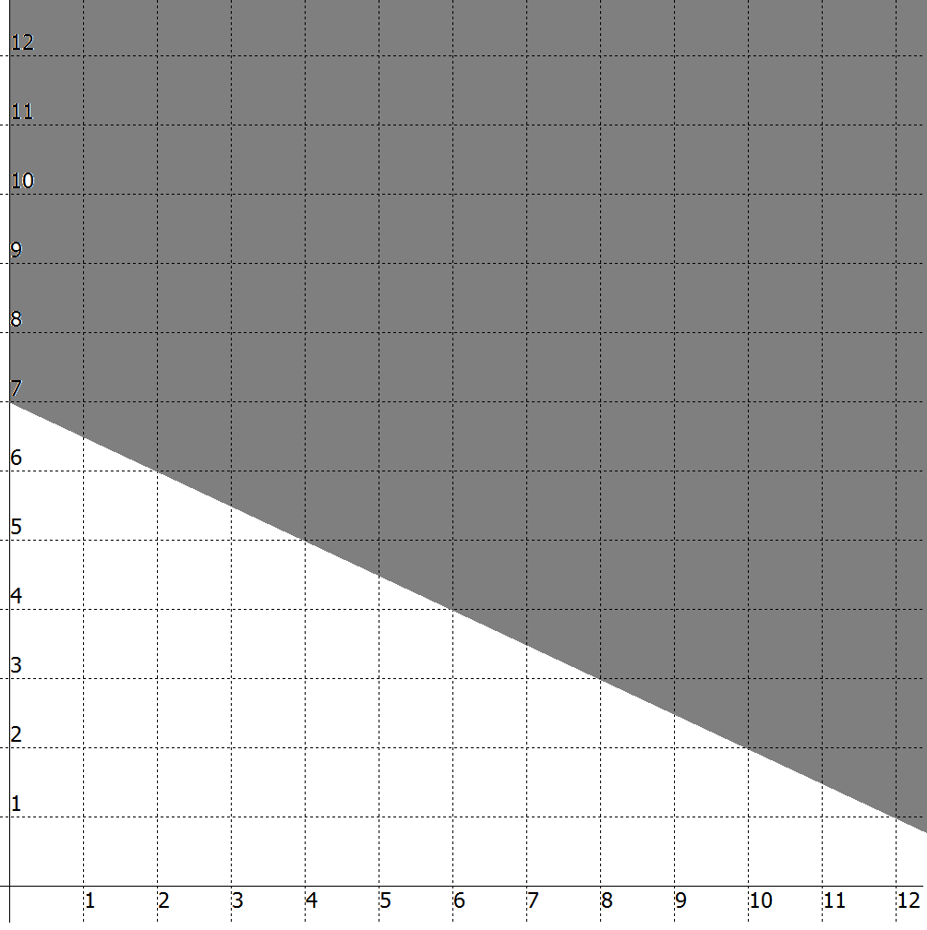
___________________________________ ___________________________________
___________________________________ ___________________________________
___________________________________ ___________________________________
Algebraic Expression: _________________ Algebraic Expression: _________________

5. 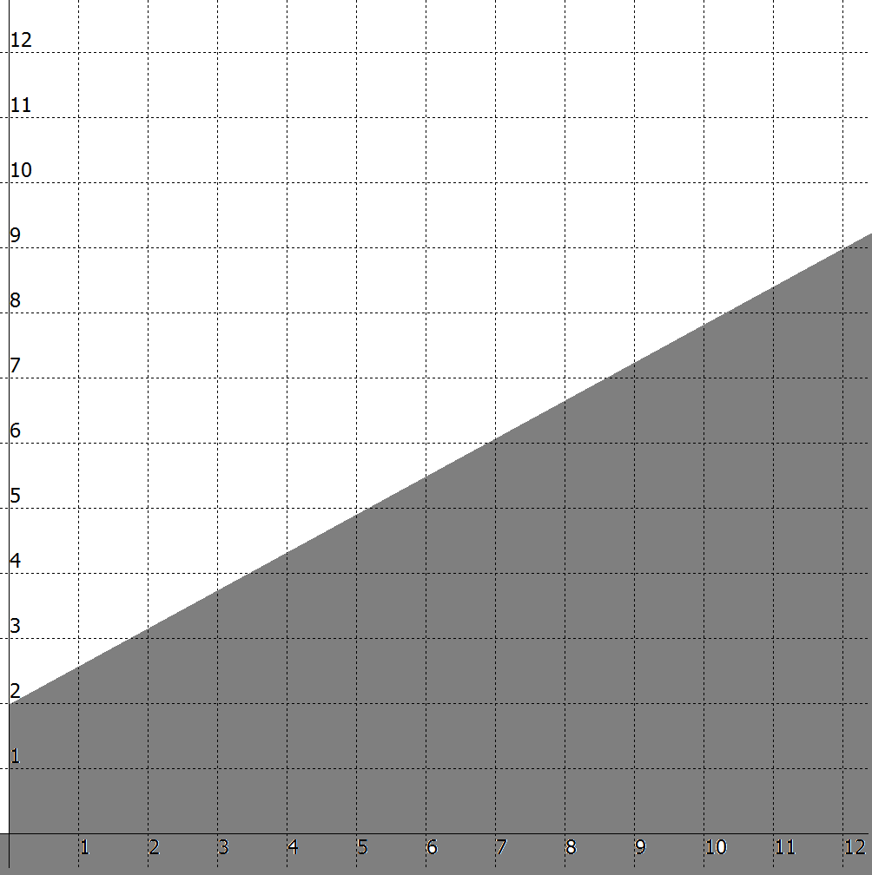 6. 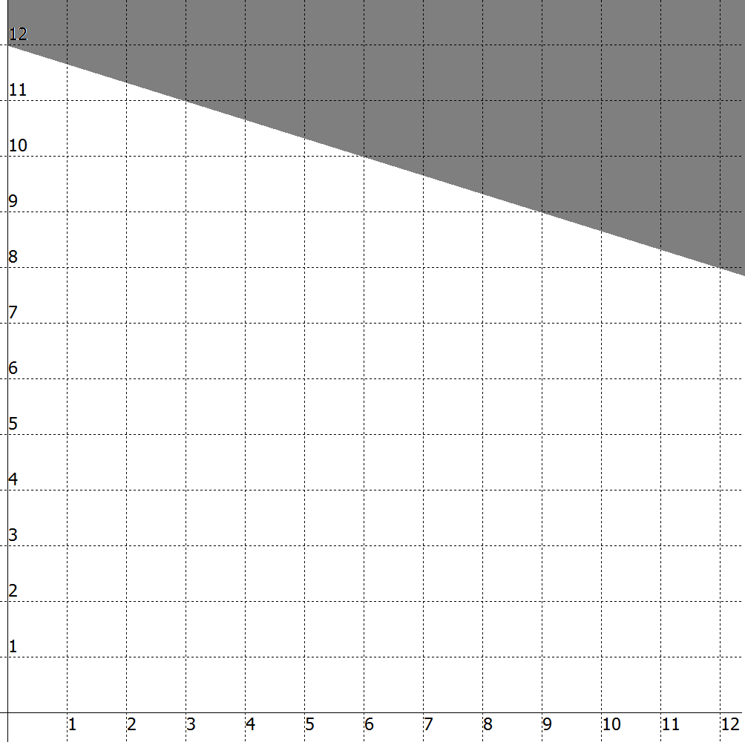
___________________________________ ___________________________________
___________________________________ ___________________________________
___________________________________ ___________________________________
Algebraic Expression: _________________ Algebraic Expression: _________________

7. 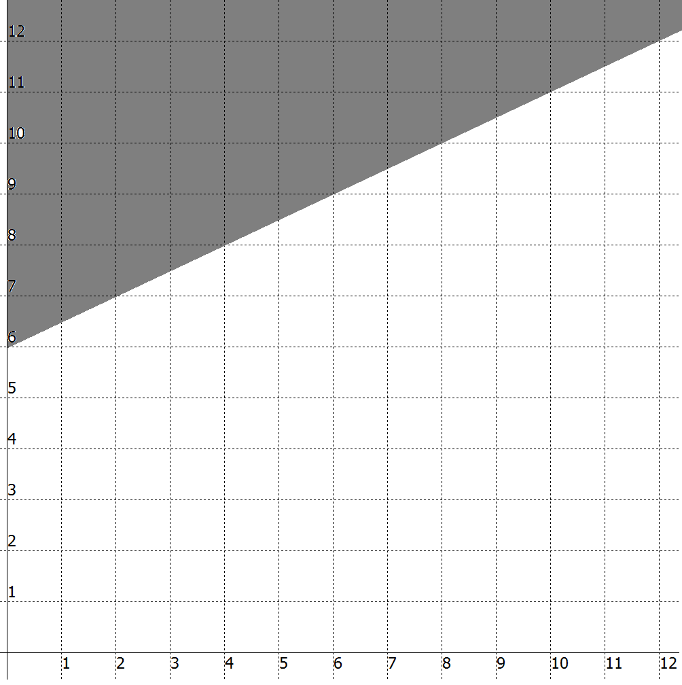 8. 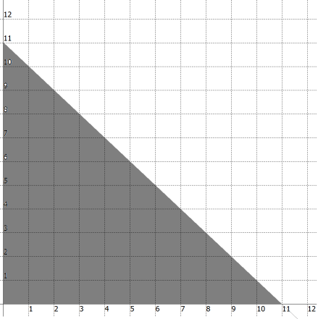
___________________________________ ___________________________________
___________________________________ ___________________________________
___________________________________ ___________________________________
Algebraic Expression: _________________ Algebraic Expression: _________________

