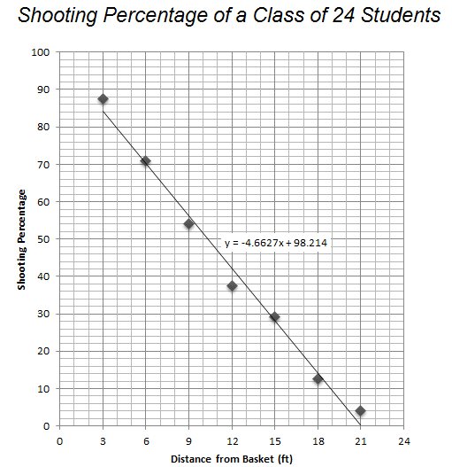  Ariana said that her shooting percentage was higher than the class shooting percentage at all distances. | Bethany said that her shooting percentage was not as good as class shooting percentage at all distances.
Camila said that her shooting percentage was never lower than the class shooting percentage. | Dante said that his shooting percentage was always at or below the shooting percentage of the class.
Elijah said that her shooting percentage was higher than the class shooting percentage from small distances but lower from big distances. | Francisco said that he shot better than the class at large distances but not as well as the class from short distances.

