Trashketball: Part 2

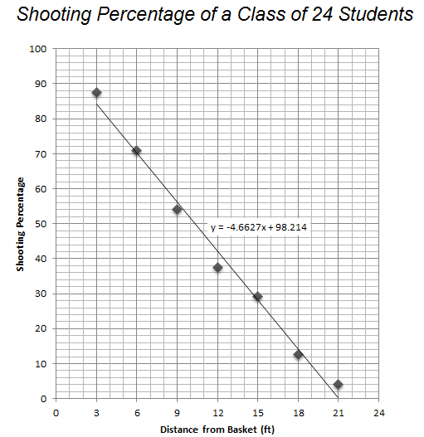
Ariana said that her shooting percentage was higher than the class shooting percentage at all distances.

Camila said that her shooting percentage was never lower than the class shooting percentage

Elijah said that her shooting percentage was higher than the class shooting percentage for small distances but lower for big distances.

Bethany said that her shooting percentage was not as good as class shooting percentage at all distances.

Dante said that his shooting percentage was always at or below the shooting percentage of the class.

Francisco said that he shot better than the class at large distances but not as well as the class from shot distances.

