Making Meaning

Sketch
In the frame below, sketch a picture of a place or item that holds special significance to you.
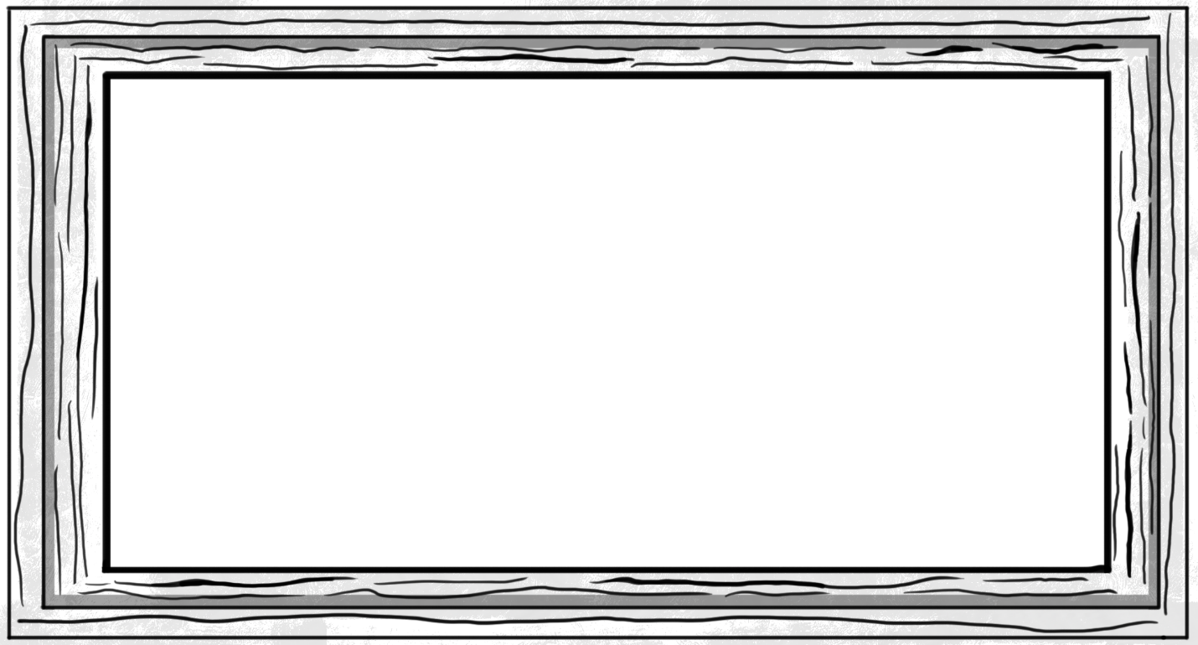

Description
What did you draw?

Why is this important to you?

What does it say about you that this is meaningful to you?

