Body Biography Handout
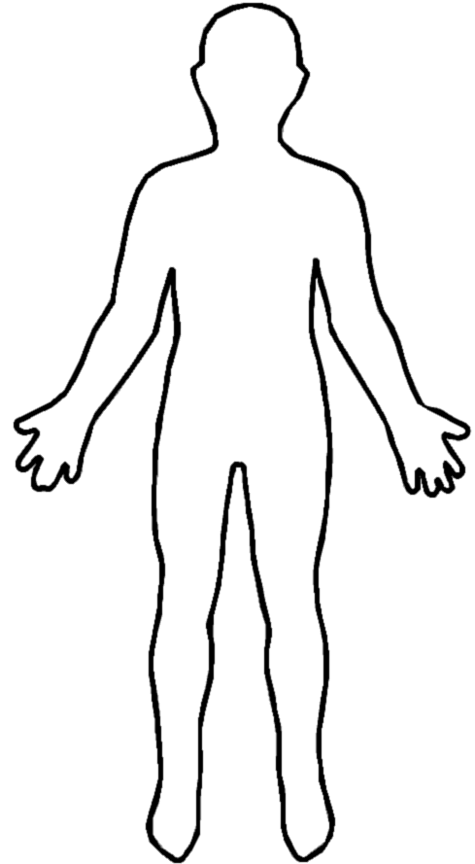
  - Citation: Wikipedia. (2007, November). File:Outline-body.png [image]. Retrieved from https://en.wikipedia.org/wiki/File:Outline-body.png

