Car Trouble
Use what you have learned during this lesson to answer the question below.
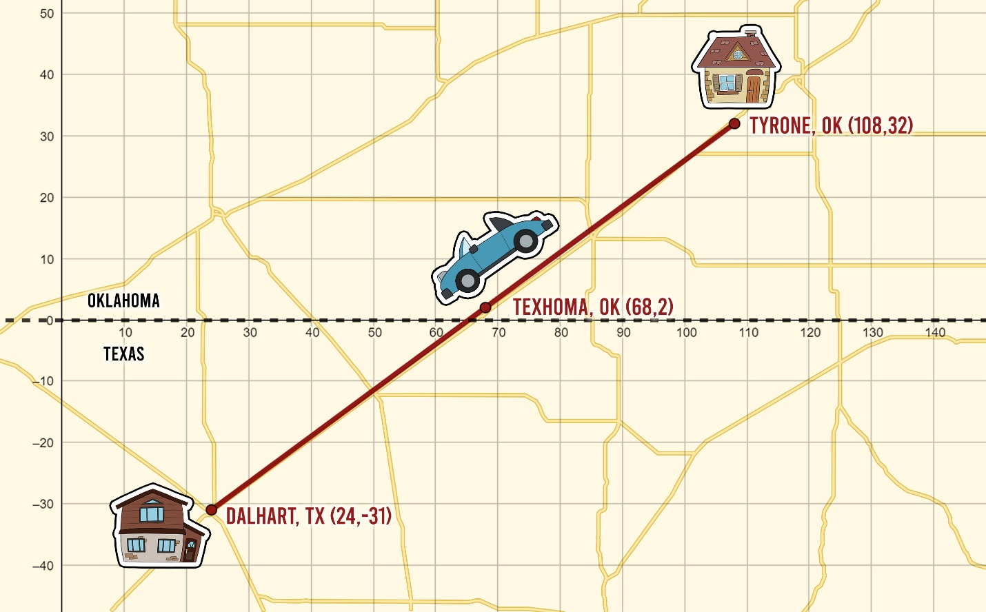
Amber, who lives in Tyrone, OK, is traveling with her family early on a Sunday morning to visit her grandmother in Dalhart, TX. The family car starts to make strange noises in Texoma, OK. Since no repair shops are open on Sunday morning, Amber’s parents decide to continue to Dalhart if they are at least half-way there, otherwise they will turn around and go back home.
What do you think they should do? Explain your reasoning using mathematical words and symbols.

