Part A: Complete the tables below.

- Our Town
- Our State
- Our Country

Year | Census Population |  | Year | Census Population |  | Year | Census Population
1960 |  |  | 1960 |  |  | 1960
1970 |  |  | 1970 |  |  | 1970
1980 |  |  | 1980 |  |  | 1980
1990 |  |  | 1990 |  |  | 1990
2000 |  |  | 2000 |  |  | 2000
2010 |  |  | 2010 |  |  | 2010

Part B: Plot the data from Part A. Use a colored pencil and straight edge to connect each point creating a line graph.

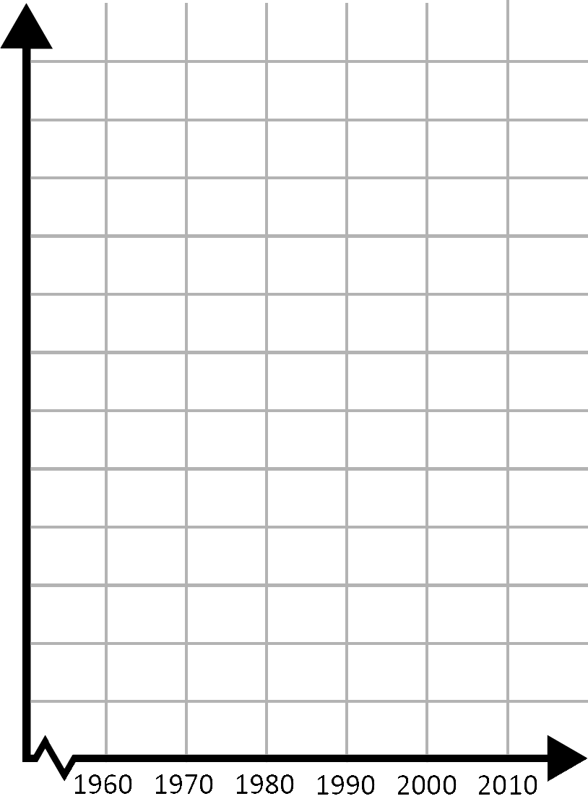

Part C: Use the data from Parts A and B to estimate the populations for the years below.

- Our Town
- Our State
- Our Country

Year | Census Population |  | Year | Census Population |  | Year | Census Population
1965 |  |  | 1965 |  |  | 1965
1975 |  |  | 1975 |  |  | 1975
1985 |  |  | 1985 |  |  | 1985
1995 |  |  | 1995 |  |  | 1995
2005 |  |  | 2005 |  |  | 2005
Explain how you found these estimates.

Part D: Use a different colored pencil to plot the values you found for each of the years in Part C on the graphs you made in Part B.
What do you notice about these points?

Part E: Conclusions
What must be true about the year you are estimating the population for to use your method from Part C?

- Definition:

- Formula:

