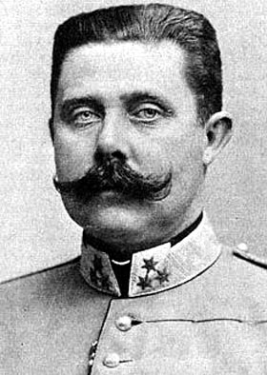
case file #06281914

The Assassination of Archduke Franz Ferdinand
In June of 1914, the heir to the throne of the Austria-Hungarian Empire, Archduke Franz Ferdinand (shown at right), traveled with his wife, Sophie, to Sarajevo, the capital of Bosnia, which had fallen under Austro-Hungarian control in 1878.
Archduke Ferdinand checked on military operations in the area before traveling to a museum opening in Sarajevo. Even as the archduke stepped into his open-air motorcar, accompanied by his wife, it was known that his life was at risk.

Archduke Franz Ferdinand
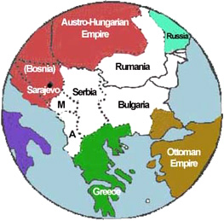
In the early 1900s, a new government had formed in neighboring Serbia—a nation populated by Slavs, the same ethnic group as those who made up most of the population of Bosnia. Serbia wanted to unify all Slavic people in the Balkans into one nation; and this goal had strong support within Bosnia, where many Slavs chafed under Austro-Hungarian rule.
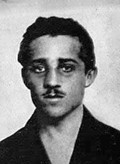
Included among the supporters of a unified Slavic nation was the militant group the Black Hand. Members of this group decided to assassinate the archduke on his visit to Sarajevo to send a message to the Austro-Hungarian Empire.

The Balkans, 1871
Six would-be assassins, armed with hand grenades and pistols, were sent to several points along the archduke’s route to the museum. All but one failed for one reason or another—one threw a bomb that bounced off the motorcade and exploded near another car, injuring 20 people. However, 23-year-old Gavrilo Princip (shown at right) succeeded.

Gavrilo Princip
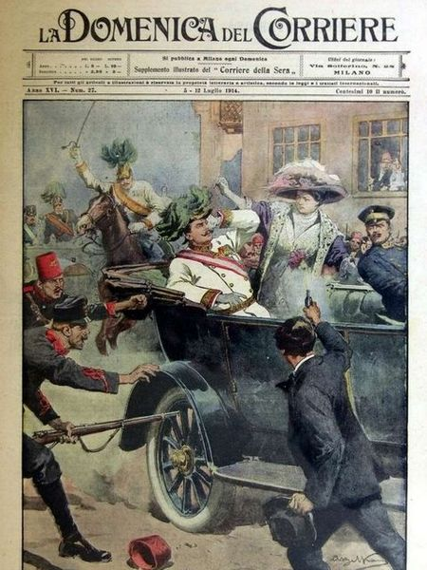
As the archduke’s motorcar made its return journey from the museum and slowed down near a delicatessen, Princip jumped forward and fired two shots, killing the archduke and his wife. He was immediately arrested and later executed.
After the assassination, anti-Slav riots broke out throughout Austria-Hungary and the Empire blamed Serbia for plotting the assassination. Austria-Hungary issued an ultimatum to Serbia, a list of 10 demands including allowing Austria-Hungary to conduct its own investigation of the assassination. When Serbia failed to comply, Austria-Hungary declared war on July 28, 1914, one month after the assassination.

L'attentato di Sarajevo (Attack in Sarajevo)
Russia, a strong nation of Slavs, was unwilling to allow its fellow Slavic nation, Serbia, to be destroyed by Austria-Hungary and moved to its aid. Germany, Austria-Hungary’s strongest ally, also mobilized its troops and declared war against Russia on August 1. Russia’s allies, France and Great Britain, were then, reluctantly, pulled into the war.
By August 4, much of Europe was involved in the conflict, although the United States would remain neutral until 1917.
Your task today: How could the assassination of ONE MAN start a WORLD WAR? Were there underlying factors that drove the major European powers into this conflict?

References:

Beltrame, A. (1914). L'attentato di Sarajevo. La Domenica del Corriere, XVI(27) [Photo]. Wikimedia Commons. https://commons.wikimedia.org/wiki/File:DC-1914-27-d-Sarajevo.jpg

EyeWitness to History. (1998). Assassination of Archduke Ferdinand, 1914. http://www.eyewitnesstohistory.com/duke.htm

Gavrilloprincip.jpg [Photo]. (n.d.). Wikimedia Commons. https://en.wikipedia.org/wiki/File:Gavrilloprincip.jpg

International School of Toulouse. (2006). The Balkans 1871 [Photo]. https://www.internationalschooltoulouse.net/igcsehistory/term1/ww1/causes/balkans.htm

History.com. (2009). Austria-Hungary issues ultimatum to Serbia. Retrieved September 1, 2026, from http://www.history.com/this-day-in-history/austria-hungary-issues-ultimatum-to-serbia

The New York Times. (1919, December 31). Archduke Franz Ferdinand of Austria [Photo]. https://commons.wikimedia.org/wiki/File:Franz_ferdinand.jpg

Wikipedia. (n.d.). Assassination of Archduke Franz Ferdinand of Austria. Retrieved September 1, 2026, from http://en.wikipedia.org/wiki/Assassination_of_Archduke_Franz_Ferdinand_of_Austria

