Case File #06281914

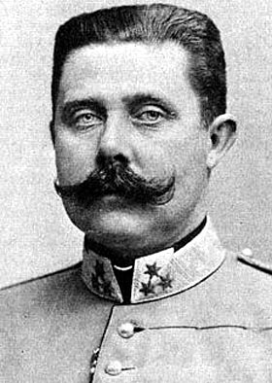
The Assassination of Archduke Franz Ferdinand

In June of 1914, the heir to the throne of the Austria-Hungarian Empire, Archduke Franz Ferdinand (shown at right), traveled with his wife, Sophie, to Sarajevo, the capital of Bosnia, which had fallen under Austro-Hungarian control in 1878.
Archduke Ferdinand checked on military operations in the area before traveling to a museum opening in Sarajevo. Even as the archduke stepped into his open-air motorcar, accompanied by his wife, it was known that his life was at risk.
  - Archduke Franz Ferdinand [2]
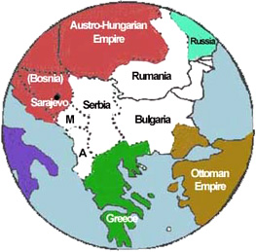
In the early 1900s, a new government had formed in neighboring Serbia—a nation populated by Slavs, the same ethnic group as those who made up most of the population of Bosnia. Serbia wanted to unify all Slavic people in the Balkans into one nation; and this goal had strong support within Bosnia, where many Slavs chafed under Austro-Hungarian rule.

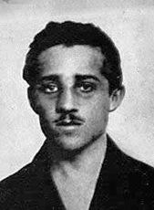
Included among the supporters of a unified Slavic nation was the militant group the Black Hand. Members of this group decided to assassinate the Archduke on his visit to Sarajevo to send a message to the Austro-Hungarian Empire.
  - The Balkans, 1871 [3]
Six would-be assassins, armed with hand grenades and pistols, were sent to several points along the archduke’s route to the museum. All but one failed for one reason or another—one threw a bomb that bounced off the motorcade and exploded near another cars, injuring 20 people. However, 23-year-old Gavrilo Princip (shown at right), succeeded.
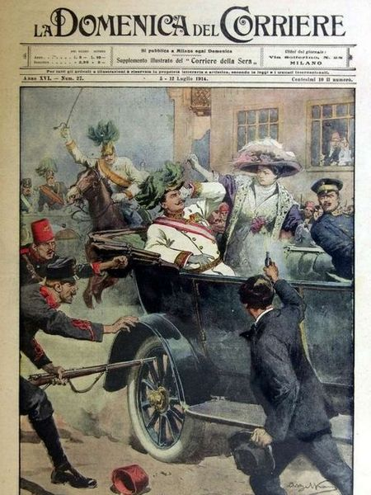
As the archduke’s motorcar made its return journey from the museum and slowed down near a delicatessen, Princip jumped forward and fired two shots, killing the Archduke and his wife. He was immediately arrested and later executed.
  - Gavrilo Princip [4]
After the assassination, anti-Slav riots broke out throughout Austria-Hungary and the Empire blamed Serbia for plotting the assassination. Austria-Hungary issued an ultimatum to Serbia, a list of 10 demands including allowing Austria-Hungary to conduct its own investigation of the assassination. When Serbia failed to comply, Austria-Hungary declared war on July 28, 1914, one month after the assassination.
Russia, a strong nation of Slavs, was unwilling to allow its fellow Slavic nation, Serbia, to be destroyed by Austria-Hungary and moved to its aid. Germany, Austria-Hungary’s strongest ally, also mobilized its troops and declared war against Russia on August 1. Russia’s allies, France and Great Britain, were then, reluctantly, pulled into the war.
  - L'attentato di Sarajevo (Attack in Sarajevo) [4]
By August 4, much of Europe was involved in the conflict, although the United States would remain neutral until 1917.

Your task today: How could the assassination of ONE MAN start a WORLD WAR? Were there underlying factors that drove the major European powers into this conflict?

  - References:
  - Assassination of Archduke Franz Ferdinand of Austria. (n.d.). In Wikipedia. Retrieved from http://en.wikipedia.org/wiki/Assassination_of_Archduke_Franz_Ferdinand_of_Austria
  - EyeWitness to History. (1998). Assassination of Archduke Ferdinand, 1914. Retrieved from http://www.eyewitnesstohistory.com/duke.htm
  - History.com staff. (2009). Austria-Hungary issues ultimatum to Serbia. Retrieved from http://www.history.com/this-day-in-history/austria-hungary-issues-ultimatum-to-serbia

  - Images:
  - [1] Beltrame, A. (1914). L'attentato di Sarajevo. La Domenica del Corriere, XVI(27). Public Domain. Retrieved from https://commons.wikimedia.org/wiki/File:DC-1914-27-d-Sarajevo.jpg
  - [2] The New York Times. (1919, December 31). Archduke Franz Ferdinand of Austria. The New York Times. Retrieved from https://commons.wikimedia.org/wiki/File:Franz_ferdinand.jpg
  - [3] The Open Door Website. (2006). The Balkans 1871. Retrieved from http://www.saburchill.com/history/chapters/empires/0060.html
  - [4] Gavrilloprincip.jpg. (n.d.). In Wikimedia Commons. Retrieved from https://en.wikipedia.org/wiki/File:Gavrilloprincip.jpg

