Gallery Walk Documents

  - Citations:
  - Andrassy, G., & Reuss, H. (1879, October 8). The Dual Alliance Between Austria-Hungary and Germany. In H. Bezhani (Ed.), Brigham Young University Library. Retrieved from http://wwi.lib.byu.edu/index.php/The_Dual_Alliance_Between_Austria-Hungary_and_Germany
  - Danielson, S. (2009). Colonialism in 1914 [Image]. Overview of Human Geography. http://debitage.net/humangeography/images/Colonialism_1914.png
  - Freiheit Der Meere. (1917). Retrieved from http://www.europeana1914-1918.eu/en/europeana/record/9200231/BibliographicResource_3000060331128
  - Green, M. (2015). Background Questions 1.The world was theirs's for the taking…. 2.1914-1918 3.About 1/10 (3,000,000/30,000,000) 4.With even power, it would be hard for. Retrieved from http://slideplayer.com/slide/8565804/
  - historicair, Fluteflute, & User:Bibi Saint-Pol. (2009, Janurary). Map of military alliances of Europe in 1914 (Rev. ed.). In Wikimedia Commons. Retrieved from https://commons.wikimedia.org/wiki/File:Map_Europe_alliances_1914-en.svg
  - Joll, J., & Martel, G. (2013). The Origins of the First World War (3rd Ed.). New York: Routledge.
  - Makarov, V. (n.d.). God save the Tsar. Russian Anthems Museum. Retrieved from http://www.hymn.ru/god-save-the-tsar-en.html
  - McAndrew, C. (n.d.). Imperialism. Mr. McAndrew. Retrieved from http://chrismcandrew.weebly.com/uploads/5/1/5/8/51581333/1069_001.pdf
The Daily Telegraph. (1908, October 28). The Daily Telegraph affair. German History in Documents and Images. Retrieved from http://germanhistorydocs.ghi-dc.org/sub_document.cfm?document_id=757
  - Thomson, J. (1740).Rule Britannia. Retrieved from http://www.poetryfoundation.org/poems-and-poets/poems/detail/45404
  - Twain, M. (1898).Stirring times in Austria. Retrieved from https://ecommons.cornell.edu/bitstream/handle/1813/2170/Twain_Austria_1898.pdf?sequence=1&isAllowed=y
  - von Bülow, B. (1899). Bülow's 'Hammer and Anvil' Speech before the Reichstag (The English Translation) (R. Hacken, Trans.). Retrieved from http://wwi.lib.byu.edu/index.php/B%C3%BClow's_'Hammer_and_Anvil'_Speech_before_the_Reichstag_(The_English_Translation)

Document A

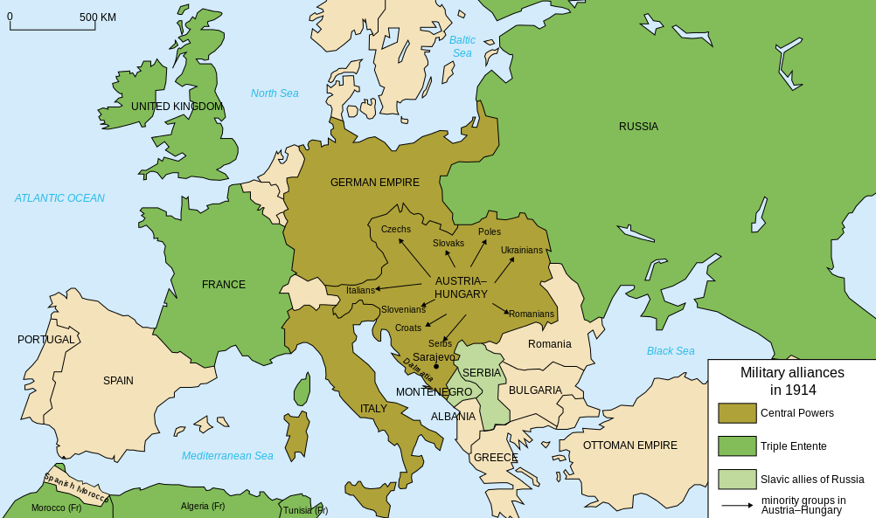
Military Alliances In 1914
  - (historicair, Fluteflute, & User:Bibi Saint-Pol, 2009)

Document B

October 7, 1879

The Dual Alliance Between Austria-Hungary and Germany [excerpt]

ARTICLE 1.
Should, contrary to their hope, and against the loyal desire of the two High Contracting Parties, one of the two Empires be attacked by Russia the High Contracting Parties are bound to come to the assistance one of the other with the whole war strength of their Empires, and accordingly only to conclude peace together and upon mutual agreement.

ARTICLE 2.
Should one of the High Contracting Parties be attacked by another Power, the other High Contracting Party binds itself hereby, not only not to support the aggressor against its high Ally, but to observe at least a benevolent neutral attitude towards its fellow Contracting Party.
Should, however, the attacking party in such a case be supported by Russia, either by an active cooperation or by military measures which constitute a menace to the Party attacked, then the obligation stipulated in Article 1 of this Treaty, for reciprocal assistance with the whole fighting force, becomes equally operative, and the conduct of the war by the two High Contracting Parties shall in this case also be in common until the conclusion of a common peace.
  - (Andrassy & Reuss, 1879)

Document C

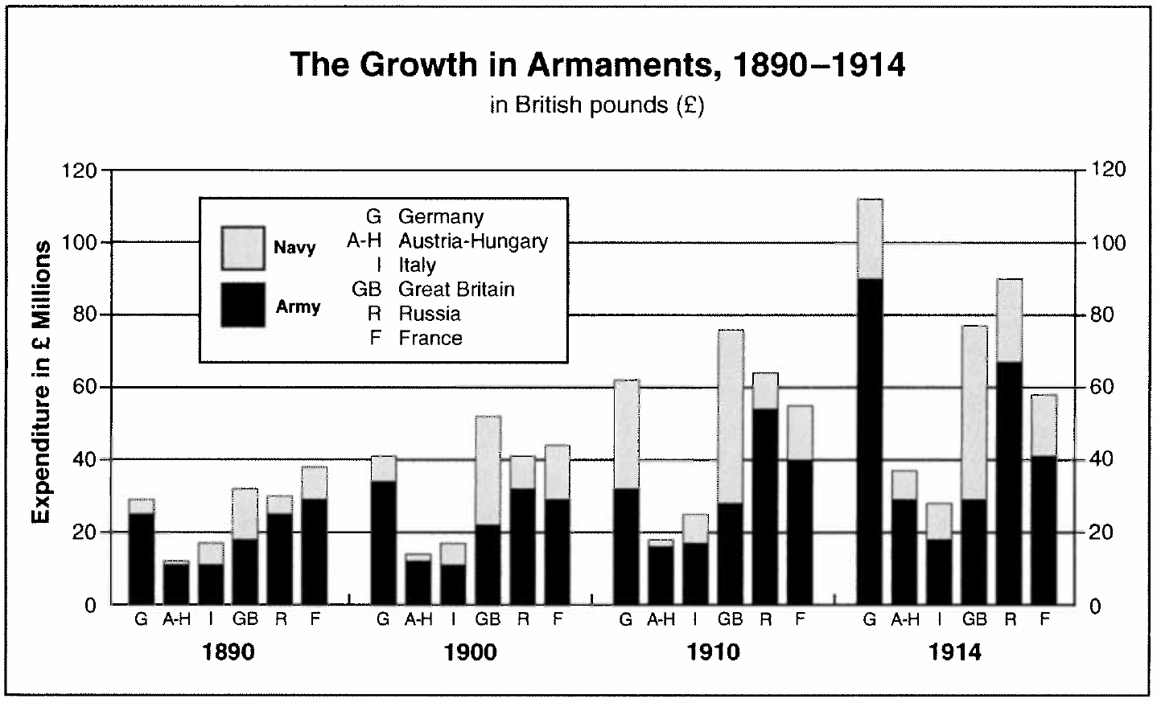

Note: By 1914 the Entente Powers could field 2.23 million men, Germany and Austria-Hungary 1.2 million.
  - (as cited in Green, 2015)

Document D

Interview with German Emperor Wilhelm II [excerpt]

October 28, 1908 , published in The Daily Telegraph

"I repeat," continued His Majesty, "that I am a friend of England, but you make things difficult for me. My task is not of the easiest. The prevailing sentiment among large sections of the middle and lower classes of my own people is not friendly to England. I am, therefore so to speak, in a minority in my own land, but it is a minority of the best elements as it is in England with respect to Germany. That is another reason why I resent your refusal to accept my pledged word that I am the friend of England. I strive without ceasing to improve relations, and you retort that I am your archenemy. You make it hard for me. Why is it?" [. . .]
"But, you will say, what of the German navy? Surely, that is a menace to England! Against whom but England are my squadrons being prepared? If England is not in the minds of those Germans who are bent on creating a powerful fleet, why is Germany asked to consent to such new and heavy burdens of taxation? My answer is clear. Germany is a young and growing empire. She has a worldwide commerce which is rapidly expanding, and to which the legitimate ambition of patriotic Germans refuses to assign any bounds. Germany must have a powerful fleet to protect that commerce and her manifold interests in even the most distant seas. She expects those interests to go on growing, and she must be able to champion them manfully in any quarter of the globe. Her horizons stretch far away."
(The Daily Telegraph, 1908)

Document E

Bernhard von Bülow, German Chancellor

Speech to the Reichstag (German Congress) [excerpt]

December 11, 1899

In our nineteenth century, England has increased its colonial empire -- the largest the world has seen since the days of the Romans -- further and further; the French have put down roots in North Africa and East Africa and created for themselves a new empire in the Far East; Russia has begun its mighty course of victory in Asia, leading it to the high plateau of the Pamir and to the coasts of the Pacific Ocean. [. . .] We don't want to step on the toes of any foreign power, but at the same time we don't want our own feet tramped by any foreign power (Bravo!) and we don't intend to be shoved aside by any foreign power, not in political nor in economic terms. (Lively applause.) [. . .] We don't ever again want to become, as Friedrich List put it, the 'slaves of humanity.' But we'll only be able to keep ourselves at the fore if we realize that there is no welfare for us without power, without a strong army and a strong fleet. (Very true! from the right; objections from the left) The means, gentlemen, for a people of almost 60 million -- dwelling in the middle of Europe and, at the same time, stretching its economic antennae out to all sides -- to battle its way through in the struggle for existence without strong armaments on land and at sea, have not yet been found. (Very true! from the right.) In the coming century the German people will be a hammer or an anvil.
  - (von Bülow, 1899)

Document F

Size of Colonial Empires in 1913

Size of Colonial Empires
Country | Area (Square Miles) | Population of Colonies
Britain | 12,740,000 | 400,000,000
France | 4,440,00 | 56,000,000
Germany | 1, 139,000 | 12,000,000
Belgium | 927,000 | 15,500,000
Italy | 579,000 | 1,600,00
USA | 125,000 | 10,000,000
Russia | 0 | 0
Austria-Hungary | 0 | 0

  - (McAndrew, n.d.)

Document G

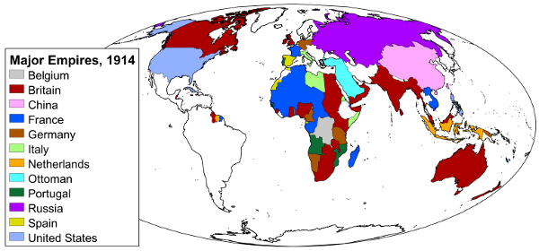
Major Empires, 1914

  - (Danielson, 2009)

Document H

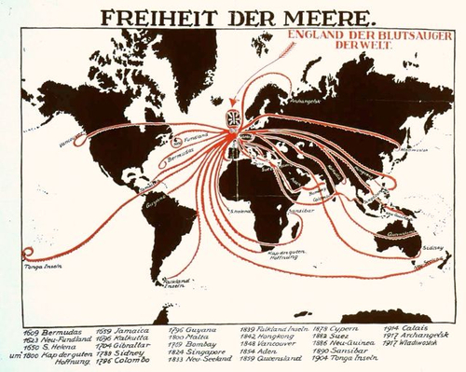
The British Octopus

German propaganda cartoon, 1917

Freiheit Der Meere = Freedom of the seas

England Der Blutsauger der Welt = England, the bloodsucker of the world

  - (Freiheit Der Meere, 1917)

Document I

Russian National Anthem, 1833-1917

Composed by Prince A.V. Lvov with lyrics by Vasily Zhukovsky [English translation]

God save the noble Tsar!
Long may he live, in pow’r,
In happiness,
In peace to reign!
Dread of his enemies,
Faith’s sure defender,
God save the Tsar!
(repeat)
(repeat previous three lines)

  - (Makarov, n.d.)

Document J

"Rule Britannia”

Poem by James Thomson, set to music by Thomas Arne, 1740 [excerpt]
When Britain first, at Heaven's command
Arose from out the azure main;
This was the charter of the land,
And guardian angels sang this strain:
"Rule, Britannia! rule the waves:
"Britons never will be slaves."

The nations, not so blest as thee,
Must, in their turns, to tyrants fall;
While thou shalt flourish great and free,
The dread and envy of them all.
"Rule, Britannia! rule the waves:
"Britons never will be slaves."

Note: Seen as the unofficial British national anthem, used by the Royal Navy and British Army

  - (Thomson, 1740)

Document K

"Stirring Times in Austria"

By Mark Twain

Published in Harper's New Monthly Magazine, March, 1898 (Volume 96), pp. 530-40. [excerpt]

I. THE GOVERNMENT IN THE FRYING-PAN
Here in Vienna in these closing days of 1897 one's blood gets no chance to stagnate. The atmosphere is brimful of political electricity. All conversation is political; every man is a battery, with brushes over-worn, and gives out blue sparks when you set him going on the common topic. Everybody has an opinion, and lets you have it frank and hot, and out of this multitude of counsel you get merely confusion and despair. For no one really understands this political situation, or can tell you what is going to be the outcome of it.
Things have happened here recently which would set any country but Austria on fire from end to end, and upset the government to a certainty; but no one feels confident that such results will follow here. Here, apparently, one must wait and see what will happen, then he will know, and not before; guessing is idle; guessing cannot help the matter. This is what the wise tell you; they all say it; they say it every day, and it is the sole detail upon which they all agree [. . .]
Nearly every day some one explains to me that a revolution would not succeed here. "It couldn't, you know. Broadly speaking, all the nations in the empire hate the government -- but they all hate each other, too, and with devoted and enthusiastic bitterness; no two of them can combine; the nation that rises must rise alone; then the others would joyfully join the government against her, and she would have just a fIy's chance against a combination of spiders. This government is entirely independent. It can go its own road, and do as it pleases; it has nothing to fear. In countries like England and America, where there is one tongue and the public interests are common, the government must take account of public opinion; but in Austria-Hungary there are nineteen public opinions -- one for each state. No -- two or three for each state, since there are two or three nationalities in each. A government cannot satisfy all these public opinions; it can only go through the motions of trying.”
  - (Twain, 1898)

Document L

Quote from newspaper run by Colonel Dragutin Dimitrijević, head of Serbian military intelligence, founder of the secret society “Union or Death” (called “The Black Hand” by its opponents), 1912 (excerpt)

The war between Serbia and Austria [. . .] is inevitable. If Serbia wants to live in honor, she can only do this by war. This war is determined by our obligation to our traditions and the world of culture. This war derives from the duty of our race which will not permit itself to be assimilated. This war must bring about the eternal freedom of Serbia, of the South Slavs, of the Balkan peoples. Our whole race must stand together to halt the onslaught of these aliens from the north.
  - (as cited in Joll & Martel, 2013)

