Student Handout: Gender
Document A: “A Flapper’s Appeal to Parents” by Ellen Welles Page, published in Outlook, December 6, 122, pg. 607 (Excerpt)
If one judges by appearances, I suppose I am a flapper. I am within the age limit. I wear bobbed hair, the badge of flapperhood. (And, oh, what a comfort it is!). I powder my nose. I wear fringed skirts and bright-colored sweaters, and scarfs, and waists with Peter Pan collars, and low-heeled "finale hopper" shoes. I adore to dance. I spend a large amount of time in automobiles. I attend hops, and proms, and ball-games, and crew races, and other affairs at men's colleges. [. . .]
You! You parents, and grandparents, and friends, and teachers, and preachers--all of you! [. . .]
Think back to the time when you were struggling through the teens. Remember how spontaneous and deep were the joys, how serious and penetrating the sorrows. Most of us, under the present system of modern education, are further advanced and more thoroughly developed mentally, physically, and vocationally than were our parents at our age. We hold the infinite possibilities of the myriads of new inventions within our grasp. We have learned to take for granted conveniences, and many luxuries, which not so many years ago were as yet undreamed of. We are in touch with the whole universe.

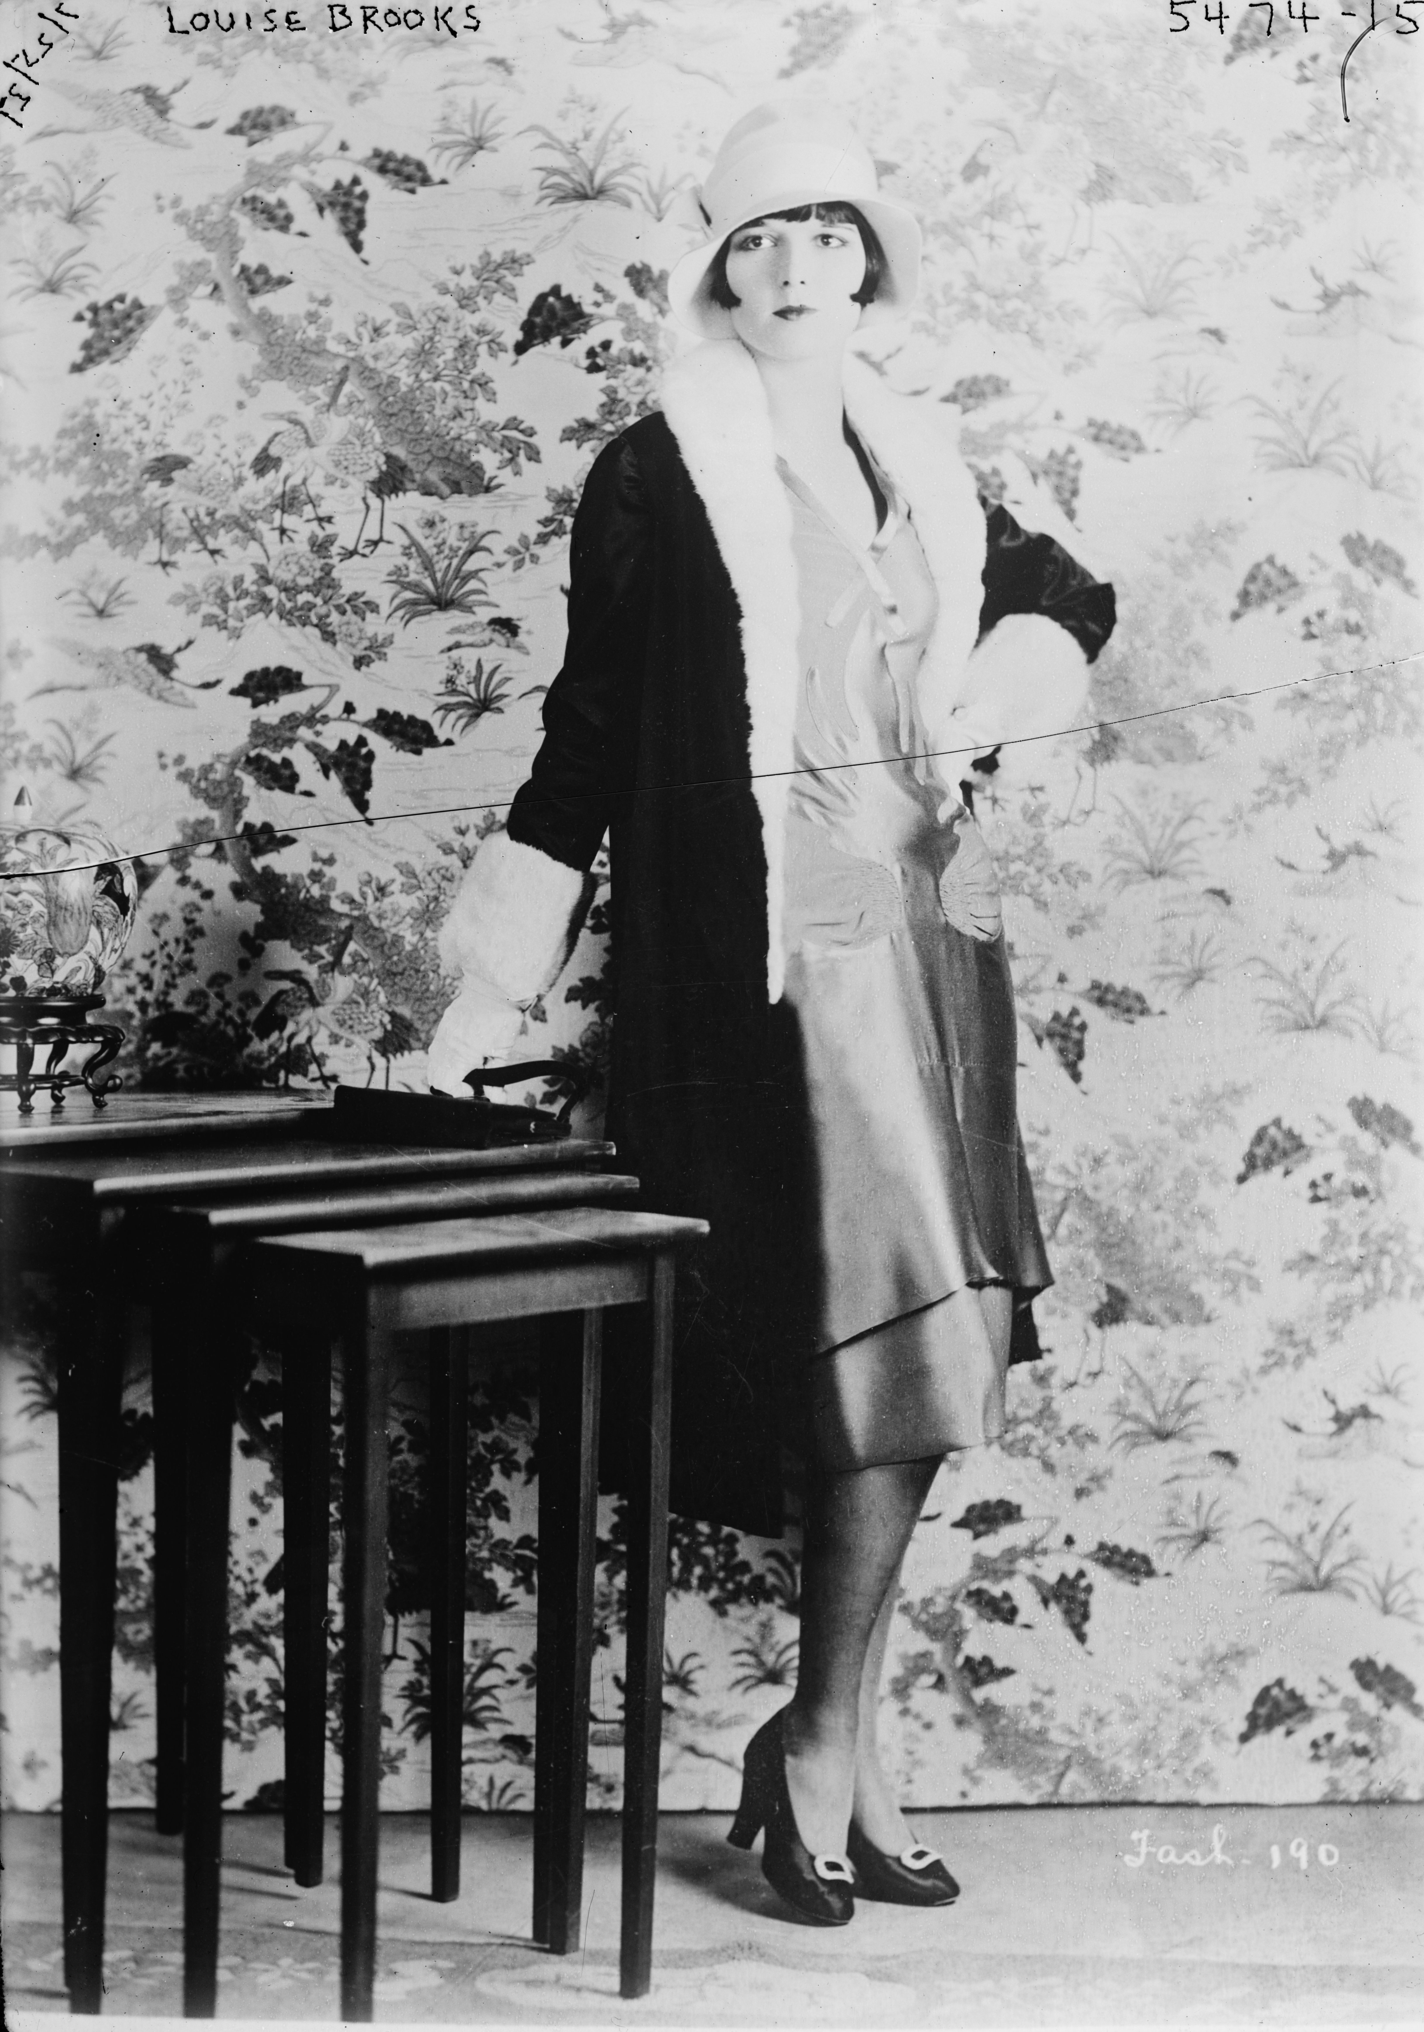
  - Page, E. W. (1922, Dec. 6). A flapper’s appeal to parents. Outlook Magazine (p. 607). Retrieved from http://websupport1.citytech.cuny.edu/Faculty/pcatapano/US2/US%20Documents/flappersappeal.html
Document B: Photographs of Flappers
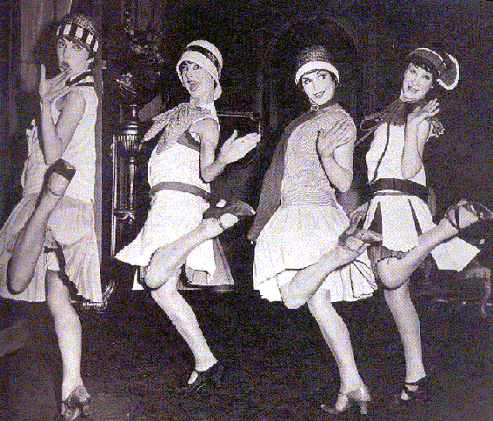

  - Public Domain

  - George Grantham Bain / Library of Congress / Public Domain
Document C: “The Case Against the Younger Generation” published in The Literary Digest, Jun 17, 1922 (Excerpt)
The greatest problem we are facing is immorality of our whole social structure. [. . .] The modern girl is an extremist. She dresses in the lightest and most flimsy of fabrics. Her dancing is often of the most passionate nature and I believe the modern dance has done much to break down the standards of morals. But do not permit me to convey the idea that the girls are entirely to blame. The fellow of to-day, in most cases, will not go out with a girl for any period of time unless she permits him to caress her. Such is accepted as the sequel of most every date. If checked for a moment by last year’s agitation, the riotous torrent of immorality sweeps onward more relentless than ever and the appalling menace of this downward trend is callousness of the popular mind to it. The sexual is flaunted everywhere. [. . .] Unless from its imperiled sleep over the pit of moral chaos, American civilization shall suddenly awake, it sleeps the sleep of death! Jazz is a little more reckless, the movies a little more obscene, the dances a little more daring, and manners a little more loose than last year. More girls are smoking cigarettes and are aspiring to be vamps and flappers.

  - Personal Glimpses. (1922, June 17). The case against the younger generation. The Literary Digest (pp. 38-42, 51-63). Retrieved from http://flappernhd.weebly.com/1920s-culture.html

Document D: Alvah Posen, "Toot This on Your Tooter," comic strip, Them Days Is Gone Forever, The Chicago Tribune, April 8, 1922
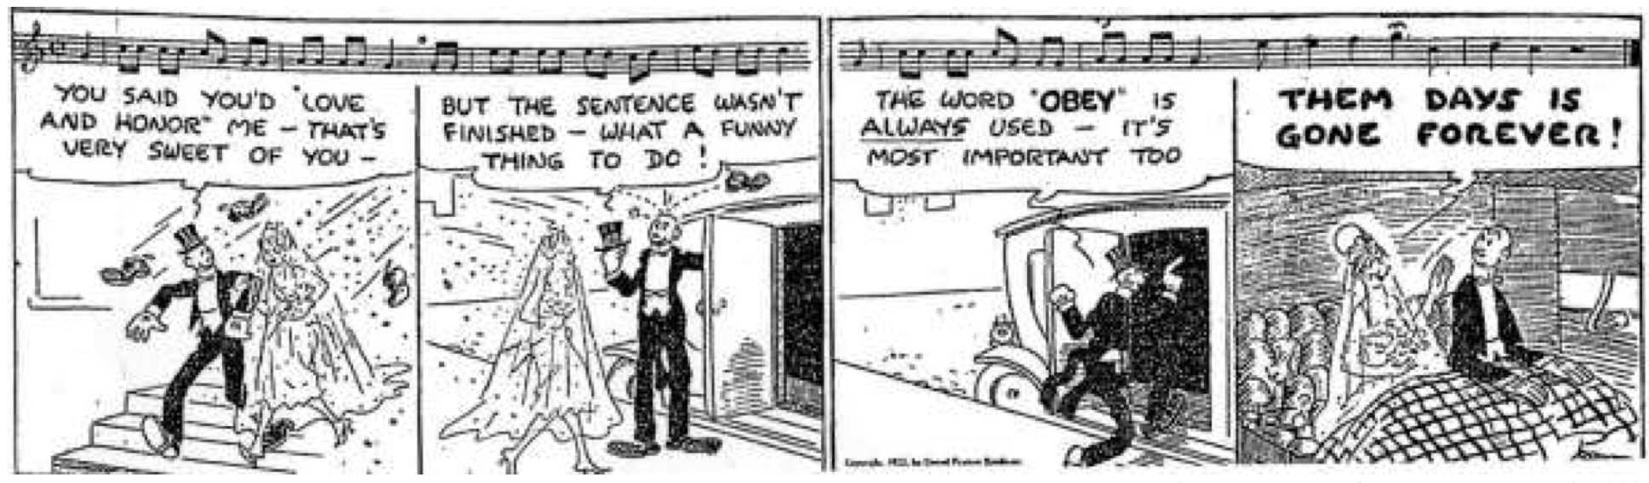

  - Posen, A. (1922, April 8). Them days is gone forever [Cartoon]. The Chicago Tribune. Retrieved from http://americainclass.org/sources/becomingmodern/modernity/text2/themdays.pdf

