Popular Culture
Document A: Songs
Swanee, 1920

Music by George Gershwin
Lyrics by Irvin Caesar

I've been away from you a long time
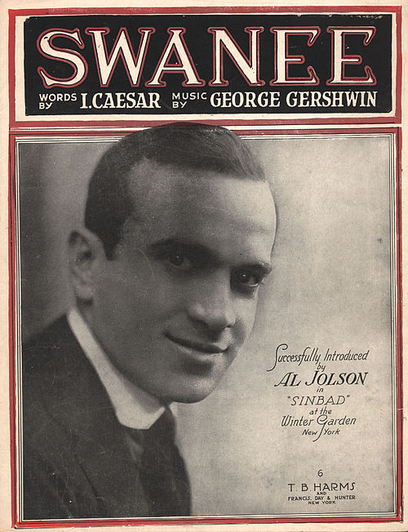
I never thought I'd miss you so
Somehow I feel
Your love was real
Near you I long to be
The birds are singing, “It is songtime”
The banjos strummin' soft and low
I know that you
Yearn for me too
Swanee you're calling me

I'll be happy
I'll be happy

Swanee
Swanee
I am coming back to Swanee
Mammy
Mammy
I love the old folks at home

  - Caesar, I. (Lyricist), & Gershwin, G. (Composer). (1919). Swanee [Lyrics]. Retrieved from https://en.wikisource.org/wiki/Swanee
Makin’ Whoopee, 1928

Music by Walter Donaldson
Lyrics by Gus Kahn

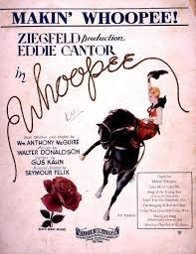
Every time I hear that dear old wedding march
I feel rather glad I have a broken arch.
I have heard a lot of people talk
And I know that marriage is a long long walk.
To most people weddings mean romance
But I prefer a picnic or a dance.
Another bride,
Another groom,
Another sunny honeymoon,
Another season,
Another reason
For making whoopee.
The chorus sings, "Here comes the bride."
Another victim is by her side.
He's lost his reason cause it's the season
For making whoopee.
Down through the countless ages
You'll find it everywhere.
Somebody makes good wages.
Somebody wants her share.
She calls him 'Toodles' and rolls her eyes.
She makes him strudles and bakes him pies.
What is it all for?
It's so he'll fall for making whoopee.
Another year or maybe less
What's this I hear?
Well, can't you guess?
She feels neglected so he's suspected
Of making whoopee.
She sits alone most every night.
He doesn't phone or even write.
He says he's busy.
But she says, "Is he?"
He's making whoopee.
He doesn't make much money:
Five thousand dollars per.
Some judge who thinks he's funny
Says, "You'll pay six to her."
He says, "Now judge, suppose I fail?"
The judge says, "Budge right into jail."
You better keep her.
You'll find it's cheaper
Than making whoopee.

  - Kahn, G. (Lyricist), & Donaldson, W. (Composer). (1928). Makin’ Whoopee [Lyrics]. Retrieved from https://play.google.com/music/preview/Tpe4uflgpny7ovqing2pge2hwq4?lyrics=1&utm_source=google&utm_medium=search&utm_campaign=lyrics&pcampaignid=kp-lyrics&u=0#

Document A: Films
Modern Times, 1936

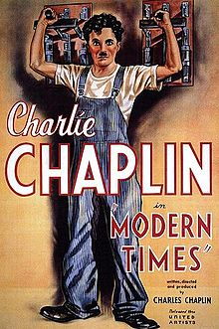
Charlie Chaplin’s silent film, Modern Times, is a commentary on the desperate employment and fiscal conditions many people faced during the Great Depression—conditions created, in Chaplin's view, by the efficiencies of modern industrialization. As a film created well after the takeover of “talkies,” films with sound, Chaplin’s choice to keep the movie silent becomes a part of the commentary itself, serving as a reminder of the recent technological changes of the time. Modern Times was deemed "culturally significant" by the Library of Congress in 1989.
In Modern Times, Chaplin portrays an assembly line worker who has a nervous breakdown after being forced to work with malfunctioning machines. The resulting chaos he creates at the factory prompts his boss to commit him to a mental hospital.
After being released from the hospital, Chaplin stumbles into the middle of a Communist demonstration and manages to end up innocently marching with the Communists while waving a red flag. Mistaken for one of the demonstrators, the police arrest him, but he’s not in jail for long. After a series of mishaps that lead him to foil a jailbreak, Chaplin is hailed as a hero and is released.
Free again, Chaplin tries to find a new job but in doing so, runs into Ellen, who is being chased by police. From that moment through the end of the film, their stories are intertwined as Ellen and Chaplin struggle to survive the Great Depression by taking odd jobs, resorting to illegal activity, and making their ways in and out of jail multiple times.
After struggling throughout the movie and getting nowhere, Ellen asks, “What’s the use of trying?” Chaplin gives her no answer, but he reassures her that they will continue as they always have before. The two walk arm-in-arm together down an empty road, facing the empty horizon and a wide-open future.

The Jazz Singer, 1927
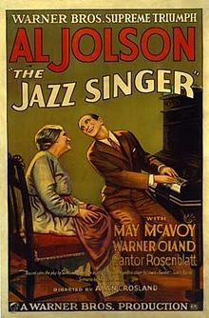
The Jazz Singer was the first feature-length talkie, early slang for a film with featuring an integrated audio component. The film signaled the rising popularity of talkies and the end of the silent film era. The film is also notable for Jakie’s donning of “blackface,” a common practice at the time when white performers would darken their faces to perform traditionally “Black songs” and prejudiced skits in places where African Americans were not typically accepted.
The story, based on Samson Raphaelson’s play, The Day of Atonement, chronicles the life of Jakie Rabinowitz (played by Al Jolson). Finding a love for jazz music, Rabinowitz defies his family’s plans for him to take on his father’s career and become a Jewish cantor, a religious official who leads the congregation in prayer through song.
After singing popular tunes in a beer garden, 13-year-old Jakie is punished by his cantor father for “misusing” his voice. As a result, Jakie runs away from home.
Around a decade later, now calling himself “Jack Robin,” Jakie has become a talented jazz singer and is offered his first big break—a leading role in a new musical. Jakie returns home to show his aging father what he’s been able to accomplish; but the elder Rabinowitz hasn’t changed his mind and kicks his son out, saying that he never wants to see the young man again. Then, only 24 hours before his musical opens, Jakie learns that his father has fallen gravely ill and needs him to sing the Kol Nidre for Yom Kippur in his place. Torn, Jakie must decide between his religion and family and his ambitions.
In rehearsals that night, Jakie’s mother finally sees him on stage and admits that on-stage, not in a religious house, is where Jakie belongs; but despite her revelation, Jakie ultimately decides to sing the Kol Nidre in his father’s stead, and the musical does not open that night. With his dying breath, Jakie’s father forgives him, saying, “Mama, we have our son again.”

