Religion
Background
The 1920s clash between modern and traditional values came to a highly publicized head in the 1925 legal battle between the State of Tennessee and substitute teacher John Thomas Scopes. On the surface, the Scopes “Monkey” Trial was about enforcing Tenessee’s Butler Act, which made it illegal to teach evolution in state-funded schools; but the legal battle drew national attention for publicizing the Fundamentalist-Modernist Controversy, a Christian dispute in the 1920s and ‘30s over the role of religion and its expression in modern culture.
The trial began on July 10, and quickly attracted spectators, national reporters, and preachers who evangelized from revival tents along Dayton, Tennessee’s, main street. Soon, other groups arrived to capitalize on the crowd. Exhibit tents and vendors, selling everything from Bibles to hot dogs, created a carnival-like atmosphere in front of the courthouse.
In Rhea County Courthouse, the climate was not much different. Each side was represented by a famous advocate. Fundamental champion and three-time democratic presidential nominee, William Jennings Bryan, represented the state’s argument while the agnostic defense attorney Clarence Darrow joined the ACLU to defend Scopes. And though Judge Raulston declared scientific testimony inadmissible in an attempt to divert focus from the Butler Act itself and onto Scopes’ violation of it, the arguments of these lawyers still centered on interpretations of the Bible and the validity of the theory of evolution.
In the end, Scopes was found guilty of violating the Butler Act and was fined $100 for it, the minimum amount for violating the law. Anti-evolutionists claimed the win as a victory for traditional, fundamentalist opinion, but the press reported that Scopes and the ACLU won the true argument. The ruling was overturned in 1927 on a technicality, but the Butler Act remained in effect for another 42 years.

  - Resources
  - Scopes Trial. (n.d.). In Wikipedia. Retrieved from https://en.wikipedia.org/wiki/Scopes_Trial
  - Fundamentalist-Modernist Controversy. (n.d.). In Wikipedia. Retrieved from https://en.wikipedia.org/wiki/Fundamentalist%E2%80%93Modernist_Controversy
  - PBS. (2001). Scopes Trial. In Evolution Library. Retrieved from http://www.pbs.org/wgbh/evolution/library/08/2/l_082_01.html
  - History.com Staff. (2009). Monkey Trial begins. Retrieved from http://www.history.com/this-day-in-history/monkey-trial-begins
  - Digital History. (2016). The Scopes Trial. In Digital History. Retrieved from http://www.digitalhistory.uh.edu/disp_textbook.cfm?smtID=2&psid=3390
Document A:
Hell and the High Schools, by T.T. Martin, Evangelist, 1923 (Excerpt)
Chapter IX “The Responsibility of Fathers and Mothers for Evolution Being Taught to Their Children,” pp. 160-164
Note: Evangelist T. T. Martin from Mississippi lectured on street corners and sold copies of his popular book, “Hell and the High Schools” (excerpt below), during the Scopes Trial in 1925:
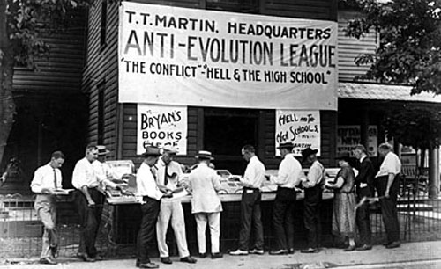
  - Licht, M. (1925). Anti-Evolution League, at the Scopes Trial, Dayton Tennessee from Literary Digest, July 25, 1925. Retrieved from https://commons.wikimedia.org/wiki/File:Anti-EvolutionLeague.jpg
Fathers and Mothers!
DO YOU remember the first faint cry from a tiny little life, when the doctor told you that you were a parent? Can you ever forget the thrill, the inexpressible joy? No language can ever describe it. Did you realize then that there was a being whom you had brought into existence who would spend eternity in Heaven or in hell? Do you realize it now? Do you realize your responsibility for the eternal destiny of that child? Do not hide behind excuses; do not try to shirk responsibility; do not, as the ostrich, when about to be captured, who sticks his head in the sand, to avoid capture, try to escape by sticking your head in the sands of infidelity and saying you do not believe there is any hell. There is as much evidence for believing there is a hell as for believing there is a heaven.
. . .
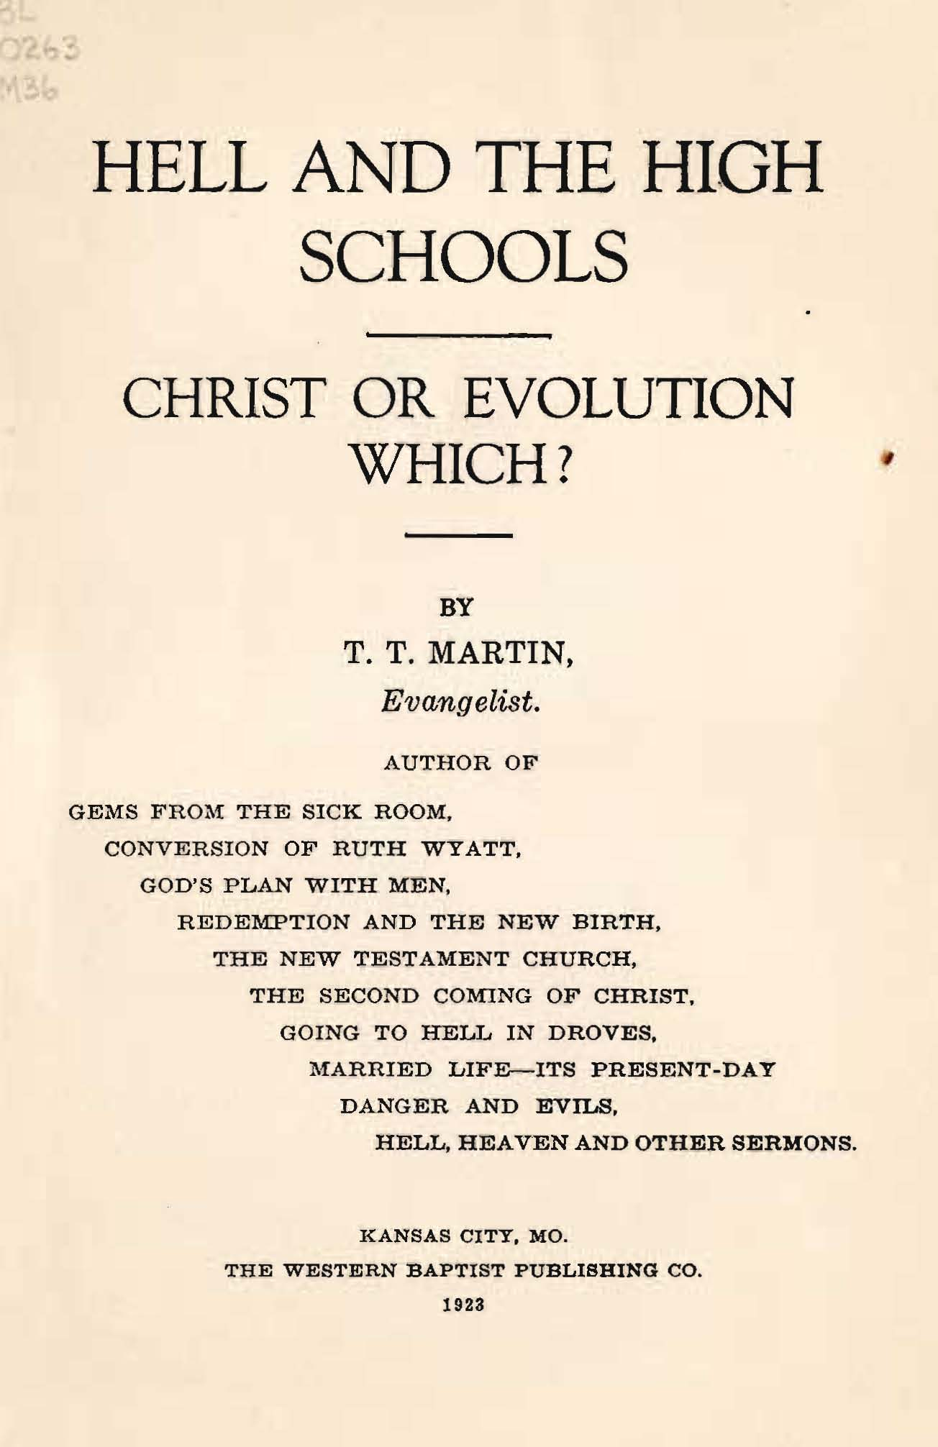
Do you realize not only the duty but the privilege of keeping out of your child's life every influence that could possibly lead to its spending eternity in hell, and of putting into its life every possible influence that would lead to its spending eternity in heaven?
. . .
But what have the High Schools of the land to do with the child spending eternity in hell? Many books being taught in the High Schools teach Evolution—that all species or kinds of beings, from the smallest insects up to man, have developed, evolved, from the lower species up to the higher; that the first living thing, not as large as the point of the finest needle, only one one-hundred-and-twentieth part of an inch in diameter, multiplied for ages, each generation differing very slightly, until a new species or kind was evolved, developed; and that this process continued till at last man was evolved; that the first man was "midway between the anthropoid ape and modern man;" that the first man did not speak a plain language, but chattered as animals in trees, having only exclamation of pain or pleasure. If this is true, then Jesus Christ was the bastard, illegitimate son of a fallen woman, not Deity, not really God's son . . .
It is in your power to save your children from this deadly, soul-destroying teaching. The Baptist, Catholic, Congregational, Disciple, Episcopalian, Lutheran, Methodist, Presbyterian and other fathers and mothers can, in twelve months, drive Evolution out of every tax-supported school in America and out of every denominational school. Will they do it?
. . .
Yet the fathers and mothers of America, some to appear "broad and liberal," some to appear "up-to-date," some, because brow-beaten by these Evolutionist high-brows and their pussy-footing apologists and defenders, are standing silently by while our children are being eternally damned.

  - Martin, T. T. (1923). The responsibility of fathers and mothers for evolution being taught to their children. In Hell and the high schools (pp. 160-164). Kansas City, MO: The Western Baptist Publishing, Co. Retrieved from http://darrow.law.umn.edu/documents/Hell_and_the_High_Schools_OCR_Opt.pdf
  - Public domain.

Document B:

Clarence Darrow questioning William Jennings Bryan at the Scopes Trial (excerpt)

June 1925
Mr. Darrow: Do you claim that everything in the Bible should be literally interpreted?
Mr. Bryan: I believe everything in the Bible should be accepted as it is given there; some of the Bible is given illustratively. For instance: "Ye are the salt of the earth." I would not insist that man was actually salt, or that he had flesh of salt, but it is used in the sense of salt as saving God's people.
Mr. Darrow: But when you read that Jonah swallowed the whale—or that the whale swallowed Jonah—excuse me please—how do you literally interpret that?
. . .
Mr. Bryan: One miracle is just as easy to believe as another . . .
Mr. Darrow: Perfectly easy to believe that Jonah swallowed the whale?
. . .
Mr. Bryan: Your honor. I think I can shorten this testimony. The only purpose Mr. Darrow has is to slur at the Bible, but I will answer his question. I will answer it all at once, and I have no objection in the world, I want the world to know that this man, who does not believe in God, is trying to use a court in Tennessee—
Mr. Darrow: I object to that.
Mr. Bryan: (Continuing) to slur at it, and while it will require time, I am willing to take it.
Mr. Darrow: I object to your statement. I am exempting you on your fool ideas that no intelligent Christian on earth believes.

  - Day 7. (1925). In Famous Trials in American History: Tennessee vs. John Scopes the “Monkey” Trial. Retrieved from http://law2.umkc.edu/faculty/projects/ftrials/scopes/day7.htm

Document C: Billy Sunday on Prohibition

Overview of prohibition.
On January 16, 1920, the ratified 18th Amendment went into effect, banning the making, transport, and sale of alcohol in the United States.
Supporters of prohibition were concerned about the impact of drinking on labor productivity, worried about the connection between wife and child abuse and the use of alcohol, and included those religious supporters who saw drinking as a sin(Mintz & McNeil, 2016). “Advocates of Prohibition argued that outlawing drinking would eliminate corruption, end machine politics, and help Americanize immigrants” (Mintz & McNeil, 2016). But, the amendment had unintended consequences.
Though the elimination of legal alcohol did initially reduce alcohol-related crimes and significantly reduce the number of people who drank (Moore, 1989), it opened the door to a new world of organized crime centered around producing and distributing “rotgut” alcohol, quickly and poorly made alcohol created cheaply with the sole intention of inebriating the user. Deaths due to alcohol poisoning rose over 400%, due to the poor quality of black-market alcohol, and the police quickly became so overwhelmed with keeping the new black market in check that they were unable to use their resources to properly fight other crime (Nash, n.d.).
After costing the United States billions of dollars and, in the end, failing to enforce sobriety (History.com Staff, 2010), on December 5, 1933, the United States ratified the 21st Amendment to repeal prohibition, 13 years after prohibition began.
Note: Billy Sunday was an intense evangelist who traveled the country in the early part of the 20th century giving fiery sermons. The following is his reaction to the ratification of the 18th amendment:
“The reign of tears is over. The slums will soon be only a memory. We will turn our prisons into factories and our jails into storehouses and corncribs. Men will walk upright now, women will smile, and the children will laugh. Hell will be forever for rent.” (Sunday, 1920)
  - History.com Staff. (2010). Prohibition ends. Retrieved from http://www.history.com/this-day-in-history/prohibition-ends
  - Sunday, B. (1920). In T. Lynch (Ed.) In the Name of Justice: Leading Experts Reexamine the Classic Article "The Aims of the Criminal Law” (p. 183). Washington, DC: Cato Institute.
  - Mintz, S., & McNeil, S. (2016). Prohibition. Digital History. Retrieved from
http://www.digitalhistory.uh.edu/disp_textbook.cfm?smtID=2&psid=3383
  - Moore, M. H. (1989, October 16). Actually, prohibition was a success. The New York Times. Retrieved from http://www.nytimes.com/1989/10/16/opinion/actually-prohibition-was-a-success.html
  - Nash, T. (n.d.) Organized crime in the 1920’s and prohibition. The Finer Times. Retrieved from http://www.thefinertimes.com/20th-Century-Crime/organised-crime-in-the-1920s.html

Document D: Prohibition Political Cartoon, Reader’s Digest, 1923

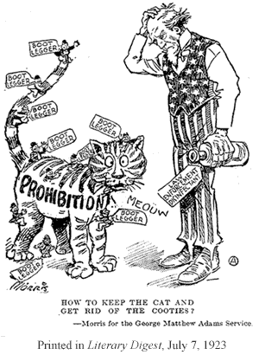

  - Morris. (1923, July 7). Literary Digest (p. 12). Retrieved from https://ehistory.osu.edu/sites/ehistory.osu.edu/files/mmh/clash/Prohibition/prohibition-page4.htm

