Women’s Fashions

Photo: Women’s fashions, circa 1915
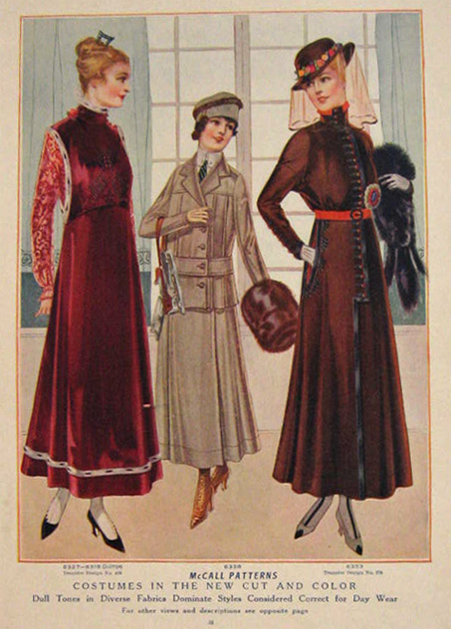

  - McCall Pattern. (1915). Costumes in the new cut and color: Dull tones in diverse fabric dominate styles considered correct for day wear [Image]. Retrieved from http://www.atticpaper.com/proddetail.php?prod=1915-womens-fashion-print-new-cut-and-color
  - Public domain.

Photo 2: Women’s fashions, circa 1922

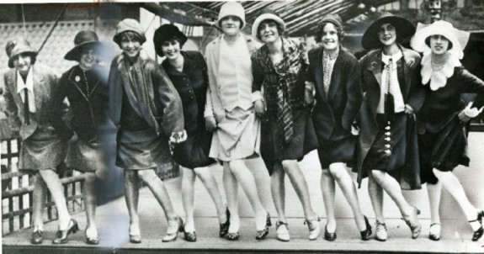

  - As cited in, Spivak, E. (2013). The history of the flapper, part 1: A call for freedom. Retrieved from http://www.smithsonianmag.com/arts-culture/the-history-of-the-flapper-part-1-a-call-for-freedom-11957978/

