Name:________________________________________ Date: _________________

Percents Make Sense Evaluation Worksheet – Possible Solutions for Part 1
Part 1.
Write a brief (3-7 sentences) response to each of the following questions. Draw pictures to illustrate your thinking.
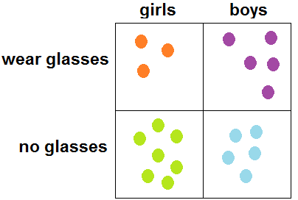
1. What is the difference between asking “What percentage of girls wear glasses” and “What percentage of people who wear glasses are girls?”
Answers will vary, but the key idea is that the two questions have different groups that act as the “whole.” In the first question, the whole is the group of people who are girls; in the second, it’s the group of people who wear glasses. See illustration.

Percentage of girls who wear glasses:
Three girls wear glasses out of a total of 10 (3+7) girls so 3/10 = 30/100 = 30%.

Percentage of people who wear glasses that are girls:
Three girls wear glasses out of 8 (3+5) people who wear glasses: so 3/8 = 37.5/100 = 37.5%.

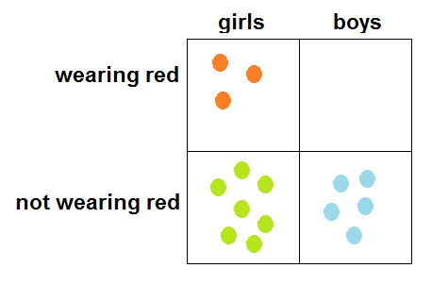
2. What is the smallest percentage possible? How do you know you know there are no smaller percentages?
The smallest percentage possible is 0%. That happens when no member of the “whole” fits the description. For example, if you asked what percentage of boys are wearing red, and no boys were wearing red, then that would be 0%. That’s the smallest because otherwise you’d have to have negative percentages, but that would not make sense.

3. What is the largest percentage possible? How do you know there are no larger percentages?
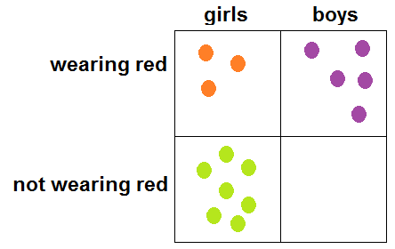
The largest percentage possible is 100%. That represents the situation where everyone in the “whole” shares the same characteristic. For example, if all boys were wearing red, then the percentage of boys wearing red would be 100%. You can’t have a bigger percentage because you can’t have more boys wearing red than there are boys.

