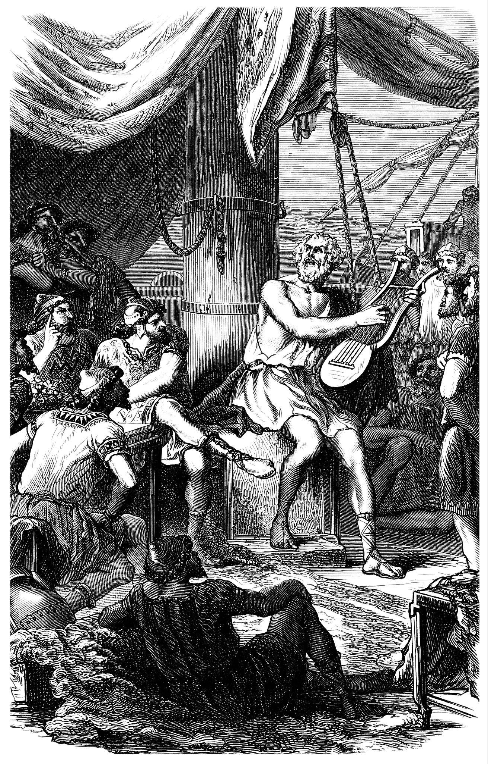
Guilane-Nachez, E. (n.d.). Ancient Greece: Homer [Image]. Adobe Stock. https://stock.adobe.com/images/ancient-greece-homer-homere/52892281
Caption this image!

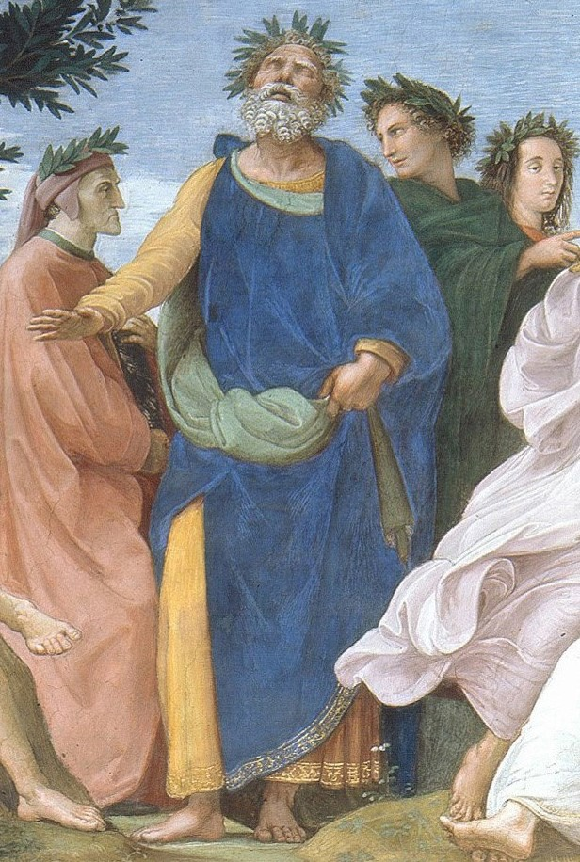
Sanzio da Urbino, R. (1509–1510). The Parnassus [Painting]. Wikipedia. https://en.wikipedia.org/wiki/Homer#/media/File:Cropped_image_of_Homer_from_Raphael%27s_Parnassus.jpg
Caption this image!

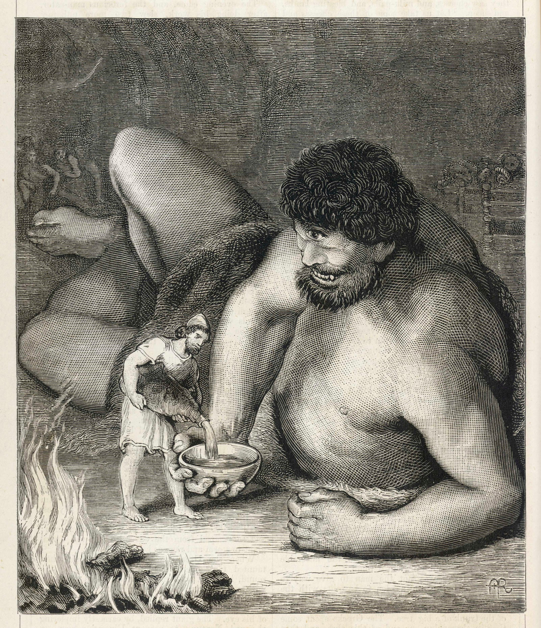
Archivist. (n.d.). Odyssey - Polyphemus [Image]. Adobe Stock. https://stock.adobe.com/images/odyssey-polyphemus/162342057

Caption this image!

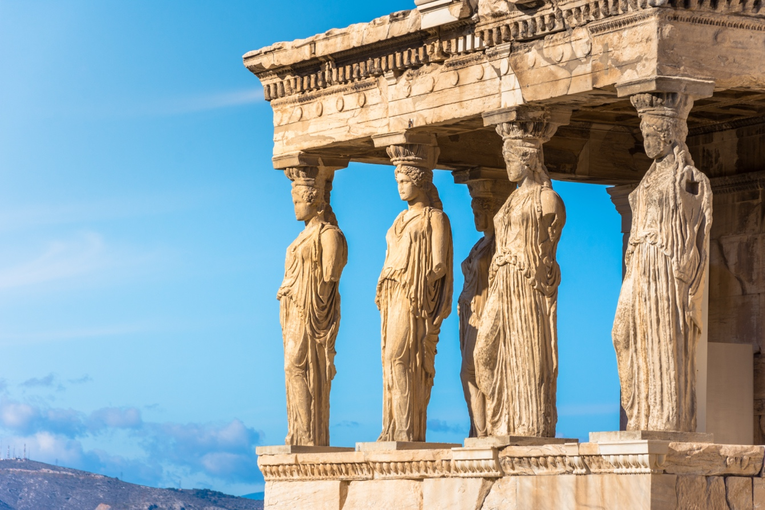
gatsi. (n.d.). Karyatides statues, Erehtheio, on the Acropolis in Athens, Greece [Image]. Adobe Stock. https://stock.adobe.com/images/karyatides-statues-erehtheio-on-the-acropolis-in-athens-greece/186420010

Caption this image!

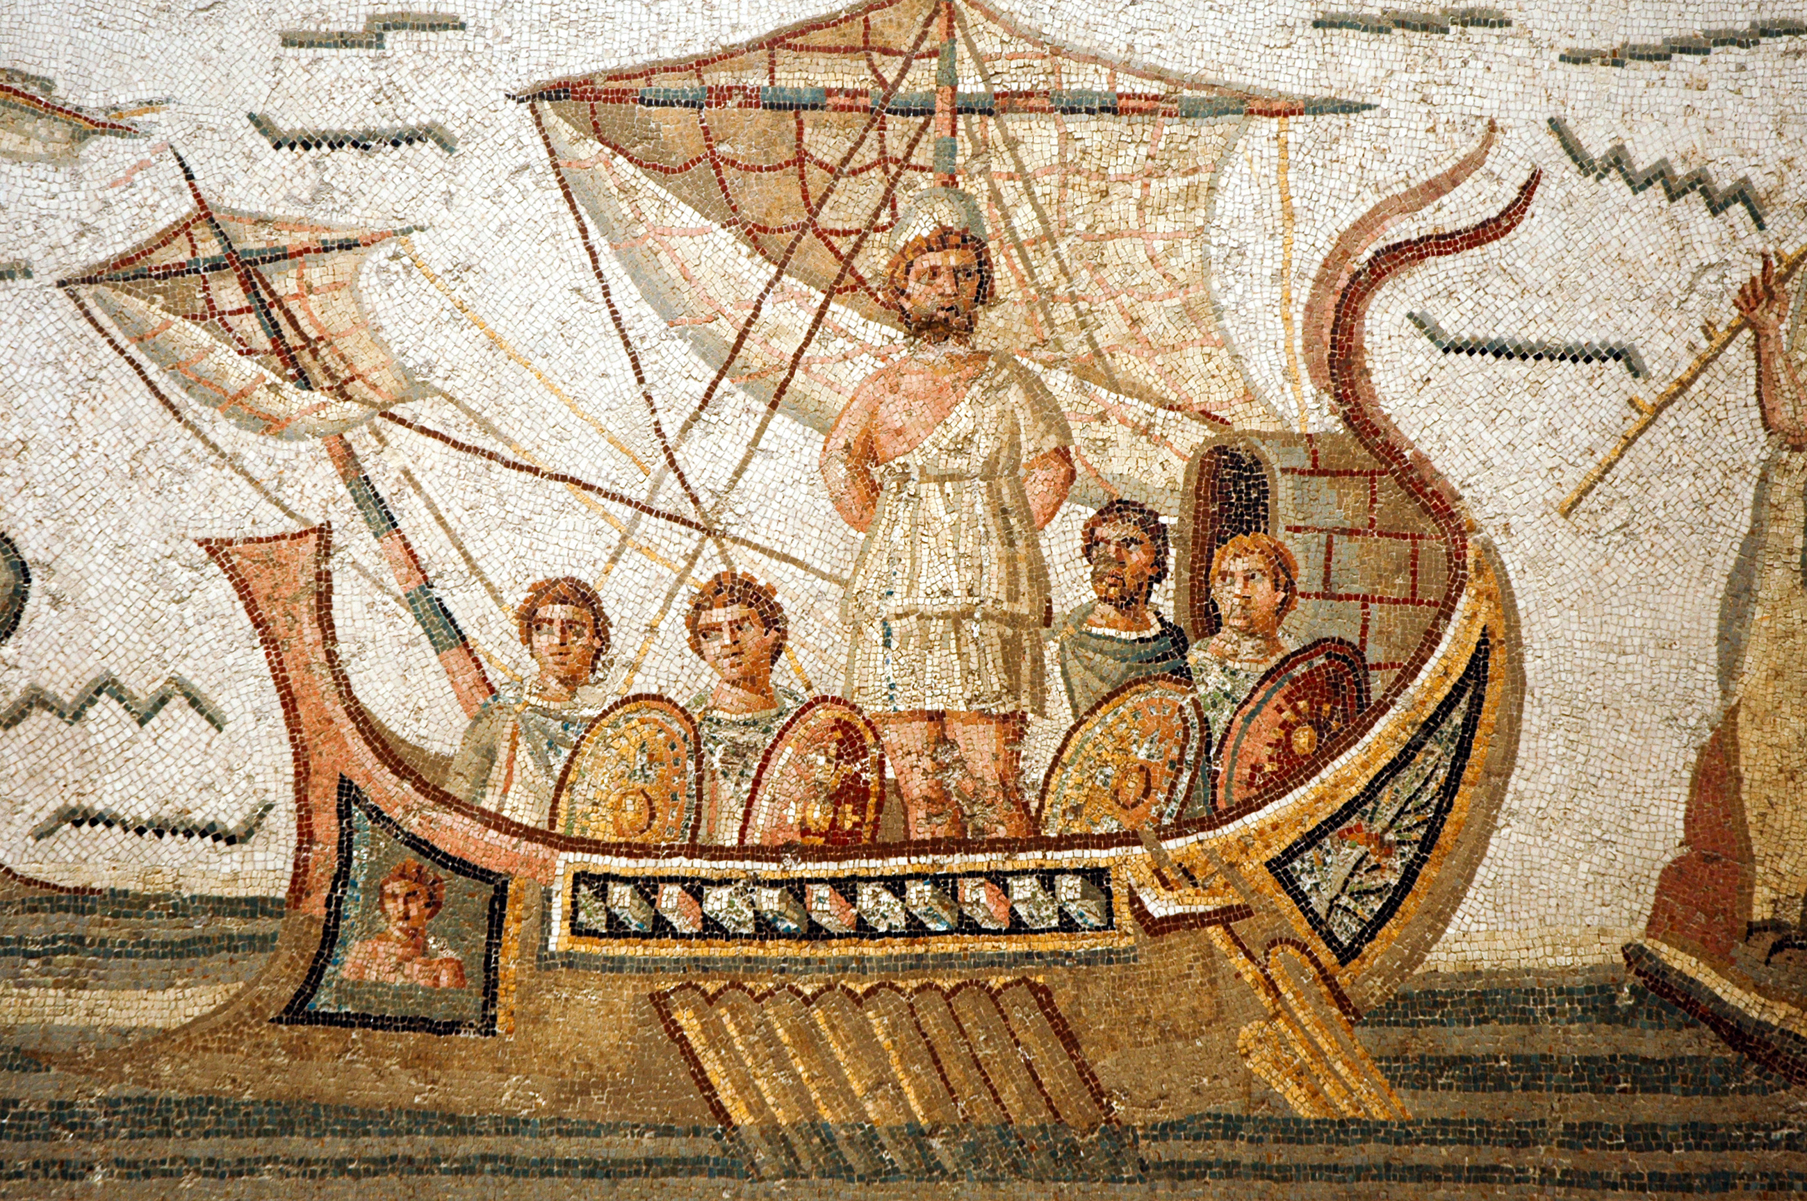
Fotokon. (n.d.). Mosaic scene from Homer’s Odyssey in Bardo Museum, Tunisia [Image]. Adobe Stock. https://stock.adobe.com/images/mosaic-scene-from-homer-s-odyssey-in-bardo-museum-tunisia/41470645?prev_url=detail

Caption this image!

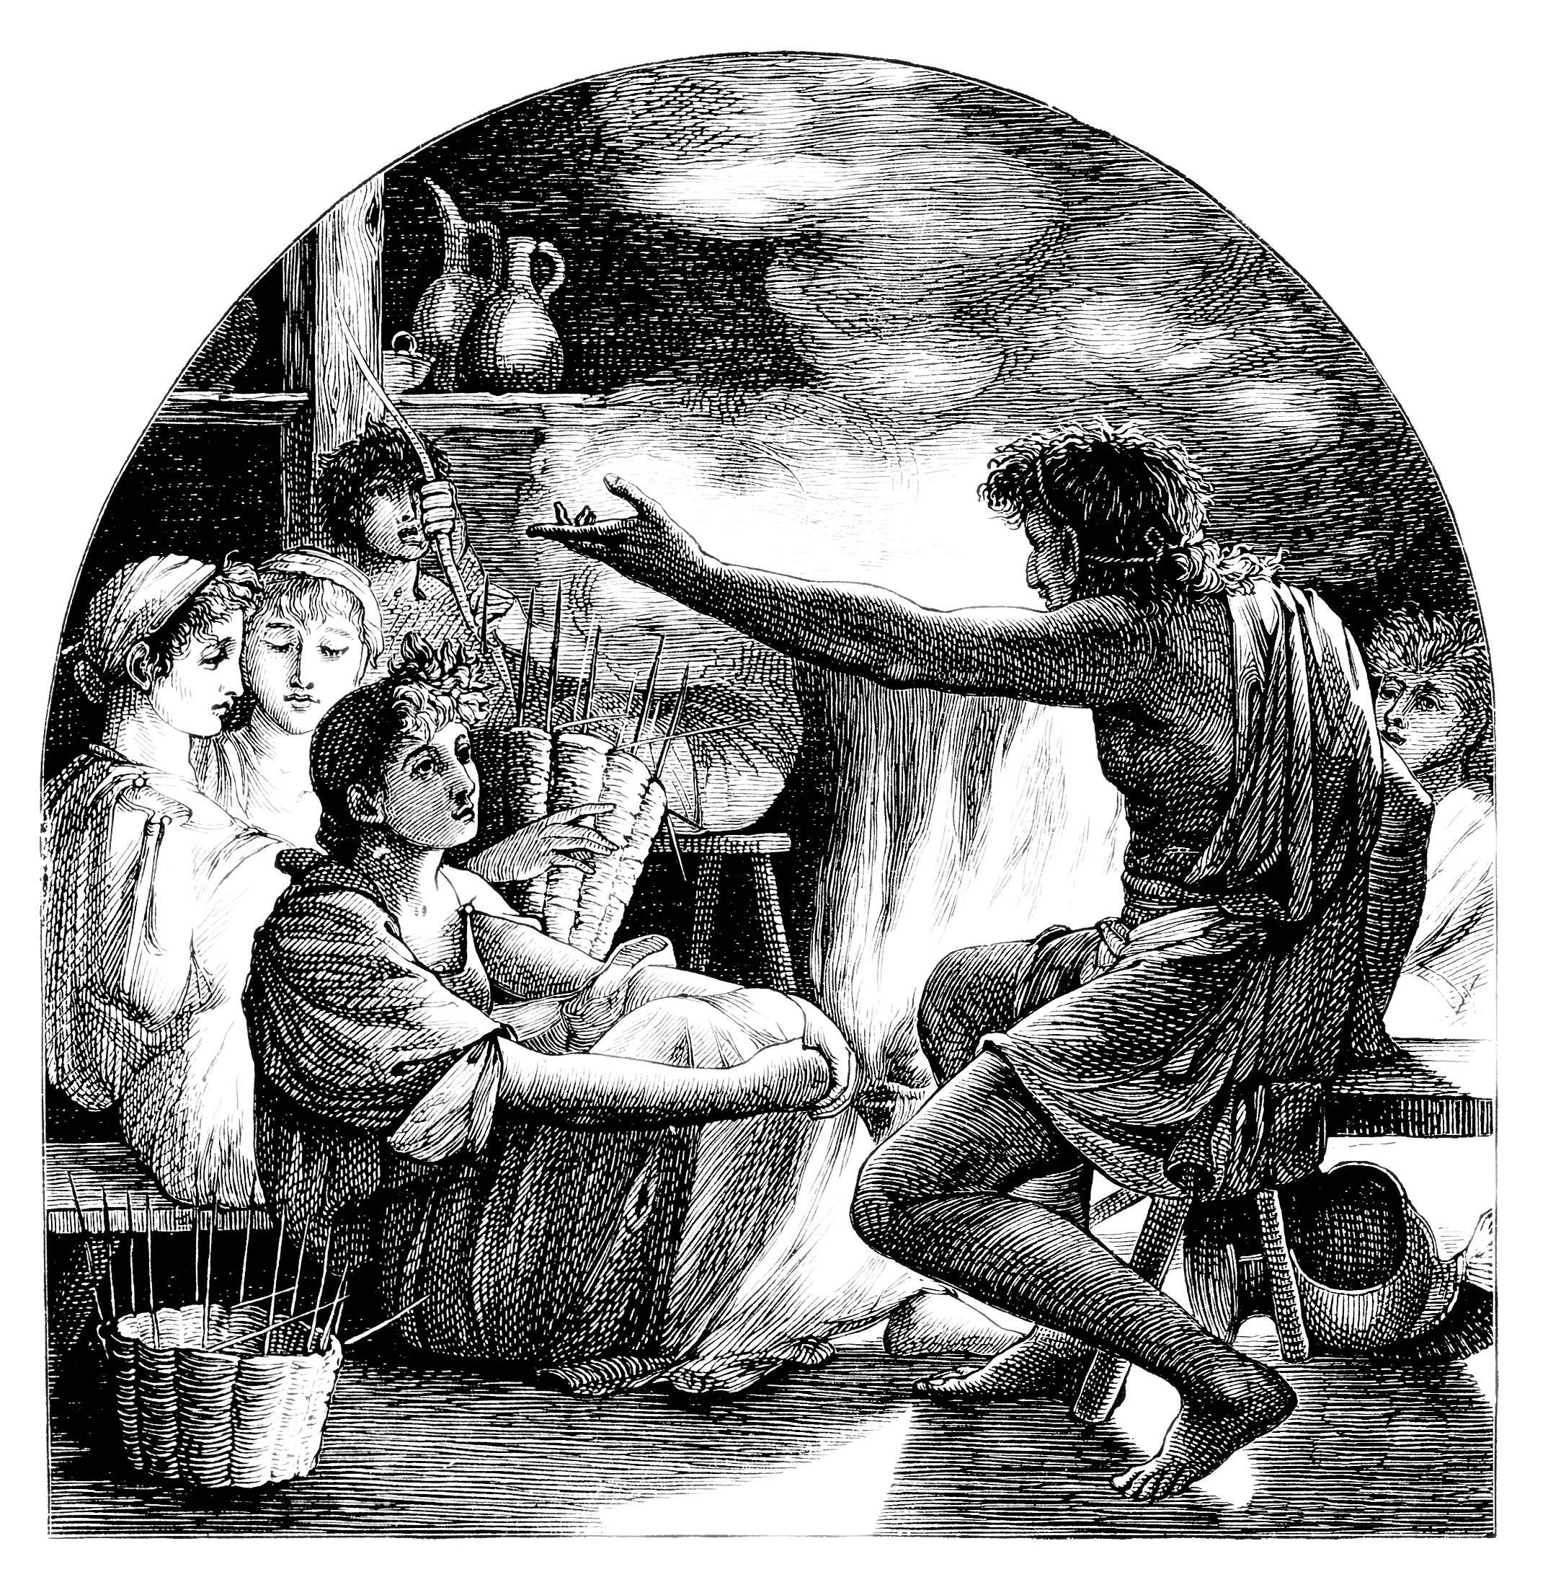
Guilane-Nachez, E. (n.d.). Antiquity: Story-teller - conteur [Image]. Adobe Stock. https://stock.adobe.com/images/antiquity-story-teller-conteur/44888883

Caption this image!

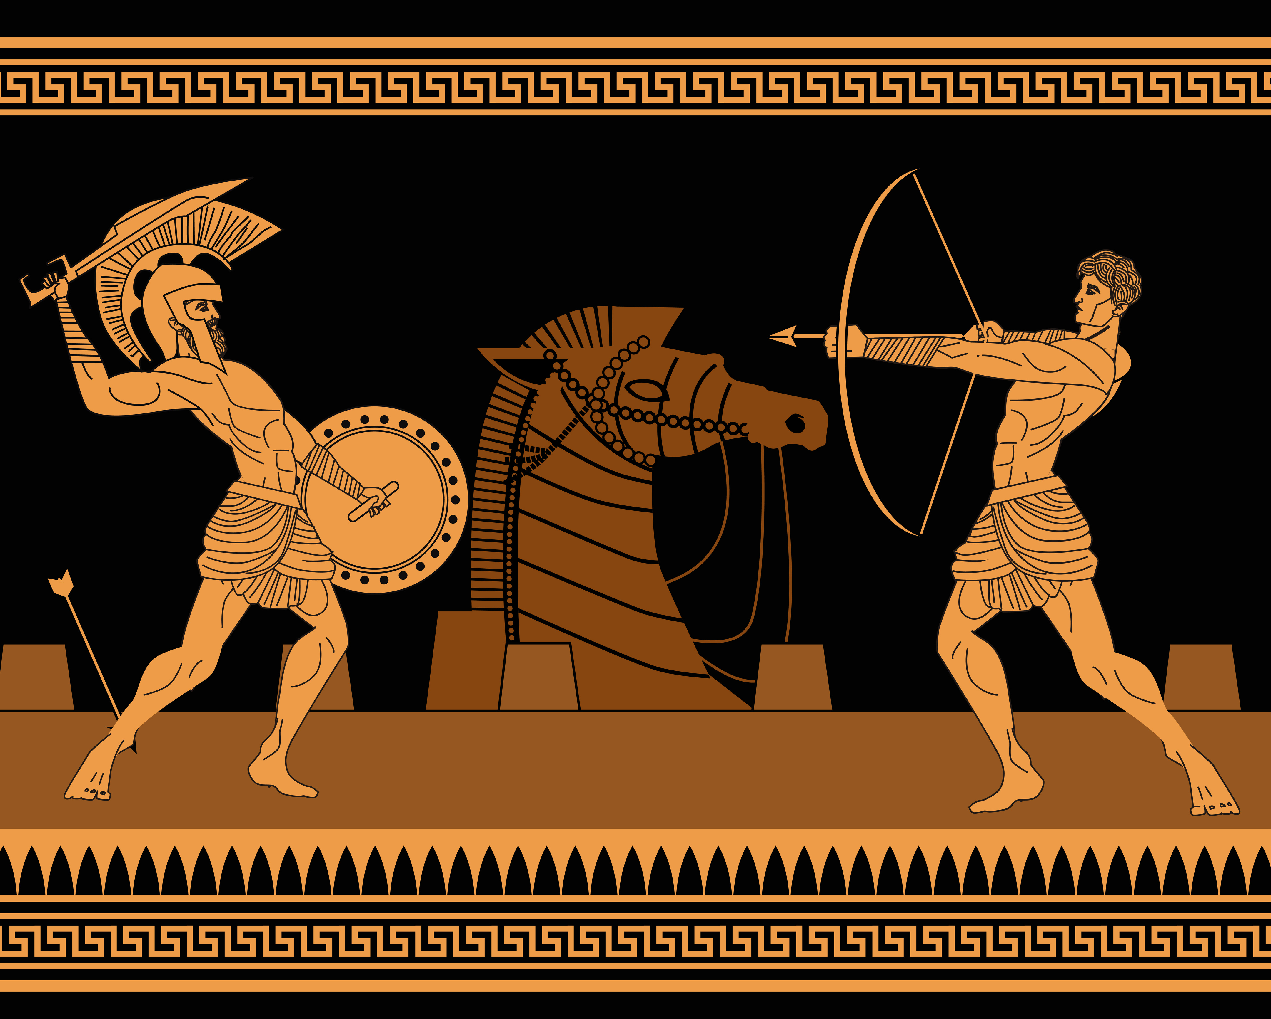
Matiasdelcarmine. (n.d.). Orange and black figures pottery amphora painting of troy war with achilles fighting [Image]. Adobe Stock. https://stock.adobe.com/images/orange-and-black-figures-pottery-amphora-painting-of-troy-war-with-achilles-fighting/365530055

Caption this image!

