Street Art

Meek, 2004, placed near Sundance Festival
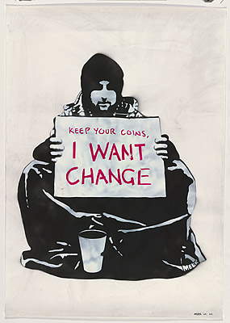

  - Meek. (2004). Begging for change (Image). National Gallery of Australia. Retrieved from http://nga.gov.au/exhibition/SPACEINVADERS/Default.cfm?IRN=162193&BioArtistIRN=33679&MnuID=4&GALID=33679&viewID=3&DTLVIEW=TRUE

