Quick-to-See Smith’s Art for Analysis

Artwork 1: Flathead Vest

Smith, J. Q-. t-. S. (1996). Flathead vest: Father and child [Painting]. Missoula, MT: Missoula Art Museum. Retrieved from http://missoulaart.pastperfect-online.com/36919cgi/mweb.exe?request=record;id=10B95593-45D8-414E-9E6A-645039211641;type=101

Artwork 2: Ode to the Chief Seattle



Smith, J. Q-. t-. S. (1991). Ode to Chief Seattle [Lithograph]. Missoula, MT: Missoula Art Museum. Retrieved from http://missoulaart.pastperfect-online.com/36919cgi/mweb.exe?request=record;id=FA68A456-6B46-4BEA-B1E7-164757597140;type=101

Artwork 3: Indian Men Wear Shirts and Ties

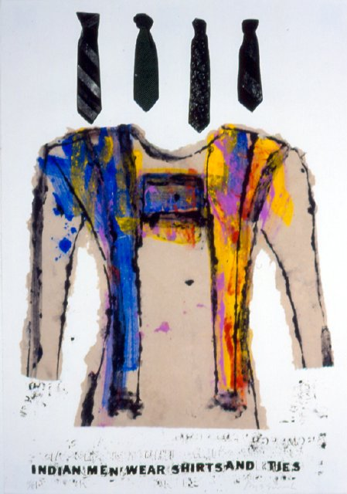

*Indian Men Wear Shirts and Ties, lithograph, ca. 1997, “41.75 X 29.25’*

Smith, J. Q-. t-. S. (1997). Indian men wear shirts and ties [Lithograph]. Missoula, MT: Missoula Art Museum. Retrieved from http://missoulaart.pastperfect-online.com/36919cgi/mweb.exe?request=record;id=61D97740-A703-4F36-AE45-971619371694;type=101