Bill of Rights Art Examples
René Magritte, “The Son of Man” (1964)

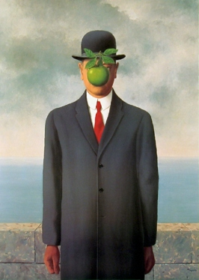

  - Magritte, R. (1964). The son of man [Painting]. Retrieved from: http://www.renemagritte.org/the-son-of-man.jsp

Banksy, “Girl and a Soldier” (2007)

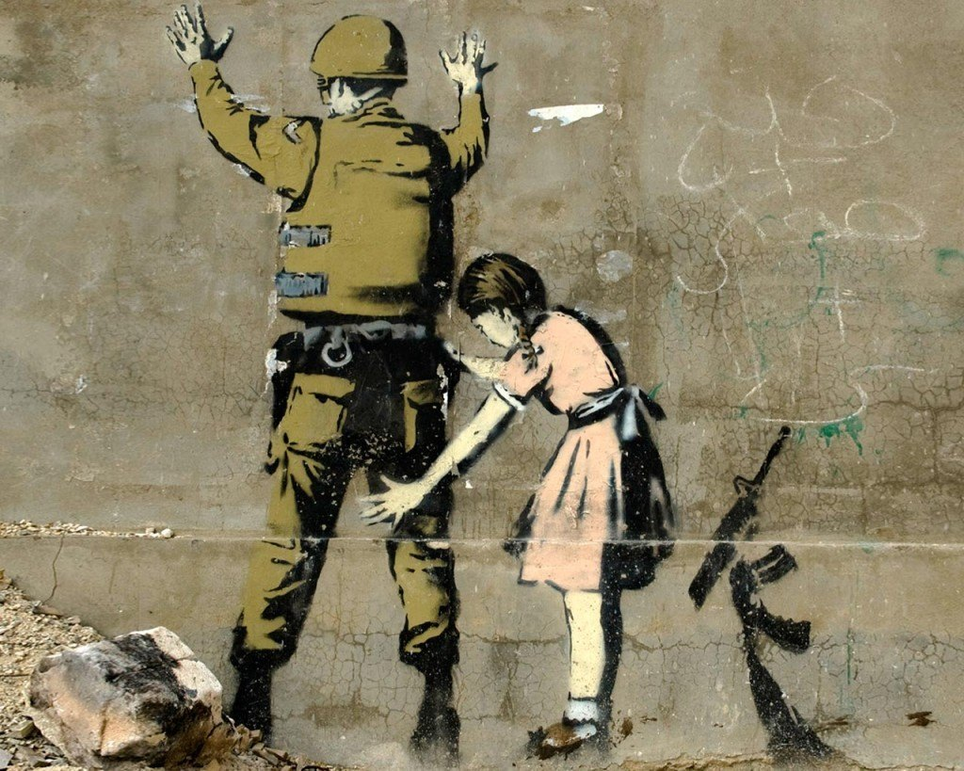

  - Banksy. (2007). Girl and a soldier [Painting]. West Bank, Bethlehem. Retrieved from http://www.stencilrevolution.com/banksy-art-prints/girl-and-soldier/

Marcellous Lovelace (with BLK75), “I Am Man” Mural (2014)

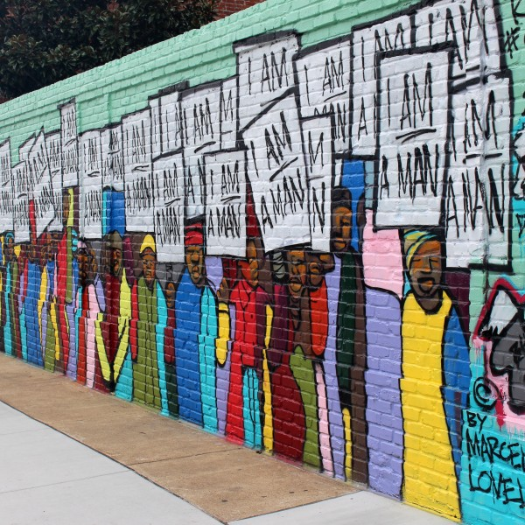

  - Lovelace, M. (2014). I am a man [Painting]. Memphis Art Project. Retrieved from http://www.memphisart.org/tag/marcellous-lovelace/

