The ADvantage of SAving With Compound Interest
Saving for the future is not always the top priority for someone who is working. There are often other concerns such as taking care of food and paying bills or rent. Saving just may not sound very glamorous—until you understand compound interest!

WHAT IS INTEREST?
Interest is the financial benefit when lenders loan out money. Banks charge interest when they lend money for mortgages or car loans, and credit card companies charge interest when you carry a balance of debt on your card. You can earn interest from a bank if you have a savings account. The bank is rewarding you with interest for leaving your money in the bank and agreeing not to withdraw it for a certain amount of time.
There are two types of interest: simple and compound. If you have $1,000 in a savings account that pays you 3% simple interest annually, you will earn $30 each year. With compound interest, you would get $30 in your first year, but then you would collect 3% of $1,030 the next year, or $30.90. The third year you will have $1060.90 in your account and collect 3% of that, or $31.82.

BENJAMIN FRANKLIN’S EXPERIMENT IN COMPOUND INTEREST
Consider Benjamin Franklin’s test. Benjamin Franklin believed in saving, and the adage of “a penny saved is a penny earned” is attributed to him. In 1790, the Founding Father created an experiment. In his will, he left 1,000 pounds of sterling each to the cities of Boston and Philadelphia. The money was to be invested at the simple interest rate of 5% annually for 100 years. He asked that up to three-fourths of the money after 100 years be used to establish trade schools or loans for students in trade schools, but that the remainder be reinvested for another 100 years. Both cities over time could not maintain the 5% interest rate that Franklin asked for because interest rates vary. Due to compound interest and the amount of principal that was reinvested, both Boston and Philadelphia reaped the benefits of Franklin’s experiment. In 1990, Boston had $5.5 million and Philadelphia had about $2.5 million.

WHAT IS COMPOUND INTEREST?
Compound interest allows your initial investment to grow a little faster each year. When the amount grows larger, the interest you earn grows larger, too. In other words, your investment generates earnings, and then those earnings generate earnings of their own. It's a relatively simple concept, but with great possibilities. The longer you leave your investment in an account with compound interest, the more rapidly it will grow.
Compound interest can have a “snowball effect.” If you continue to add more money to your beginning investment, then the compound interest determined by the bank also increases faster.
Here is how it works. Say you put $2,000 in the bank. Each year it stays in the bank, the interest (10% for this example) is added to the principal, or the amount you started with. Then, interest is earned on the NEW principal amount. Consider what your amount would be if you added just $50 to the principal monthly.
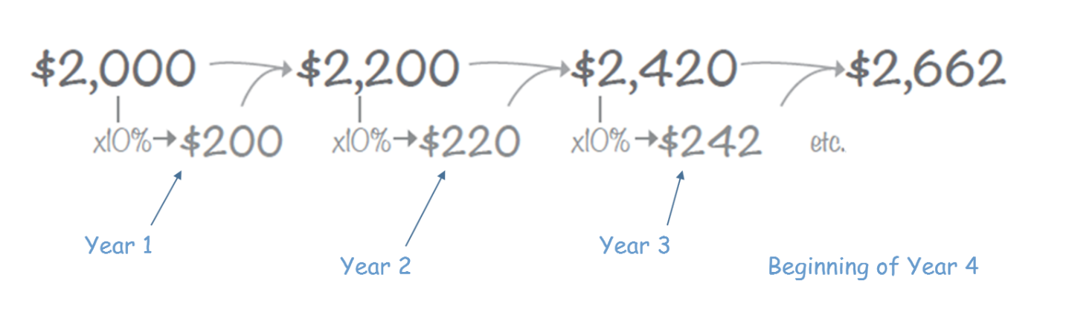
You can also use a math formula to find out the result of saving with compound interest. Interest rates can be compounded annually, quarterly, monthly, or daily. That is the period (n). The more often the interest compounds, the higher the future value.
n
FV = PV x (1 + r)
Future Value (FV) is equal to Present Value (PV) times one plus the interest rate (1 + r) raised to the exponent of the number of interest payments (n). We can use the savings above as an example. If we keep our money in the bank for three years, we will have $2,662.
2,662 = 2,000 x (1 +.10)³
Start with your interest rate and multiply exponentially: (1.10)³ = 1.10 x 1.10 x 1.10 = 1.331
Multiply that value by the principal savings (2,000).
Sources:
Segal, T. (n.d.). Compound interest. Investopedia. https://www.investopedia.com/terms/c/compoundinterest.asp
Glydon, N. (n.d.). Making money with Benjamin Franklin. Math Central. University of Regina. http://mathcentral.uregina.ca/beyond/articles/CompoundInterest/Money.html
Benjamin Franklin Historical Society (2014). Legacy. http://www.benjamin-franklin-history.org/legacy/

