GIST
Read each probability scenario carefully, decide whether it shows experimental probability or theoretical probability. On the back, explain the reasoning for your choice in 28 words or less. Be sure to use vocabulary.
Scenario | Experimental | Theoretical
If you flip a coin 10 times, what is the best prediction possible for the number of times it will land on tails?
A band played an encore at two of its last six shows. What is the probability that the band will play an encore at its next show?
Michael surveyed 16 students at his school and found that eight of them planned to take auto shop as their next elective. What is the probability that a randomly selected student plans to take auto shop?
If you roll a six-sided die six times, what is the best prediction possible for the number of times you will roll a four?
A white-and-green spinner landed on white 10 out of 14 spins. What is the probability that the next spin will land on white?
You pick a card at random
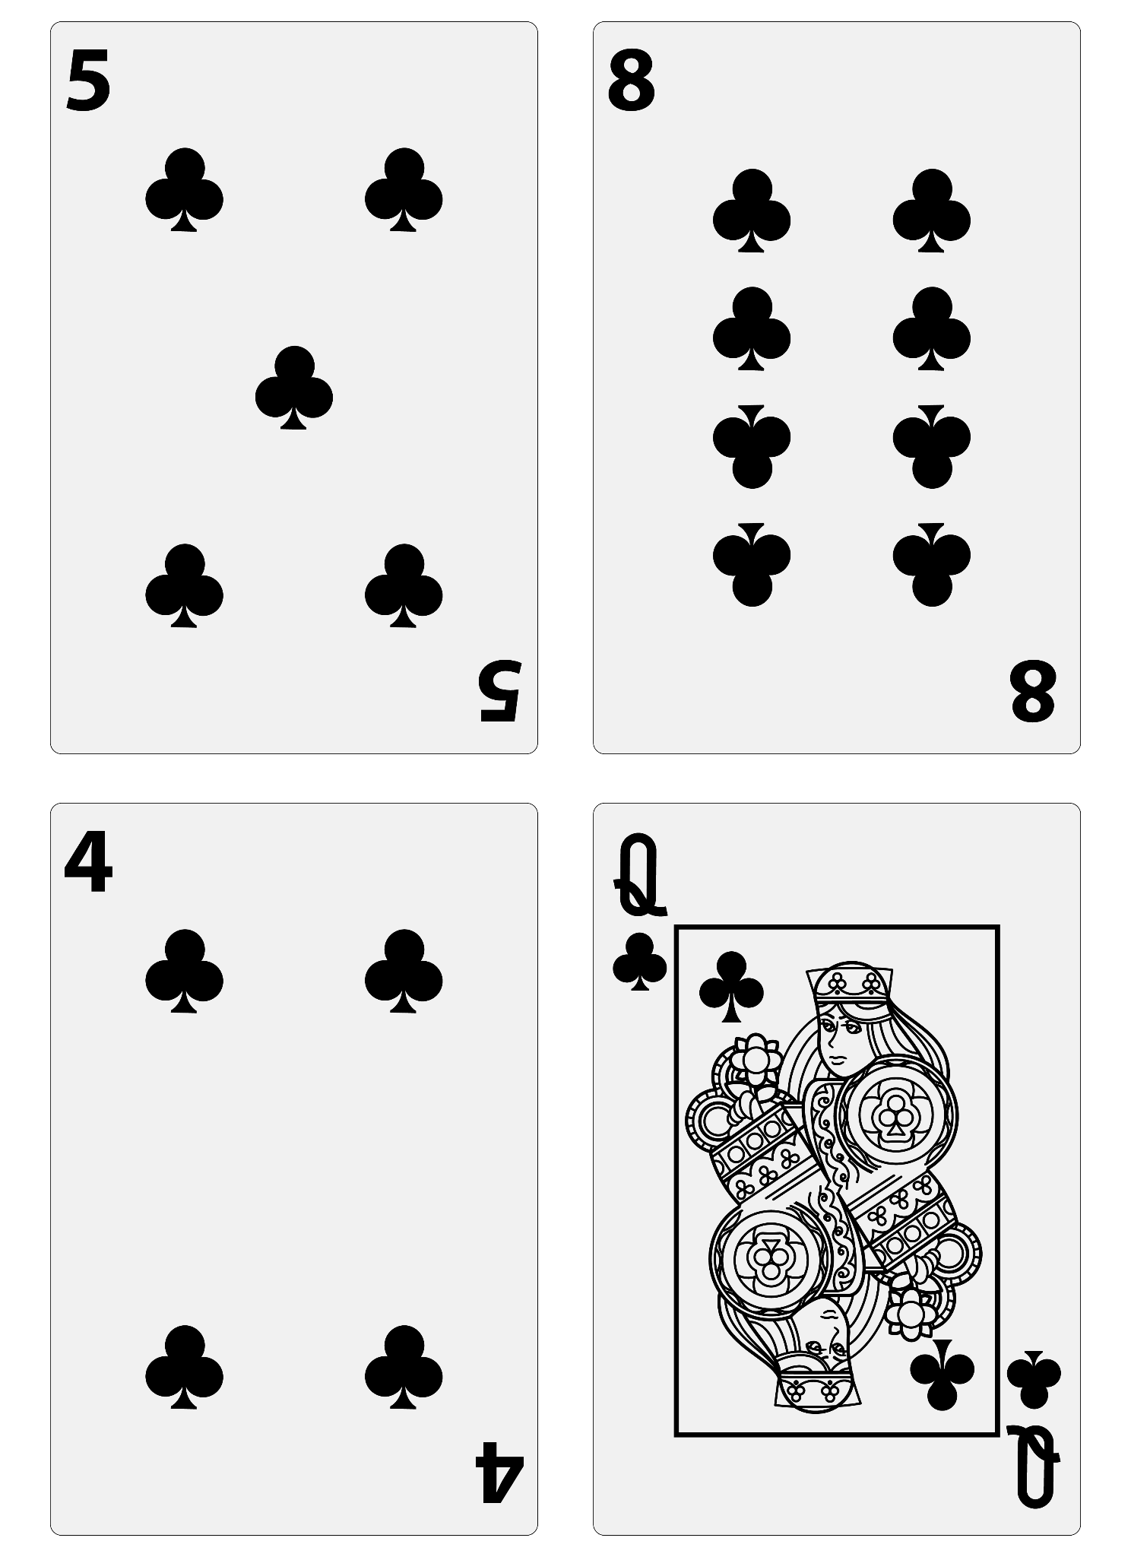
What is the probability of choosing a card less than 5?

Gist

_______________ _______________ _______________ _______________

_______________ _______________ _______________ _______________

_______________ _______________ _______________ _______________

_______________ _______________ _______________ _______________

_______________ _______________ _______________ _______________

_______________ _______________ _______________ _______________

_______________ _______________ _______________ _______________

