Stations journal
Rotate to and complete three different interactive stations.

Balloon Rockets

Materials
- 1 Balloon
- 10-15 foot strand of fishing wire
- 1 plastic straw
- Tape

Directions
- Tie one end of the fishing line to a chair, doorknob, or other support anchor.
- Put the loose end of the fishing line through the straw. Then, tie the loose end to another chair, doorknob, or other support anchor.
- Blow up the balloon—don’t tie it! Pinch the end to keep the air from escaping.
- Tape the balloon to the straw, as shown in the diagram below.
- Release the end of the balloon to launch!

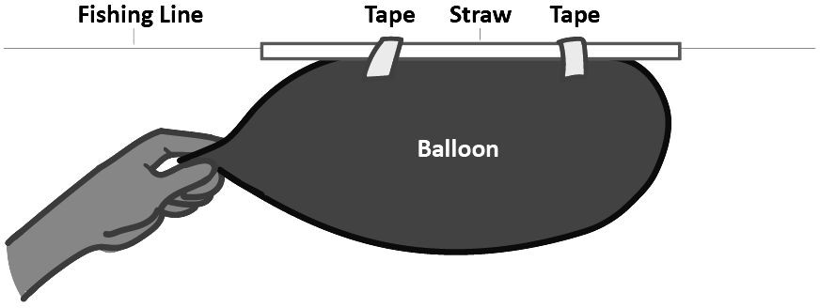

Analysis
- Draw a diagram of your observations of the experiment. Label the balloon, fishing line, and straw. Include arrows to show the direction of forces interacting, air flow, and the balloon’s movement.

- Describe what causes the balloon to move. Then, explain what direction the balloon is moving in versus the direction of the air released from the balloon.

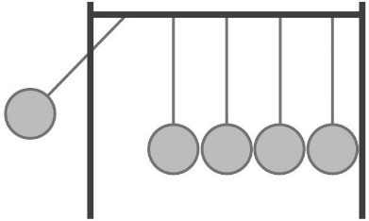
Newton’s Cradle

Materials
- Newton’s Cradle

Directions
Perform each task below and answer the following question.
- What happens when you pick up and release one marble, as in the image above? Why?

- What happens when you pick up and release two marbles on the same side? Why?

- What patterns do you notice about the two questions above?

- Name an example familiar to you, or one you have experienced, that follows the pattern you describe in your answer above.

Double Dice

Materials
- 1 Double Die

Directions
Perform each task below and answer the following question.
- Roll the double die. What number turned up on the outside and inside die?

- Roll the dice again. Did the number on the inside die change?

- How might the double die be like a brain inside a skull?

- What would happen if the internal die were similar in size to the external die?

