Stations journal

Visit each station and participate in each activity based on the directions below. Record your observations and respond to the questions for each station as you work.

# Balloon Rockets

## Materials

* 1 balloon
* 10–15-foot strand of fishing wire
* 1 plastic straw
* Tape

## Directions

* Tie one end of the fishing line to a chair, doorknob, or other support anchor.
* Put the loose end of the fishing line through the straw. Then, tie the loose end to another chair, doorknob, or other support anchor.
* Blow up the balloon, but **don’t tie it**! Pinch the end closed to keep the air from escaping.
* Tape the balloon to the straw, as shown in the diagram below.
* Release the end of the balloon to launch it.

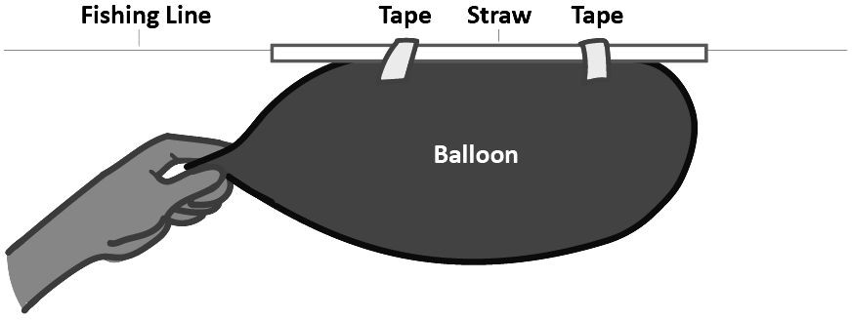

## Analysis

1. Draw a diagram of what you observed during the experiment. Label the balloon, fishing line, and straw. Include arrows to show the direction of forces interacting, air flow, and the balloon’s movement.
2. Describe what caused the balloon to move. Explain which direction the balloon moved and which direction the air was released from the balloon.

# Newton’s Cradle

## Materials

* Newton’s Cradle

## Directions

Perform each task listed below then respond to each question.

1. What happens when you pick up and release one marble, as pictured in the image above? Why did that happen?
2. What happens when you pick up and release two marbles on the same side? Why?
3. What patterns did you notice in the two activities above?
4. Describe an example that you have experienced or are familiar with that follows the pattern you found above.

# Double Dice

## Materials

* 1 double die

## Directions

Perform each task below and answer the following question.

1. Roll the double die. What number turned up on the outside die and the inside die?
2. Roll the dice again. Did the number on the inside die change?
3. How might the double die be like a brain inside a skull?
4. What would happen if the internal die were similar in size to the external die?