The ganges River
The Ganges, sometimes called Mother Ganga, is the second largest river on the Indian subcontinent. Ganges river is named after a Hindu goddess called Ganga. Scholars regard the Ganges as the center of Indian culture, tradition, religious activities, and daily living.

Geography
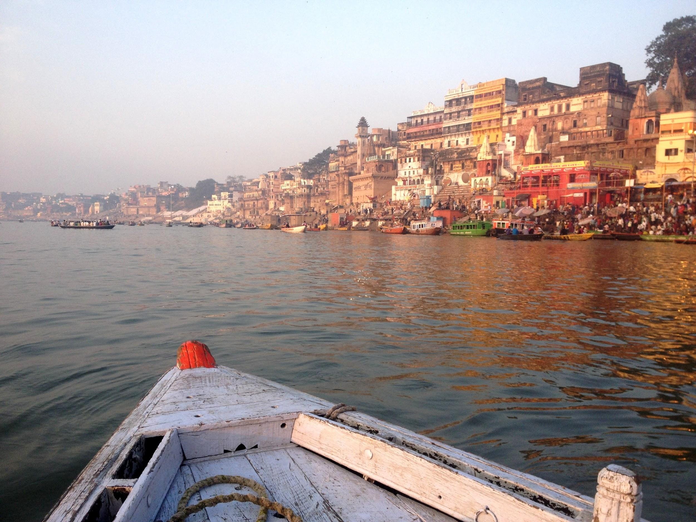
The river starts from a glacier in the Garhwal region of the Himalayas. The Ganges flows through northern India and ends at the Bay of Bengal in eastern India. Overall, it flows 1,569 miles, making it one of the longest rivers in the world. The major rivers which flow into the Ganges are the Brahmaputra River, the Gomti, the Kosi river, the Gandak, the Ghaghra river, the Yamuna river, and the Son river.
The Ganges river passes through the towns of Kanpur, Soron, Kannauj, Allahabad, Varanasi, Patna, Ghazipur, Bhagalpur, Mirzapur, Ballia, Buxar, Saidpur, and Chunar. It accounts for 25% of India’s water resources
Irrigation
The Ganges and its smaller tributaries have been used for irrigation since ancient times. The Ganges-Brahmaputra-Meghna basin has a huge hydroelectric potential, on the order of 200,000 to 250,000 megawatts, nearly half of which could be easily harnessed. As of 1999, India tapped about 12% of the hydroelectric potential of the Ganges.
Photo Source: Nicole West, Unsplash

Religious Significance: Hinduism
Hindus regard the Ganges River as sacred. In Hinduism it is considered holy to make a pilgrimage to one of the holy cities on the Ganges and take a dip. Many Hindus believe that bathing in or drinking from the Ganges can purify a person's soul of all past sins, and some believe that it can also cure illnesses. Many Hindu families keep Ganga water in their homes, considering it to be very pure because of its sacredness. Holy cities including Haridwar, Allahabad, Kanpur, and Varanasi attract thousands of pilgrims from across India to bathe and drink the river’s holy water. In Hinduism, it is also the last resting place for the dead, whose cremated ashes are immersed in the water in the hope of spiritual rebirth.

Economy
The Ganges Basin with its fertile soil is instrumental to the agricultural economies of India and Bangladesh. The Ganges and its tributaries provide irrigation for agriculture to vast amounts of land. Crops cultivated include rice, sugarcane, lentils, oil seeds, potatoes, and wheat. Along the banks of the river, the presence of swamps and lakes provide a rich growing area for crops such as legumes, chilies, mustard, sesame, sugarcane, and jute. Despite pollution, there are also many fishing opportunities along the river.

Tourism
Tourism is another related activity. Three towns holy to Hinduism—Haridwar, Prayag (Allahabad), and Varanasi—attract thousands of pilgrims to its waters to swim in the Ganges, adding to the local economy of each town. The rapids of the Ganges are also popular for river rafting and attracting adventure seekers in the summer months. Several towns have developed riverfront walkways along the banks to attract tourists.

Pollution and Environmental Concerns
The Ganges suffers from extreme pollution levels, caused by the 400 million people who live close to the river. Raw sewage from many cities along the river's course, industrial waste, and religious offerings wrapped in non-degradable plastics add large amounts of pollutants to the river as it flows through densely populated areas. Since 1974, India has spent millions of dollars attempting unsuccessfully to regulate and protect the resources of the Ganges. Efforts have been made to curb industrial waste and raw sewage dumped into the river. Levels of fecal coliform (human and animal waste) have exceeded safe levels in 41 of 45 sampling stations as of 2016, the last annual report. Toxic metals and pesticides from industrial pollution exceeded standards for safe bathing in multiple areas. For example, tanneries in Kanpur dump tanning chemicals into the river. The water near the city turns dark gray to red as foam from these chemicals float along the river.
Local and state governments, assigned to the task of setting up programs to reduce industrial waste and build sewage treatment plants, have been ill-prepared to handle the magnitude of the work. Lack of accountability and government oversight has led to very little being done in some cities. Corruption of government officials has also prevented clean-up efforts. Some Hindus believe that the Ganges has the spiritual power to purify and heal itself, rather than any efforts by governmental agencies. This has sometimes complicated the ability to gather public support for conservation efforts. The problem is also aggravated by the fact that many people rely on the river daily for bathing, washing clothes, drinking, and cooking.
Sources:
Ahmad, N., Lodrick, D. (n.d.). Ganges river. Encyclopedia Britannica online. Retrieved from https://www.britannica.com/place/Ganges-River
Das, P., Tamminga, K. (2012). The Ganges and the GAP: An assessment of efforts to clean a sacred river. The journal of sustainability (4)8. 1647-1668.
Ganges facts for kids. (n.d.) Kids encyclopedia facts. Kiddle. Retrieved from: https://kids.kiddle.co/Ganges
Scarr, S., Cai. W., Kumar, V. & Pal, A. (2019). The race to save the river Ganges. Reuters. Retrieved from https://graphics.reuters.com/INDIA-RIVER/010081TW39P/index.html
West, N. (2019, January 8). Photo by Nicole West on Unsplash. Retrieved from https://unsplash.com/photos/WgwFuXU_A7g

