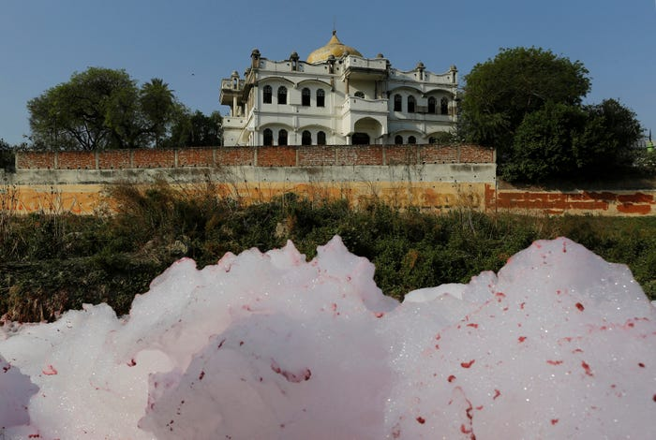
Layers of foam float in a sewage drain flowing into the river Ganges in Kanpur, India.
India.

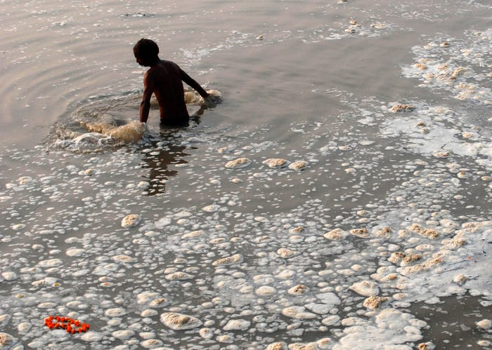
A devotee takes a holy dip in the polluted Sangam, confluence of three rivers, the Ganga, the Yamuna and mythical Saraswati, in the northern Indian city of Allahabad, November 10, 2008.
India.

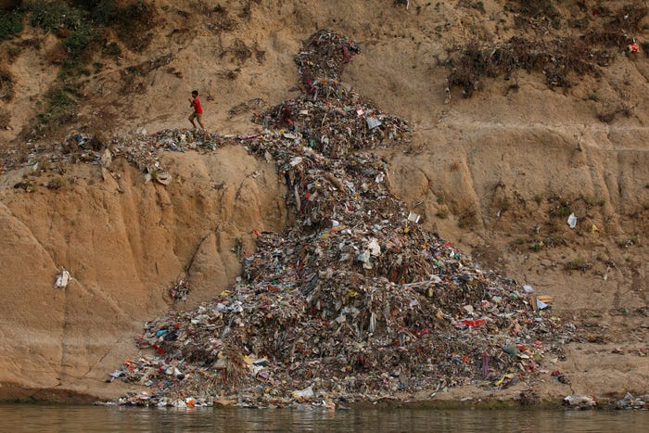
A boy runs past a pile of garbage along the river Ganges in Mirzapur, India.
India.

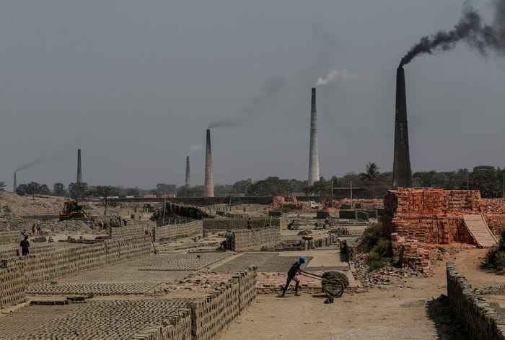
Laborers work at brick kilns along the river Ganges in Raytala, south of Kolkata, India.
India.

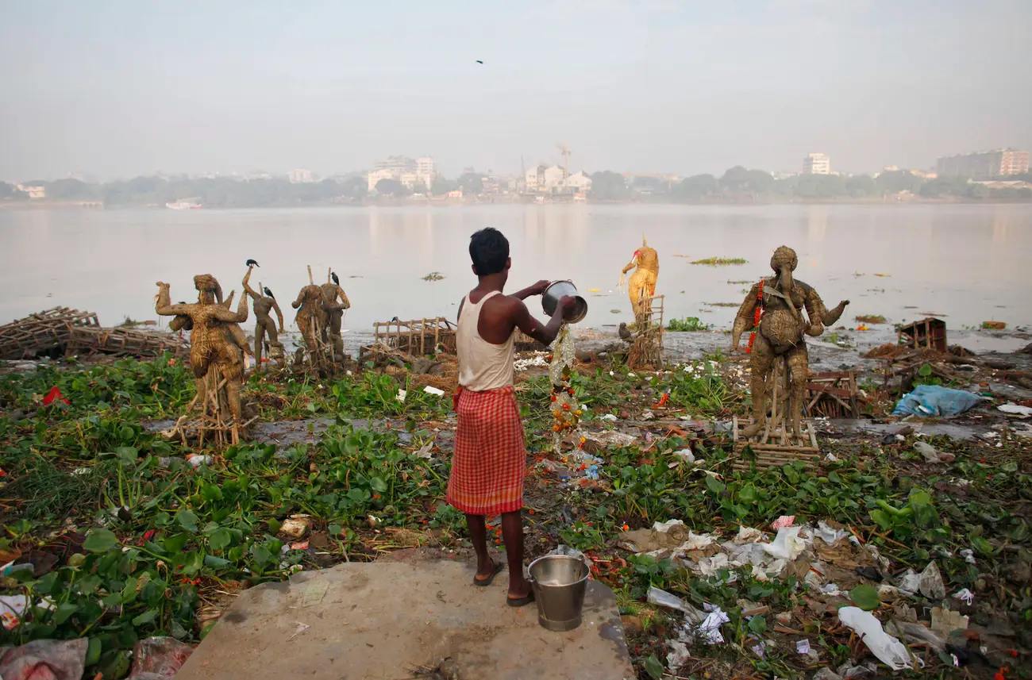
A man pours water on the polluted banks of river Ganges beside the idols of Hindu gods and goddesses that were immersed during the Durga Puja festival in Kolkata.
India.
Photo Source: Siddiqui, 2018

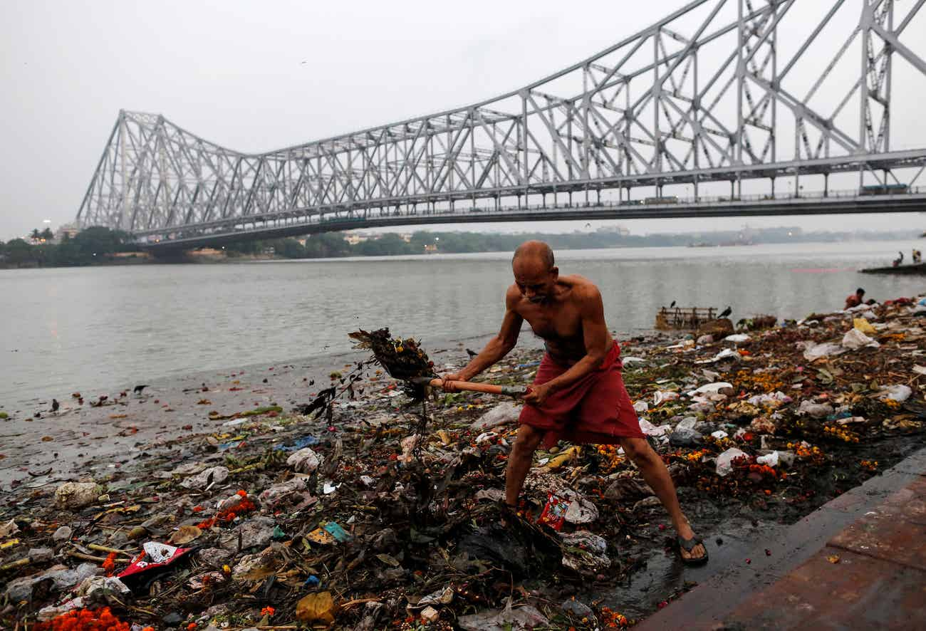
A man cleans garbage along the banks of the river Ganges in Kolkata, India, April 9, 2017.
India.
Sources:
Siddiqui, D. (2018). Layers of foam float in a sewage drain flowing into the river Ganges in Kanpur, India [Photograph]. Reuters. https://i.dailymail.co.uk/i/pix/2017/07/11/23/422FA7EC00000578-4681110-image-a-27_1499811244917.jpg
Prakash, J. (2008). A devotee takes a holy dip in the polluted Sangam [Photograph]. Reuters. https://images.firstpost.com/wp-content/uploads/2014/07/ganga1.jpg
Siddiqui, D. (2017). A boy runs past a pile of garbage along the river Ganges in Mirzapur, India [Photograph]. Reuters. https://d.newsweek.com/en/full/634252/boy-running.webp?w=737&f=7fa04ab1983277b74777f1cbf1a014d7
Siddiqui, D. (2017). Laborers work at brick kilns along the river Ganges in Raytala, south of Kolkata, India [Photograph]. Reuters. https://www.ibtimes.co.uk/photos-show-how-industrial-pollution-human-waste-are-killing-indias-sacred-river-ganges-1629885
Krause, R. (2010). A man pours water on the polluted banks of river Ganges beside the idols of Hindu gods and goddesses that were immersed during the Durga Puja festival in Kolkata [Photograph]. Reuters. https://e3.365dm.com/17/12/2048x1152/skynews-ganges-river_4180701.jpg?20171212112210
Siddiqui, D. (2017). A man cleans garbage along the banks of the river Ganges in Kolkata, India, April 9, 2017 [Photograph]. Reuters. https://i.dailymail.co.uk/i/pix/2017/07/11/23/422FA4C300000578-4681110-image-a-34_1499811264696.jpg

